Please take the time to fill in the following health questionnaire. All information will be treated in confidence. Any data given here will be treated in confidence and stored safely. Please return to christian.tiplady@outlook.com with any questions you may have. Thank you.

1. Personal Information

Full name:

Address:

Home Telephone:

Mobile:

Email:

Date of Birth:

Occupation:

2. Medical Information:

Do you currently suffer from, or have you suffered from any of the following conditions in the last 10 years? Please choose any that are relevant, indicating ‘Y’ (for yes) and adding details as necessary.

Allergies
Anaemia
Anxiety
Bone/joint issues (e.g. arthritis, disc issues etc.)
Blood pressure issue (low)
Blood pressure issue (high)
Cancer
Circulatory problems (e.g. varicose veins)
Depression
Digestive problems
Dizziness
Epilepsy
Eye problems
Hearing problems
Heart problems
Hernia
Insomnia
Menstrual problems
Migraine
Respiratory problems (e.g. asthma)
Post Traumatic Stress Disorder (PTSD)
Any other medical conditions or issues? (Please specify)

Any recent operations (in the last year)? (Please specify)

Are you currently taking medication? (Please specify)

Are you currently pregnant?

3. Other Information:

Have you practised yoga before?

If so, for how long?

What style of yoga was it?

Why are you interested in yoga?

What do you hope to gain through your practice?

What other physical disciplines are you involved in?

What other spiritual disciplines are you involved in?

How would you describe your diet?

Any other information you think I should know?

4. Disclaimer

If in doubt about my fitness I understand that I should consult a doctor before beginning yoga. I accept the services offered to me are undertaken at my own risk and that the tutor cannot be held liable for personal injury caused by my own negligence.

Signed: Date:

(Add initials or electronic signature above) (Add date above)

Thank you for filling in this questionnaire. This information will be treated in confidence.

Please return save this questionnaire with your full name e.g. ‘Sam Brown Yoga Questionnaire’ and then send as an attachment to christian.tiplady@outlook.com with any questions you have.

>>>See information below about yoga with Christian.
5. Information on Yoga with Christian

Style of yoga

I have always been inspired by two styles of yoga in particular: Ashtanga yoga (a type of dynamic flow yoga), which is powerful and energetic; and also a particular type of Hatha yoga (usually called ‘Scaravelli-inspired’ yoga), which is gentler and more deeply intuitive.

Depending on the yoga participants I’m working with, I may infuse an essence of the one into the other; Bringing the softness and intelligence of Hatha yoga into Dynamic Flow classes, and a little of the energy of a more dynamic yoga into Hatha classes. In short, I teach what the context needs.

Ultimately, I think that yoga is not to be put into boxes, so I look to avoid the labels. The goal is to tailor the teaching to the individual or the group as much as is possible. You will work with postures, breath and some chants, in a variety of ways in order to maximize the benefits for you personally: a calm mind, a strong, flexible body and potentially a new outlook.

Background, Qualifications and Study

- Practised yoga for 40 years, since starting to learn yoga at school.
- Studied Ashtanga Yoga in the UK, the USA and India with teachers including Ginny Dean, John Scott and Pattabi Jois, and completed an initial teacher-training course with Richard Freeman (Boulder, USA)
- Studied Scaravelli-inspired Yoga in the UK with teachers including John Stirk, Gary Carter and Peter Blackaby.
- Completed the British Wheel of Yoga (BWY) Diploma with Janet Bond in 2005, and a BWY Children’s Certificate in 2009.
- Qualified and insured through the British Wheel of Yoga (BWY), one of the principal training and authorising bodies in the UK.
- Regular CPD including First Aid and training for teaching yoga online.

Teaching Experience

Experience teaching classes at David Lloyd Brighton, LA Fitness Brighton, Virgin Active Falmer and within community centres in Brighton and Hove including Cornerstone Community Centre and Kemptown Church. Currently teaches one-to-one classes and workshops.

How was I drawn to yoga?

An interesting and lucky start…I first learned yoga with my Religious Education teacher at school, when I was aged about 10. I was drawn to it I guess because it had an element of the esoteric, and was also quite challenging physically. (I also loved the fact that I could relax in the school garden once a week and do some breathing, exercise and relaxation whilst listening to the birds and the insects!)

Since then I have continued my love of yoga for the same two reasons: for the spiritual and for the physical, which have always felt interconnected. Yoga has also helped me out in times of crisis, for example after a back injury, which doctors once suggested would probably severely limit my movements for life. Needless to say, it didn’t. Yoga has helped in so many ways including keeping me free of body and of mind. I hope it can do similar things for you.

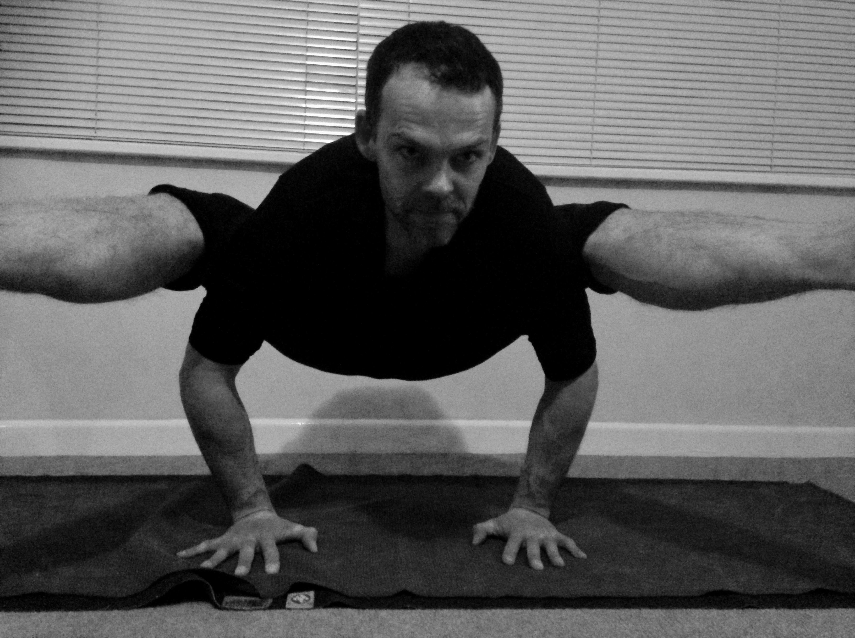
Please email me at christian.tiplady@outlook.com with any questions you may have.

