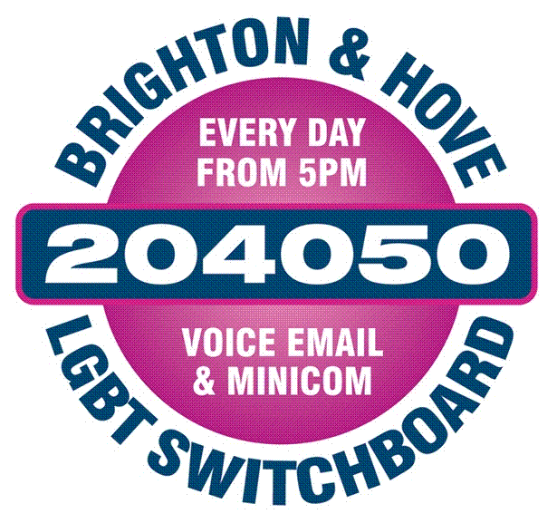

- Please complete this form in type or black ink.
- Please retain a photocopy of your completed form.
- Please state the names of two referees who are able to comment on your practice as a Counsellor/Therapist.

Return this form, with any supporting documents as soon as possible to:

Maria Antoniou
Brighton &Hove LGBT Switchboard

Community Base

113 Queens Road Brighton
BN1 3XG
UK

Or you can email it to: maria.antoniou@switchboard.org.uk

Personal details:

Title (Ms, Mr, Mrs, Mx etc.)

First Name Surname

Address: -

Email

Telephone Number

Education and Qualifications including current study:
Institution Attended | Dates (i.e. from to) | Subject of study | Results or expected | Date obtained

Please give details of any criminal convictions including spent convictions? (If offered the position you will be subject to an enhanced DBS check)

Employment History. Please include any voluntary work and account for any gaps in employment. (Continue on a separate sheet if necessary)
From | To | Position Held | Name and address of Organisation
Membership of organisations:

Name of organisation ………………………………………………………………..

Currently a member YES-NO Seeking Application YES- NO

Membership Number …………………………………… Renewal date --/--/--

Please describe why you wish to apply for this role and how you will benefit the charity. Please be specific about how you meet the enclosed person specification using examples of personal and professional experiences.

I certify that the information provided is correct and complete to the best of my knowledge.

Signature ……………………………

Date ……………………………….
References: please give the names of two people who have direct knowledge of your professional ability - state their names and addresses below.
Please state clearly for how long and in what capacity your referees have known you.

Can we contact your referees prior to interview yes [ ] no [ ]

1.

2.

To assist us with marketing please tell us where you heard about the vacancy:

