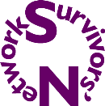
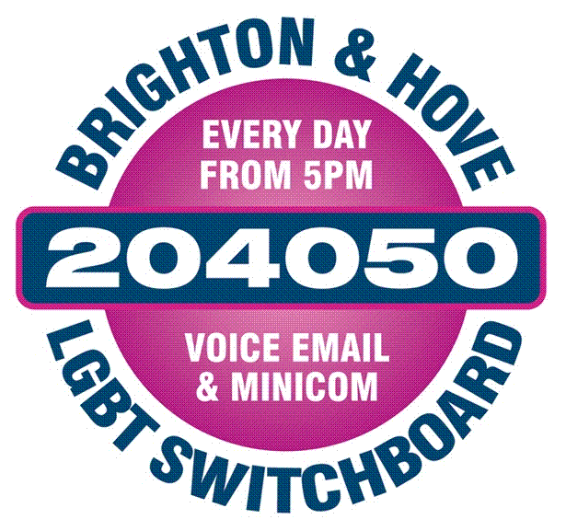
Strictly confidential

Please email the completed form to: transsurvivorsswitchboard@gmail.com

Survivors Network and LGBT Switchboard are very happy to announce that we are recruiting volunteers for our Trans Survivors Helpline. Our recent research into the accessibility of sexual violence recovery services for trans survivors has highlighted the lack of appropriate and accessible services for trans survivors. We are dedicated to addressing that gap and launched a specialist helpline for trans survivors in July 2016. We are currently recruiting additional volunteers to staff this service.

If you are successful in being offered this volunteer role, we would ask that you be able to commit to the following:
--Training to take place on the following days:
29 January 6:30-9 pm
5 February 6:30-9 pm
12 February 6:30-9 pm
Saturday 3 March 10-4
-- Two shifts per month which take place on a Sunday either from 1-3 pm or 3-5 pm.
--Operations meeting and supervision every other month on the first Monday of the month from 5:15-6:45.

We welcome applications from ex-service users. However, in order to promote clients’ and volunteers’ self-care, we do not accept volunteer applications for Survivors’ Network’s volunteer-led and counselling services from individuals who are currently using or have used any of those services within the last 2 years.

Name and pronoun(s): | Address:
Email address: | Address:
Phone numbers  Home:  Mobile: | Address:

Why this project?
Please describe what you hope to achieve by being a help-line volunteer with the Trans Survivors Switchboard.

Your skills and experience
Please describe any relevant skills, experiences, knowledge, and personal qualities you have that would enable you to fulfil the role of help-line volunteer. Please specifically evidence your knowledge and experience of the trans community and the issues that affect trans people. Additionally, please evidence your knowledge and experience of supporting survivors of sexual violence.

Please give details of any criminal convictions including spent convictions? (If offered a volunteer opportunity you will be subject to an enhanced DBS check)

References
Please provide the details of two referees who can comment on your suitability for the role of volunteer help-line operator. At least one of these referees must be somebody who knows you professionally or academically, as opposed to personally.
Reference one
Name:
Relationship with referee and how long they have known you:

Name and pronoun by which this reference knows you:
Address and phone number:

Email address:

Reference two
Name:
Relationship with referee and how long they have known you:

Name and pronoun by which this reference knows you:
Address and phone number:

Email address:

IT requirement
All volunteer help-line operators are required to have basic computer skills, in particular communicating via e-mail, and performing internet searches to locate resources for help-line callers and email enquirers.

Thank you for completing this application form which will be reviewed by the Helpline manager. If you appear to meet the requirements for the volunteer role you will be contacted regarding attending an interview.
If you have any questions in the meantime please contact us on the above details, or the administrator can be emailed at transsurvivorsswitchboard@gmail.com

I agree to become a member of Brighton & Hove LGBT Switchboard and consent to my details being held on the member’s register

SIGNATURE DATE

MONITORING FORM
Please complete this form by answering the questions below. This information will assist us in monitoring service users in a confidential manner. This will enable us to gather useful information, target our services effectively, and meet the needs of our service users.

1) What is your gender?

2) What is your ethnic group?
(Please circle a group from A-E then tick appropriately to indicate your cultural background.)
A. WHITE
Scottish English Welsh
Irish Other (please specify)
B. MIXED
Please specify
C. ASIAN/ASIAN BRITISH, SCOTTISH, WELSH, IRISH
Indian Pakistani Bangladeshi
Chinese Other (Please specify)
D. BLACK/BLACK BRITISH, SCOTTISH, WELSH, IRISH
Caribbean African
Other (Please specify)
E. OTHER ETHNIC AND CULTURAL BACKGROUND. (Please specify)

3) What is your sexual identity?

4) What is your age?

5) Do you consider yourself to have a disability?
(If answering yes please specify what the disability is)
Yes No

The current definition of disability under the disability discrimination act is: ‘A person has a disability for the purpose of this act if he has a physical or mental impairment which has a substantial and long term adverse effect on his ability to carry out normal day to day activities.’
Thank you very much for completing this form

