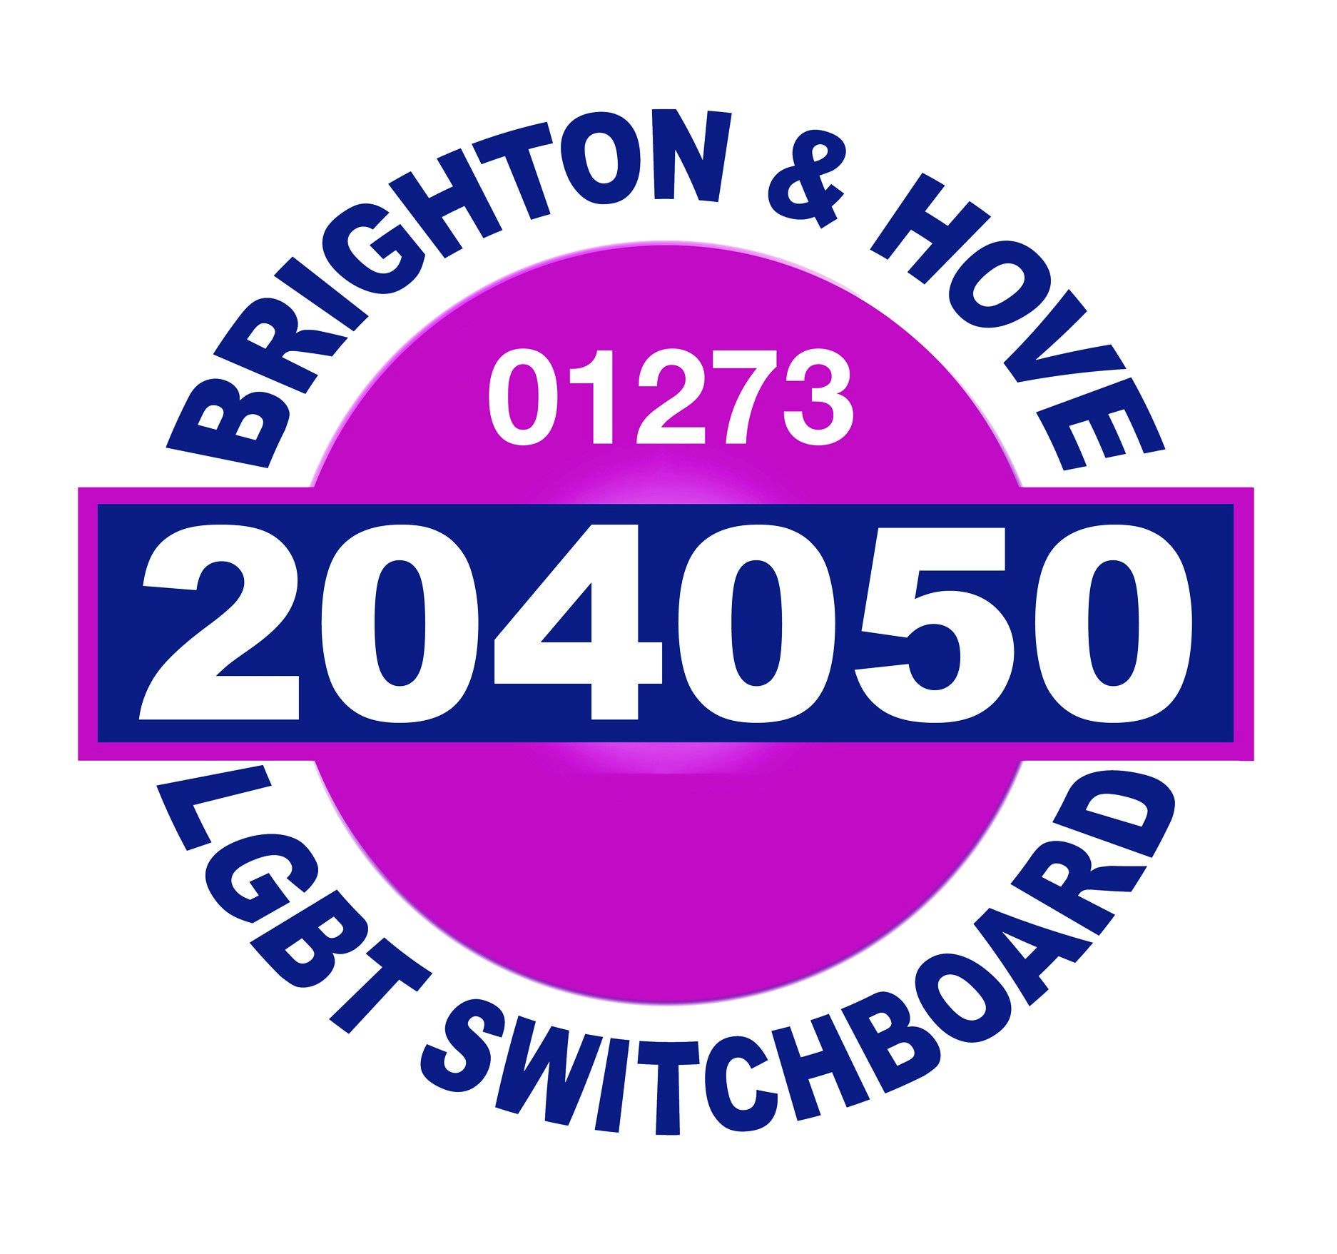  VOLUNTEER COORDINATOR  Position Applied For: | Application Form

Please complete all sections of the form in black ink or type directly into the boxes (the boxes will expand as you type into them). Application forms that are not completed in full will be automatically rejected. CV’S WILL NOT BE ACCEPTED.

Applications should be returned to:
- POST: RECRUITMENT, BRIGHTON & HOVE LGBT SWITCHBOARD, COMMUNITY BASE, 113 QUEENS ROAD, BRIGHTON. BN1 3XG
- EMAIL: brighton.admin@switchboard.org.uk

The closing date for return of completed applications, including a completed equal opportunities monitoring form is: WED 21st MARCH 2018 (12 noon)

Date reserved for interview is: TUES 27th MARCH 2018

If you require this form or any of the accompanying information in large print, please contact us on 01273 234009

Personal contact details

Please fill in all of the below details. This section of the application form will be treated as confidential and will only be used to contact you.

Surname

First names(s)

Pronouns (he/she/they etc)

Address

Post code

Home telephone number

Work telephone number

Mobile telephone number

Email address

Which method of contact do you prefer?

Are there any restrictions on you taking up employment in the UK? (if yes, please provide more details)

Yes No

References

Please provide two references that we are able to approach should you be offered the position. These references will not be taken up until we have offered the post and received confirmation of acceptance.

 | Current Employer/ First Referee | Second Referee
Name
Address
Postcode
Tel
Email
Capacity

Training and Education

Please complete this section, listing your qualifications/training received. If you need more space, please continue on a separate sheet clearly stating the section of the form, your name and position you are applying for.

Dates | Course | Qualification/Grade

Current Experience

Please complete this section, listing details of your current employer and the duties you perform in your current role.

Current Employer
Employer’s Address
Position Held
Date Employed
Duties and Responsibilities

Reason for leaving

Previous employment

Please include paid or unpaid work and account for any gaps. If you need more space, please continue on a separate sheet clearly stating the section of the form, your name and the position you are applying for.

Name & Address of Organisation | Dates | Brief description of duties and responsibilities (including reason for leaving)

Experience, skills, abilities and knowledge

Please use the space below to clearly demonstrate how you meet the criteria as per the person specification (points marked A (for application) are the points that we short list on for interview). You can use paid or unpaid work or other experiences to demonstrate how you meet the criteria, giving examples. If you are completing and returning this form electronically, the box will expand as you type. If you are completing this application form by hand, please use a separate sheet if you need more space, including your name and position applied for.

Essential (E)

Desirable (D)

Declaration of criminal convictions

The Rehabilitation of Offenders Act 1974 (ROA) ensures that ex-offenders who have not re-offended for a period of time since the date of their conviction are not discriminated against when applying for jobs. The ROA enables ex-offenders to ‘wipe the slate clean’ of their criminal records in the sense that they are no longer legally required to disclose to an organisation convictions that are ‘spent’, unless the role they are applying for is exempted from the Act.

Any declaration you make will be kept confidential as part of the recruitment process and each case will be decided on its own merits (Note some people are banned from working with children under the Protection of Children Act 1999 & Criminal Justice and Court Services Act 2000). When looking at declarations the recruitment panel will consider:
- Whether the information revealed is relevant to the position
- The seriousness of the offence(s)
- The length of time since the offence(s)
- Whether this was part of a pattern of offending or a one-off incident
- The age of the applicant at the time and circumstances of the offence and explanation(s) of the applicant.

Please be as honest as possible at this stage as an Enhanced Criminal Records Disclosure may be requested prior to confirmation of appointment and your appointment will be subject to this being received and satisfactory as part of your recruitment. If you are unsure whether you need to declare something please contact the NACRO Resettlement Plus Helpline on
0207 8406464.

HAVE YOU EVER BEEN CONVICTED OF ANY CRIMINAL OFFENCE/S OR RECEIVED A CAUTION OR BIND OVER?

YES / NO (please delete as appropriate)

If yes, please give particulars and dates:

Date: ____________________ Signature: _______________________

Full Name (Block Capitals): _____________________________________________

Declaration

Are you related to or known by anyone at Brighton & Hove LGBT Switchboard who is either a volunteer or an employee?

Yes No

Please specify any special arrangements you may require

How much notice would you be required to give your current employer?

_______________________________________________

If you are disabled please note here any arrangements which would need to be made if you are called for interview: (please note we are part of the Positive about Disabled People recruitment scheme).

I certify that the information given on this form is correct to the best of my knowledge.
I agree to Brighton & Hove LGBT Switchboard holding the information supplied subject to the Data Protection Act 1998. I also consent to Brighton & Hove LGBT Switchboard obtaining a criminal record disclosure (DBS check).

The information supplied will remain confidential within Brighton & Hove LGBT Switchboard, and will only be accessible by authorised staff and volunteers, and will not be supplied to any third parties.

Signed: _________________________ Date: ____________________________

Please ensure you have:
- COMPLETED ALL SECTIONS OF THE APPLICATION FORM
- COMPLETED THE EQUAL OPPORTUNITIES MONITORING FORM
- SIGNED THE APPLICATION FORM

