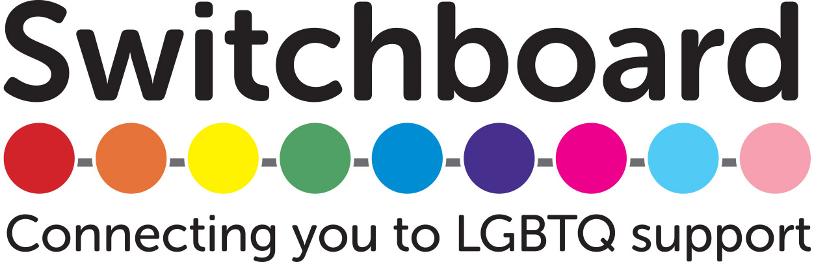

Rainbow Cafe Volunteers
The Rainbow Café is a monthly drop-in session for people with Dementia from the LGBTQ community, their friends, carers and loved ones. We will also be organising quarterly information sessions to answer questions that people might have about memory loss, pathways into dementia services and accessing support for friends who might have the condition. In addition to peer support we aim to raise awareness of the specific needs and concerns of LGBTQ people with dementia amongst service providers, commissioners & local LGBTQ people engaged with as part of the project.
We have two roles available, one more people focused (events), the other more about marketing and research. These could be made into one role if you felt you wanted a more rounded experience, have appropriate skills or are interested in both.

Events Volunteer
Role duties:
- One to one, group and facilitator support. Provide company, support and reassurance for people with dementia during Rainbow Cafe i.e. conversation, helping people find their way around, assisting with co-ordinated practical tasks during art, making or object handling activities
- Room set-up for events & information sessions
- Meet & greet, take participant register/details
- Distributing and collecting event evaluation paperwork
- Organising and making of teas, coffees, serving food to attendees, clearing away and washing up after the event
You are:
- A member of and passionate about supporting the LGBTQ community
- Committed, organised and friendly
- Good with people, patient, kind, energetic, able to respond to situations quickly and calmly (think on your feet) and have a sense of humour
- Happy to go flyering, into pubs etc. to market our events, converse with individuals about what we do, feed back to us people's concerns and response to what we offer
- Have an interest in learning more about issues that affect LGBTQ older people, their unique support and social infrastructures
In this role you will:
- Work at monthly events for up to 4 hours per month plus up to 4 hours per month flyering/marketing at local community locations
- Meet other LGBTQ people who are committed to supporting our community
- Receive training on how to work with people with Dementia, regular feedback and support from the Rainbow Café Development Worker
- Be a valued part of the Switchboard team, helping us deliver our vital services
- Uphold LGBTQ Switchboard’s standards of confidentiality, inclusivity and professionalism

Research and Marketing Volunteer
Role duties:
- Research local Dementia peer support groups and services, older LGBTQ support groups, carers and befriending organisations to support Rainbow Development Worker in their role of networking to raise awareness of issues affecting people from LGBTQ community with Dementia.
- Research informal social structures of older people from LGBTQ community i.e pubs, alt social gathering spaces in order to target hard to reach individuals, with a view to a potential pop-up information/activity session in a local community space
- Research and compile list of press, listings and social media opportunities for marketing and promotion of Rainbow Café
- Research local practitioners knowledgeable in areas such as Power of Attorney, Next of Kin, and Befriending organisations to support Rainbow Cafe Development Worker organise information sessions
- Update and compile contact, community and marketing databases for Rainbow Café
You are:
- A member of and passionate about supporting the LGBTQ community
- Committed, organised and friendly
- Comfortable using Excel for compiling databases
- You have an interest in learning more about issues that affect LGBTQ older people, their unique support and social infrastructures
In this role you will:
- Work flexibly, either remotely or in the office up to 4 hours per week
- Gain experience in administrative work in a vibrant LGBTQ charity
- Develop new transferable skills
- Meet other LGBTQ people who are committed to supporting our community
- Be a valued part of the Switchboard team, helping us deliver our vital services
- Uphold LGBTQ Switchboard’s standards of confidentiality, inclusivity and professionalism

Deadline for these roles is 6 September, interviews are on 18 September. Please fill in or download the application on our website https://www.switchboard.org.uk/how-you-can-help/

