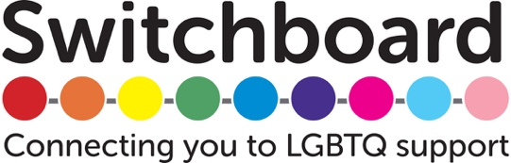

**Intersectionality: Race/Ethnicity and LGBTQ People in Brighton & Hove**

Community Engagement and Consultation Report

**June 2018**

Switchboard’s Health & Inclusion Project

in partnership with

The Trust for Developing Communities

**Intersectionality: Race/ethnicity and LGBTQ Identity in Brighton & Hove**

Brighton and Hove NHS Clinical Commissioning Group (BH CCG) and Brighton and Hove City Council (BHCC) have commissioned the [Trust for Developing Communities](http://trustdevcom.org.uk/) (TDC) and the [Health and Inclusion Project](https://www.switchboard.org.uk/projects/health-and-inclusion-project/) (HIP) at [Switchboard](https://www.switchboard.org.uk/) to conduct a series of consultation and engagement activities with local communities. The aim is to use the information gathered to feed into local service commissioning, planning and delivery.

This report was conducted in partnership by TDC and HIP, under the theme of ‘intersectionalities’. The consultation explored the intersection between race/ethnicity and LGBTQ communities in Brighton & Hove, with a specific focus on experiences of work and employment.

Please note, the following report presents information about the consultation and engagement work conducted by TDC and HIP and should not be taken as a position statement of any participating organisation.

Switchboard’s Health and Inclusion Project and the Trust for Developing Communities are extremely grateful to all partners who contributed insights and energy to this consultation, especially the community advisory panel, Brighton QTIPOC Narratives, Brighton & Hove’s LGBTQ groups, and Stonewall.

**CONTENTS**

1. Executive Summary 5

1.1 Background 5

1.2 Scope & methods 5

1.3 key insights 6

1.4 Recommendations 8

2. Scope of the work 13

2.1 Intersectionalities project 13

2.3 Community advisory panel 13

2.4 Issues addressed 13

2.5 Further insights 14

3. Background: Defining the terms 14

3.1 Introducing intersectionality 14

3.2 Working intersectionally 15

3.3 Avoiding tokenism 16

3.4 Defining BAME/ PoC 16

3.5 Defining LGBTQ 19

3.6 summary 19

4. Background: Local situation 20

4.1 Brighton & Hove population 20

4.2 Employment 21

4.3 Racism in the LGBTQ community 22

4.4 Existing networks 23

4.5 Health 24

4.6 Hate crimes 24

5. Methodology 25

5.1 Partner meetings 25

5.2 community Survey 26

6. Findings - Advisory panel discussion themes 27

6.1 Workplace issues 27

6.2 Role models 29

6.3 LGBTQ spaces in the city 29

7. Findings - Brighton QTIPOC Narratives discussion themes 30

7.1 Background of Brighton QTIPOC Narratives 30

7.2 Role models 31

7.3 Mental health 32

7.4 Workplaces 32

8. Findings - Stonewall discussion themes 33

8.1 Organisational questions 33

8.2 Role models 34

9. Findings - Meetings with Brighton & Hove LGBTQ organisations 35

9.1 Organisation A 35

9.2 Organisation B 37

9.3 Switchboard QTIPOC ex-volunteer 39

9.4 Switchboard 39

10. Findings - Community Survey 41

10.2 Demographics 41

10.1 note on analysis 41

10.2 Workplaces 47

10.3 Discrimination at work 52

10.4 Race/ethnicity at work 60

10.5 LGBTQ+ identities at work 64

10.6 Tackling workplace inequalities 67

11. key insights 73

11.1 for the statutory and public sectors 73

11.2 For the statutory, public, community, and voluntary sectors 75

11.3 for the community and voluntary sectors 76

12. Recommendations 77

12.1 Public and statutory sectors 77

12.2 Community and voluntary sectors 78

13. Conclusions 81

14. Key contacts 82

# 1. Executive Summary

## 1.1 Background

Switchboard and the Trust for Developing Communities worked in partnership to explore the intersection between Brighton & Hove’s lesbian, gay, bisexual, trans, and queer (LGBTQ) communities, and Black, Asian, and Minority Ethnic (BAME) and/or People of Colour (PoC) communities.

Locally, we have very limited evidence about the intersection between race and LGBTQ identity. Existing data reviews the LGBTQ community and the BAME/PoC community as two separate groups. Although limited, the evidence indicates that LGBTQ BAME/PoC face multi-layered barriers when seeking support from health and wellbeing services, as well as the charity and voluntary sectors in Brighton & Hove.

Whilst there are lively informal networks and initiatives run by and for LGBTQ BAME/PoC, many people report facing hostility and racism in mainstream LGBTQ organisations and social spaces. A past consultation on this topic found that LGBT BAME people felt frustrated and tokenized by the inaction of LGBTQ groups to address these issues.

## 1.2 Scope & methods

Since this consultation was carried out by a White British LGBTQ person, we convened an advisory panel of five people who were both LGBTQ and BAME/PoC. Panel members shared personal thoughts about what would be useful from this consultation; they did not represent any organisation or wider community.

The advisory panel set the scope of the consultation: to explore the intersection of race/ethnicity and LGBTQ identity in relation to employment. The focus included individuals’ everyday experiences in the workplace, alongside more structural questions about what actions are being taken to recruit and support LGBTQ BAME/PoC as staff. The panel advised against consulting only with BAME/PoC, to avoid creating extra labour and re-traumatizing people, without any guarantee of significant change.

Workplace issues were addressed through a series of meetings with leadership at Brighton & Hove LGBTQ organisations, exploring their role as employers and service providers; partner meetings with Brighton QTIPOC Narratives and Stonewall to discuss role models projects; and a community survey that was open to LGBTQ people of any race/ethnicity who lives, works, studies, or socializes in Brighton & Hove.

## 1.3 key insights

LGBTQ people of all races and ethnicities experience workplace harassment in Brighton & Hove. The findings show that race and LGBTQ identity intersect: LGBTQ BAME/PoC report more discrimination than White British LGBTQ people, and non-White LGBTQ BAME/PoC face an even more serious situation. This is having lasting impact on the health and wellbeing of LGBTQ BAME/PoC. Within and beyond workplaces, visible representation of LGBTQ BAME/PoC role models is lacking, which adds to isolation and shame. There are no specialized services to support LGBTQ BAME/PoC in Brighton & Hove, who often face exclusion in mainstream LGBTQ group as well as health and wellbeing services. Evidently, there is more work to be done.

### 1.3.1 for the statutory and public sectors

#### Intersectional oppressions in the workplace

Whilst White British LGBTQ people reported discrimination, these experiences are more widespread among LGBTQ BAME/PoC. LGBTQ BAME/PoC are more likely to experience discrimination for being LGBTQ, gender-based discrimination, as well as racist discrimination. Issues range from subtle harassment to sustained bullying and being forced to leave jobs.

#### Differences within the LGBTQ BAME/PoC community

Non-White LGBTQ BAME/PoC reported even higher levels of discrimination and harassment at work than the average among all LGBTQ BAME/PoC. Respondents’ backgrounds differed in more ways than race and ethnicity, so race and ethnicity shouldn’t be taken as the only or main explanation for the findings, however.

#### Workplaces are causing harm to LGBTQ BAME/PoC

The results show a serious impact on people’s health and wellbeing. Many LGBTQ BAME/PoC are experiencing low confidence, despair and hopelessness, as well as exhaustion and isolation because of what they experience at work. Some have taken extended sick leave and suffered a long-term mental health impact.

#### White British colleagues do not recognize the experiences of LGBTQ BAME/PoC

LGBTQ BAME/PoC are often dismissed when talking about their experiences. The reality of harassment among LGBTQ BAME/PoC remains poorly understood by most White British people. That includes White British LGBTQ people, who have a more optimistic view of racial equality at work and greater trust in managers.

#### Workplaces are not proactive

Workplaces rarely address the needs of staff who are LGBTQ BAME/PoC until someone has arrived in an organisation and faced difficulties. The burden of changing the environment falls on individuals who have been harmed, who feel helpless and resigned to harassment. Leadership should be proactive even if there are no staff members who are LGBTQ BAME/PoC.

#### Specialised mental health support is vital

There is a critical need for specialised mental health and wellbeing services that are equipped to work with LGBTQ BAME/PoC. LGBTQ BAME/PoC feel significantly safer working with an LGBTQ BAME/PoC therapist, because they trust they won’t be asked to justify themselves and their identities, or be dismissed as over-reacting when talking about racial/ethnic discrimination.

### 1.3.2 For the statutory, public, community, and voluntary sectors

#### Brighton & Hove has few spaces specifically for LGBTQ BAME/PoC

There are not enough spaces where LGBTQ BAME/PoC can talk openly about their experiences without having to justify themselves, censor themselves, or fear a backlash.

#### Visibility is a problem

There is a real lack of visible representation of LGBTQ BAME/PoC in Brighton & Hove, leaving some people feeling isolated. A role models project is wanted among partners to share stories and increase understandings across local populations.

#### Creative initiatives already exist

Vibrant community-led initiatives already exist in Brighton & Hove, often without any formal funding or institutional support. These groups would be well-placed to lead on future initiatives and projects.

### 1.3.3 for the community and voluntary sectors

#### LGBTQ organisations are often unsafe

LGBTQ BAME/PoC are frustrated with the widespread inaction among LGBTQ organisations, which have too often prioritised the voices of White British LGBTQ service users. It is key to reflect on how far organisations reflect communities they aim to serve, and actions taken.

#### Engagement varies across Brighton & Hove’s LGBTQ groups

There is a very mixed picture of how proactive LGBTQ groups are, though only one of three participating groups runs any specialized services for LGBTQ BAME/PoC.

#### LGBTQ BAME/PoC staff are lacking in LGBTQ Organisations

As a sector, Brighton & Hove’s LGBTQ organisations do not have nearly enough BAME/PoC staff members to reflect the local population. This can make BAME/PoC service users feel unsafe and undermine aims to run projects for LGBTQ BAME/PoC, which must be delivered by LGBTQ BAME/PoC staff.

#### Resources and funding are a significant barrier

Past and present LGBTQ BAME/PoC initiatives have been run without specific funding. Whilst every participating organisation expressed a commitment to taking action, this is often prevented by major funding cuts.

#### Switchboard has not engaged with LGBTQ BAME/PoC

Whilst intersectional inclusion is a core value, actions have not been taken to work with and recruit LGBTQ BAME/PoC. LGBTQ BAME/PoC are under-represented among service users, staff, trustees, and volunteers, meaning that services have not engaged and supported LGBTQ BAME/PoC.

## 1.4 Recommendations

### 1.4.1 public and statutory sectors

#### a) Workplace environments: BHCC and BH CGC lead initiatives to improve the work environment for LGBTQ BAME/PoC

* + Work with managers across public sector organisations, to consider new strategies to address workplace harassment and discrimination beyond existing measures. Strategies to focus on pro-active education of White British employees and avoid placing a burden on LGBTQ BAME/PoC staff.
  + Explore ways to hold public and commercial sectors to account on being pro-active in addressing discrimination against LGBTQ BAME/PoC at work.
  + Implement a mentoring/ support scheme to link up LGBTQ BAME/PoC employees across different workplaces in the public and statutory sectors.

#### b) Mental health support: BH CCG offer specialized mental health support for LGBTQ BAME/PoC

* + BH CCG prioritise employing a support worker with specialized knowledge and experience of working with LGBTQ BAME/PoC. Ideally the worker should themselves be LGBTQ and BAME/PoC.
  + Raise awareness about specialized services with existing community groups.

#### c) Training: the intersection of race, ethnicity and LGBTQ identity to be part of mandatory equality and diversity training

* + Within public and statutory sector groups, all mandatory staff trainings on equalities and diversity should specifically address the intersection of race, ethnicity, and LGBTQ identity. Content and format to be developed with LGBTQ BAME/PoC trainers, using materials such as Gires’ *Inclusion*, by Sabah Choudrey. Trainings to take into consideration the fears of LGBTQ BAME/PoC staff.
  + Staff in all mental health services to receive additional awareness training on working with LGBTQ BAME/PoC.

#### d) Make funding available to support community projects led by LGBTQ BAME/PoC

* + Public sector to partner with voluntary sector and community groups on a role models project, to increase visibility and representation of LGBTQ BAME/PoC in Brighton & Hove.
  + Support new initiatives that engage with and support LGBTQ BAME/PoC.

#### e) Prioritise further research with the LGBTQ BAME/PoC community

* + Gather more evidence about the experiences of LGBTQ BAME/PoC, including the impact of intersectional oppressions like disability and migrant status. Aim to identify barriers to accessing health care (specifically mental health services), and community support.
  + Research should be led by people who are both LGBTQ and BAME/PoC. Work with existing local LGBTQ BAME/PoC initiatives to develop questions and approaches.

### 1.4.2 voluntary and community sectors

#### f) Role models: work on developing projects to support the visibility and representation of Brighton & Hove’s LGBTQ BAME/PoC communities.

* + Stonewall and TDC bring together potential partners to explore logistics, funding sources, and legacies of a role models project. Partners identified through the consultation include Brighton QTIPOC Narratives. For archiving, possible partners include QueenSpark Books, Brighton & Hove City Council Libraries, The Keep, and New Writing South.
  + Switchboard and TDC explore options for training LGBTQ BAME/PoC as community researchers, to carry out a role models project, and support in future consultations.
  + Learn from Stonewall’s Role Models Programme, especially that the project should be owned, led, and delivered by LGBTQ BAME/PoC.

#### g) Community engagement: voluntary organisations work more closely with the LGBTQ BAME/PoC community groups

* + All voluntary groups in Brighton & Hove build closer links with existing initiatives, to support and signal boost their work.
  + LGBTQ organisations to lead on supporting LGBTQ BAME/PoC initiatives. BAME/PoC groups to be invited to all events, including groups for migrants, refugees, and asylum seekers.
  + TDC include LGBTQ BAME/PoC community groups at the 2019 Wellbeing Event, to facilitate sharing and connection across communities.

#### h) Workplaces: TDC work towards developing inclusive workplace policies and share with the voluntary sector

* + TDC update HR policies to improve access and inclusivity, paying attention to BAME/PoC and LGBTQ communities. Collaborate with partners and communities in developing new, inclusive approaches to recruitment, job opportunities, and working environments for paid staff and volunteers from BAME/PoC and LGBTQ communities.
  + Job/ volunteer applications: key issues include updating scoring systems and job criteria to value different kinds of expertise; having an open morning or named person to speak with before applying; offering support with completing application forms; and leaving enough time for deadlines. Shortlisting to be done with care, time, and attention – not just ticking off key words.
  + Working arrangements: key issues include flexibility with working hours and days, to support people with caring responsibilities and other commitments; being open to job shares; building an intersectional lens into all new projects.
  + Share findings with the sector, for example via Community Works networks and the Volunteer Co-ordinator Forum.

#### i) Partnership initiatives: LGBTQ and BAME/PoC organisations work in partnership to develop initiatives to improve workplaces for LGBTQ BAME/PoC

* + LGBTQ organisations partner with BAME/PoC organisations to explore creating an informal mentoring scheme to connect LGBTQ BAME/PoC in different organisations, especially where they are the only person at their workplace.
  + Explore creating a training programme on LGBTQ BAME/PoC staff, to deliver to other organisations. This should take into account fears of being singled out and re-traumatised among LGBTQ BAME/PoC.

#### j) LGBTQ employers: LGBTQ organisations to be proactive in recruiting and supporting LGBTQ BAME/PoC as volunteers, staff, and trustees

* + Implement self-reflection and monitoring of all staff, volunteers, and trustees as a routine practice, to ask how far the organisation reflects the communities it aims to serve, and take action when issues are identified.
  + Take positive action to encourage BAME/PoC people to apply for positions as trustees, volunteers, and staff, by identifying and working with new channels to advertise posts and opportunities. That includes BAME/PoC groups as well as LGBTQ BAME/PoC community initiatives.
  + LGBTQ organisations host a joint meeting to write new policies on anti-racism and supporting LGBTQ BAME/PoC as staff.
  + Switchboard continue discussions with Stonewall about facilitating a session on race and ethnicity for Brighton & Hove’s LGBTQ organisations.

#### k) National links: build links with national organisations to bring learnings from national projects into Brighton & Hove’s voluntary sector

* + Switchboard and TDC to work on developing links with Stonewall and Black Pride, to share information about national LGBTQ BAME/PoC initiatives and groups.

#### l) Raise awareness: Switchboard & TDC use platforms to discuss intersection of race, ethnicity, and LTGBTQ lives

* + TDC use its platform across health and wellbeing services to discuss the intersection of race/ethnicity and LGBTQ lives. When consulted by statutory, public, voluntary, and community groups on racial and ethnic inclusion, include a specific discussion about LGBTQ BAME/PoC. Training include breaking down assumptions that BAME/PoC are not LGBTQ.
  + Switchboard and TDC centre intersectional identities in community cohesion work, support work, and future projects.

#### m) TDC: identify where links can be built with existing community work

* + Begin asking questions with community influencers and leaders in BME and neighbourhoods work, to scope areas that are open to community conversations or building links with LGBTQ groups.
  + Questions aim to identify areas open to future projects, such as role models work. This is not about forcing people to come out as LGBTQ, having formal training, or over-riding existing concerns and priorities of community groups.
  + Links aim to build common ground, encourage connection and support allyship.

#### n) Switchboard: implement a programme of work around race and ethnicity as a strategic priority

* + Establish an action plan in a staff workshop. Staff to reflect on how race and ethnicity fit into their work, collectively set outcomes, and problem-solve together. Work should be taken on by the whole organisation, with one trustee designed to lead and monitored by the Service User Advisory Panel.
  + Once an action plan is established, issue a public apology for the lack of support for LGBTQ BAME/PoC and set out what steps will be taken.
  + Hold training for all existing and new trustees, staff and volunteers addressing the intersection of race, ethnicity, and LGBTQ identity.
  + Take positive action to encourage BAME/PoC people to apply for all positions
  + Explore options for hosting specialized services for LGBTQ BAME/PoC in Brighton & Hove. Consider designating one night per week on the helpline for LGBTQ BAME/PoC callers, where volunteers on the phone will all be LGBTQ BAME/PoC. Build on the model of the Trans Survivors helpline: this should be volunteer-led, so can happen once Switchboard has more LGBTQ BAME/PoC volunteers.

# 2. Scope of the work

## 2.1 Intersectionalities project

Brighton & Hove NHS Clinical Commissioning Group (BH CCG) commissioned TDC and LGBT HIP to carry out a consultation around the theme of ‘Intersectionalities’. TDC and LGBT HIP worked in partnership to explore the intersection between two communities in Brighton & Hove: lesbian, gay, bisexual, trans, and queer (LGBTQ) people, and Black, Asian, and Minority Ethnic (BAME) people and/or People of Colour (PoC).

## 2.3 Community advisory panel

Both organisations felt that this consultation should be led by someone who is both BAME/PoC and LGBTQ. However, neither Switchboard nor TDC has any openly LGBTQ BAME/PoC staff members. The consultation was carried out by a White British LGBTQ person; we feel it is important to acknowledge since there may well be gaps in understanding. It is our intention that future work in this area should be led by a community member who is BAME/PoC.

Early in the process we convened an advisory panel of five people who are both LGBTQ and BAME/PoC to guide the scope of this consultation. The panel advised us to focus on workplaces; their full comments are included in our findings.

## 2.4 Issues addressed

The scope of this consultation is to explore how race/ethnicity and LGBTQ identity intersect and affect people at work in Brighton & Hove. The panel emphasized that workplace issues cross from the micro- to the macro-levels. That is, they span from individuals’ everyday experiences up to the ways that institutions and structures are organized.

### 2.4.1 Individual experiences

In part, the consultation addresses individual experiences. It recognizes that seemingly subtle everyday acts of ‘othering’ can build up over time to have a substantial impact on people’s wellbeing, health, and employment. A survey across LGBTQ people of all races and ethnicities asked questions about employment, discrimination, and the pressure to educate others in the workplace (both on race/ethnicity and on LGBTQ identities). We aimed to bring out how paid employment, voluntary work, and higher education, differ across LGBTQ people who are white and British and LGBTQ people who are Black, Asian, and Minority Ethnic and/or People of Colour.

The advisory panel cautioned that asking BAME/PoC to talk about racism can be a burden that re-traumatizes community members. They urged us to do more than catalogue individual instances of biphobia, homophobia, queerphobia, racism, and transphobia at work. The panel advised that the consultation should ask questions of White British people and interrogate the whiteness of local organisations – especially LGBTQ organisations.

### 2.4.2 Structures

The other part of this consultation focuses on the structures. It aims to understand more about how organizations are (or are not) working to recruit, support, and nurture LGBTQ BME/PoC staff. In-depth discussions were had with LGBTQ organisations on how they view and address these issues. This consultation is a first step to identify areas where more action is needed and unpick what that work might look like.

## 2.5 Further insights

The Trust for Developing Communities ran a simultaneous consultation about employment among BAME/PoC communities in Brighton & Hove. Some – but not all – of the issues addressed by our two consultations overlap, and we recommend reading their report for an in-depth look at the situation across the wider BAME/PoC community.

# 3. Background: Defining the terms

## 3.1 Introducing intersectionality

All of us live with multiple identities. We are members of more than one community at the same time. These communities can be tied to our gender, sexual orientation, health, disabilities, race or ethnicity, location, religion, faith, or spirituality, socio-economic status, education level, and many more.

Our positions in these communities means that we face different kinds of oppression – even if we share LGBTQ identities. We can be asexual and live in insecure housing. We can be Jewish and non-binary. We can be queer and visually impaired. We can be black and a lesbian. Our experiences can never be reduced to one part of our identity alone.

**Working intersectionally means looking at how all of these positions come together to impact our lives. A starting point can sometimes be to think about the many communities that we are part of. That doesn't mean creating a simple list of our identities. Intersectionality recognizes that when our identities come together (or intersect) they multiply. We don't experience our identities as separate factors - they combine to create new forms of oppression.**

For example, a black gay man doesn't face racism and homophobia separately. His experience is shaped by how those forces come together. The racism he faces is reinforced by homophobia - his experience is different to a black man who is straight. At the same time, the homophobia he faces is reinforced by racism - his oppression is different to a white man who is gay. The total impact on him is more than racism plus homophobia, because when these forces come together they amplify their impact. Paying attention to these intersections is at the heart of intersectional approaches.

This isn't a question of working out who is the most oppressed or who has the most privilege. It is impossible to predict how different positions will come together, because our identities intersect at so many levels.

**Taking an intersectional approach is a key first step towards understanding the complexities of our experiences. It helps us to move past blanket assumptions about LGBTQ people and what our lives are like. By paying attention to how oppressions intersect, we can identify important differences in people's needs. We can start to understand experiences of inequality that we had overlooked in the past. By recognizing these differences, we can better work towards creating conditions for full inclusion.**

## 3.2 Working intersectionally

Intersectionality has become a buzzword across organizations working for social change. It has been taken up widely as part of efforts to improve equality, diversity, and inclusion. Although intersectionality is a useful tool for analysis, there is no simple agreement over how to put it into practice.

Understanding how to work intersectionally is tricky because intersectionality is such a wide-reaching concept. One disagreement is about whether it relates to individuals or structures. That is, if we should focus on people’s own identities, or think about the positions of groups of people.

The most common way intersectionality has been used within organizations is by noting the diversity of individuals within groups that share one part of their identity. This can be a useful step towards understanding social issues. It helps to point out different experiences and move away from blanket assumptions. However, recognizing difference is not the end goal of intersectional approaches.

Sabah Choudrey produced an invaluable guide to working intersectionally, which focuses on including BAME trans people.[1] The guide was a key resource for this consultation and offers key practical steps that organisations can take to make their work meaningfully inclusive. As Sabah points out, working intersectionally requires organisations to shift their approach:

Inclusion is a word that I feel we use thoughtlessly to imply the opposite. ‘We are inclusive of people of colour,’ translates to, ‘We thought about you enough to mention you, but that’s as much thought as we’ll give you.’ We say we are inclusive and believe that’s enough to be inclusive. Inclusion isn’t all about the words we use, it’s about who we think about before we choose what words to use. Trans people of colour are often an afterthought, an addition to a dialogue that didn’t include us in the first place.[2]

## 3.3 Avoiding tokenism

There is a risk that intersectionality can become an exercise of making lists of different identities among communities. That doesn’t necessarily have any impact on marginalized groups or help their inclusion. At times it can have the opposite effect. For example, if we only list identities that are marginalized, then dominant groups can seem like the norm. This often happens when race or ethnicity is only noted for people who are not white, which makes whiteness appear as standard.

**When paying attention to different identities, there can be a tendency to assume that someone from a marginalized group can speak for their whole community. That places a real burden on one person. It also ignores a key point of intersectionality: that our experience is not shaped by only one part of our identity. If we rely on one person to represent their group, we risk being tokenistic, and our efforts become more about proving our moral standing than addressing the real needs of the community.**

Making a list of identities can also divert attention from oppression. Intersectionality pays attention to our multiple identities in order to understand the oppressions attached to our identities, and how those oppressions reinforce each other. Those oppressions can create material barriers. They can expose us to abuse and violence, limit our job opportunities, or force us to live in insecure housing. When we think about multiple identities, it is also important to ask about these oppressions.

**Intersectionality is not a one-off exercise for any organization. It isn’t an end goal or something that can be achieved. Intersectional working is a process that needs to be embedded through policies, systems, and projects. Working towards the full inclusion of diverse voices needs real commitment and means that we need to be open to working in different ways.**

## 3.4 Defining BAME/ PoC

This consultation works with a broad definition of Black, Asian, Minority Ethnic and/or People of Colour, or BAME/PoC. In line with Brighton & Hove City Council, we use the term Black, Asian, & Minority Ethnic (BAME) to refer to anyone who identities their ethnicity as something other than White English/ Welsh/ Scottish/ Northern Irish/ British. That includes all of the following groups:

* Asian/ Asian British: Bangladeshi
* Asian/ Asian British: Chinese
* Asian/ Asian British: Indian
* Asian/Asian British: Pakistani
* Other Asian background: Thai
* Asian/Asian British: Any other Asian background
* Black/Black British: African
* Black/ Black British: Caribbean
* Black/ Black British: Other black background
* Mixed: White and Asian
* Mixed: White & Black African
* Mixed: White & Black Caribbean
* Mixed: African
* Mixed: Asian
* Other Mixed background
* Not known
* Other Ethnic Group: Turkish
* Other Ethnic Group: Arab
* White: British
* White: European
* White: Irish
* White: Gypsy/ Traveller
* Other white background

The term, sometimes written BME (Black & Minority Ethnic) is widely used in government institutions and tied to categories used in the census and population data. Increasingly, some communities traditionally labelled BAME use different language, identifying themselves as a person/people of colour (PoC). People of colour is term that describes any person who is not white.

Language is an essential part of respecting people’s identities. Terms differ across and within communities, geographies, and generations. Words can have multiple meanings, and terms that are empowering for some are not for others. These issues were discussed at length by the advisory panel, who advised that we should refer to BAME/PoC for this consultation. Throughout the report, we work with the term BAME/PoC, unless reporting on someone else’s words, when we use their own language.

### 3.4.1 Key points on Race & Ethnicity TErms from the advisory panel

* BAME is an accepted term in workplace settings, recognizable and widespread. Within communities there are ongoing conversations about the term, which stem from its history in political blackness, and questions about whether BAME should be expanded. There are generational variations, too– some people fought for the term, whereas younger people tend to use PoC. The panel felt people of colour is a more empowering term because it was created by people of colour themselves, not by white institutions.
* Most panel members disliked ‘BAME’ and didn’t feel it resonates with them personally. It was pointed out that ‘BAME’ minimises people of colour by referencing them as ‘minorities’, which centres whiteness. Globally white people make up a minority, so to call people of colour a minority is not right.
* Within PoC, people have different levels of privilege. At the same time as working together to identify shared issues, there is a need to explore different layers of oppression as a person of colour, e.g. as an African Caribbean person, or as an Asian person, instead of painting everyone with a broad brush. The panel pointed out that there are key differences like colourism, nationality, class, economic precarity, and migrant status within PoC. There is no uniform experience of being a person of colour in the UK.
* Several panel members discussed jarring experiences of having to define themselves as people of colour when they arrived in the UK. Coming from Asia, Africa, or parts of the Middle East and arriving in a place that is majority white, people are suddenly expected to define who they are in terms of their ethnicity. The term ‘BAME’ is unfamiliar to most people who migrated to the UK, whereas ‘people of colour’ is more widely known.
* ‘PoC’ was noted as a more inclusive term because some people feel excluded by ‘BAME’ if their parents are from different ethnic groups.
* White people often use ‘people of colour’ wrongly by saying ‘coloured people’, which means that people of colour then have to do extra work to educate them.
* Panel members felt comfortable with ‘BAME/PoC’ – it would suggest the issue had been thought through, and an age-inclusive approach.
* When we use umbrella terms to discuss people of colour as a whole we should still differentiate when we are referring to specific experiences e.g. among black people or Asian people.

As the panel noted, when we refer to BAME/PoC, we are not speaking about a homogenous or coherent group. There are certainly shared experiences across large parts of BAME/PoC communities, as well as important variations:

There are some BME communities that have been settled in the UK for decades, if not centuries. There are South Asian people who migrated to the UK as young adults in the 1970s and who are now reaching retirement age. There are older people who accompanied their family members. There are more recent immigrants. There are people who live with the trauma of fleeing their home and seeking asylum. The term “Black and ethnic minority” itself covers a huge range of people from all over the world, all with different experiences.[3]

## 3.5 Defining LGBTQ

We use LGBTQ as an umbrella term for people who identify as lesbian, gay, bisexual, trans, queer, questioning, or in some way outside of traditional norms of gender and/or sexuality.

This definition was also discussed by the advisory panel, although in less depth than BAME/PoC. Some panel members shared that the term LGBTQ feels whitewashed, meaning that historically and today the term tends to focus on white communities and make BME/PoC communities invisible. This is backed up by evidence that some BAME/PoC communities do not use the language of the mainstream LGBTQ movement to discuss gender and/or sexuality, instead using terms that are more relevant to their languages or cultural contexts.[4] However, panel members were undecided on a better term to use.

Several panel members prefer to use the term QTIPOC (Queer, Trans, and Intersex People of Colour), using ‘queer’ as an umbrella term. They nonetheless pointed out that ‘queer’ is not accepted by all BAME/PoC, and older generations are often resistant to the reclaimed word, possibly because of how it was used in the past.

As with BAME/PoC, we should note that there are important differences according to where someone falls under the LGBTQ umbrella.

## 3.6 summary

This consultation works with an understanding of intersectionality that is about more than listing oppressions. It understands that LGBTQ BAME/PoC have specific experiences, which are more than racism plus biphobia/homophobia/queerphobia/transphobia.

Consulting on race/ethnicity and LGBTQ identity in the workplace doesn’t mean that we can speak for all LGBTQ BAME/PoC. There are significant variations according to people’s specific racial backgrounds and/or ethnicities, as well as their gender and/or sexualities. People are also affected by many more intersecting oppressions, along axes like age, faith, disability, class, and citizenship. Whilst this consultation cannot address every intersection, it is important not to flatten the experiences of these groups.

# 4. Background: Local situation

## 4.1 Brighton & Hove population

### 4.1.1 Limited evidence

Locally, we have very limited evidence about the intersection between race, ethnicity, and LGBTQ identity. There is some population data on LGBTQ people and BME people as separate groups, though these figures do not tell us about the overlap between the communities. From existing evidence, it isn’t possible to make inferences about the overall size and makeup of the population of LGBTQ BAME/PoC in Brighton & Hove.

The Brighton & Hove City Council compiled a large amount of data on the local BME population in 2015 to inform the Brighton & Hove BME Needs Assessment Steering Group, but reported that ‘There is no robust quantitative information about the ethnic profile of our lesbian, gay and bisexual residents or our transgender residents’.[5] Data is limited because questions are asked in inconsistent ways, if at all, information is not always recorded or analysed, and individuals may choose not to disclose.

The Brighton & Hove Trans Needs Assessment (TNA) from 2015 faced similar difficulties. There was no conclusive data about race or ethnicity among the local trans population, as different reports suggest very different patterns. Trans people of colour who responded to the TNA pointed out that there is still a real need for local services to recognize the complexity of their experiences. One participant commented that meeting other trans people of colour ‘made me eventually feel comfortable enough to start coming out…that was kind of integral to me having somewhere where I felt accepted as a trans person of colour’.[6]

### 4.1.2 LGBT population

A 2014 estimate that compiled large scale surveys and audits conducted over the last ten years suggests that 11-15% of Brighton & Hove’s population is lesbian, gay, or bisexual.[7] As yet, there is still no reliable data on the size of the local trans population.[8]

### 4.1.3 BME population

The most recent census data suggests that 20 percent of residents in Brighton & Hove are BME, and 80% are White UK/British.[9] All but one of the minority ethnic communities in Brighton & Hove grew significantly from 2001 to 2011, with the largest increase being the Other White category. The 2011 census data also showed that:

* We had a higher than average proportion of residents who class themselves as Other White at 7.1% (19,524 people) compared to 4.6% nationally.
* We had fewer than average Asian or Asian British residents at 4.1% (11,278 people) compared to 7.8% nationally.
* We had a higher than average proportion of residents of Mixed or multiple ethnicity at 3.8% (10,408 people) compared to 2.3% nationally.
* We had a lower than average proportion of Black or Black British residents at 1.5% (4,188) compared to 3.5% nationally.
* We had a higher than average proportion of Arabs at 0.8% of the population (2,184 people) compared to 0.4% nationally.

## 4.2 Employment

### 4.2.1 Brighton & Hove City Council

The Brighton & Hove City Council has found significant inequalities in unemployment across local residents from different ethnicities. According to the 2011 census, BME residents had an unemployment rate of 9%, compared to a citywide average of 7.3%. However, there were major variations within the wider BME community. All non-white ethnic groups had unemployment rates higher than the city average. Unemployment stood at 18.7% among Black African residents, 16.9% among White & Black African residents, 15.9% among White & Black Caribbean, and 15.3% among Gypsy or Irish Traveller (compared to 7.3% city average). The report cautions that we should not see ethnicity as the main or most likely explanation for these differences, pointing to intersectional barriers such as migrant status, and poor service delivery.[10]

### 4.2.2 Stonewall

At the national level, Stonewall recently reported on troubling levels of workplace harassment and discrimination across the whole LGBTQ community. However, these experiences were compounded for BAME LGBTQ people, as well as LGBTQ people who are disabled, and trans people. Based on YouGov research with 3,213 LGBT employees, it found that 10% of BAME LGBT staff have been physically attacked because of their sexual orientation and/or gender identity, compared to 3% of white LGBT staff. The report also noted that 12% of BAME LGBT employees have lost a job in the last year because of being LGBT, compared to 4% of white LGBT staff.[11] This evidence points to the impact of intersectional oppressions.

## 4.3 Racism in the LGBTQ community

### 4.3.1 Count Me in Too

The Count Me in Too (CMIT) project offers some insights into the experiences of LGBTQ people in Brighton & Hove from different racial and/or ethnic backgrounds. CMIT found that white respondents were much more likely to want LGBT-specific services than BME people. BME respondents were often fearful that LGBT services would not be inclusive of them. One focus group member commented:

I did once try and go to occupational health through statutory services, but it was just such a negative experience, that since then I've just gone through lesbian and gay services and then had to talk about the BME issue. I wrote on the form that I wanted someone who was sensitive to BME issues. The woman who I worked with said that somebody volunteered in the group, and she said ‘Do you have any experience of BME issues?’ and he said, ‘No, but I don't think that matters’. I think that says a lot about what the problem is.[12]

Over 80% of BME respondents in CMIT felt it was difficult to live in Brighton & Hove as an LGBT person with additional social differences, and 38% felt marginalised by their BME identity. The three most common experiences of marginalisation included bullying, abuse, discrimination, and exclusion. These issues most often happened at LGBT venues and events, by other LGBT people, or in employment. Isolation was another key issue. Whilst 33% of all respondents said that they felt isolated in Brighton & Hove, 75% of BME respondents did, along with 50% of traveller and other ethnic groups.

### 4.3.2 HIP Consultation

A 2014 HIP Consultation with BAME LGBTQ people found a real need for an LGBT BAME forum in Brighton & Hove. Focus group members wanted a space that was BAME-led and owned, which could facilitate different kinds of support, campaigning, and community-organising. They spoke of having to withdraw from past engagement roles in the city because of racism, which was often compounded by LGBTQ discrimination. In addition, LGBT spaces and organisations were often sources of racism. The participants were frustrated that LGBT services were not offering BAME-specific programmes and events, feeling that their engagement with LGBTQ BAME communities was often tokenistic.[13]

### 4.3.3 *FS*

This fits with a national picture of racism within the LGBTQ community. In a survey of 850 readers, Gay men’s health and life magazine FS found that 75% of black gay men, 81% of east and South-East Asian gay men, 100% of Arab gay men, and 86% of South Asian gay men said they have personally experienced racism on the British gay scene.[14] Otamere Guobadia points out that beyond evidence of racism being widespread, we should be asking deeper questions about the nature of that racism. Otherwise, there is a risk that ‘the complex, and toxic systems of dominance, violence and disenfranchisement faced by queer people of colour in mainstream LGBTQ communities, get boiled down to oversimplified statistics about how many people have simply ‘experienced racism’.’[15]

## 4.4 Existing networks

We should be cautious about painting a negative picture and making assumptions about the networks available to LGBTQ BAME/PoC. In the 2014 HIP consultation, one participant pointed out that many support networks simply aren’t on the radar of white workers in LGBT organisations. Community support and lively informal networks already exist, and BME LGBT people were reported to be more active in national movements like trade unions.[16]

Sabah Choudrey points out that outsiders to a community often don’t have the privilege of seeing how wide it really is. This doesn’t mean communities don’t exist: ‘There are small but lively pockets of QTIPOC communities all over the UK’, including social and support groups that are often unfunded.[17] Many of these groups are intentionally secret, to ensure safety and discretion for members.

In Brighton & Hove, there are a number of creative initiatives and community projects by and for LGBTQ BAME/PoC, outside the work of LGBTQ organisations. Through the course of this consultation, we started building links with the Brighton & Hove Narratives Collective. There is more scope for LGBTQ organisations and BME/PoC organisations to build partnerships with these initiatives.

## 4.5 Health

### 4.5.1 Count Me In Too

Discrimination can have serious and lasting impact on people’s health and wellbeing. The CMIT questionnaire asked LGBT people whether they had experienced mental health difficulties in the last 5 years with emotional distress, depression, anxiety, anger management, fears/phobias, problem eating, panic attacks, self-harm, addictions/dependencies, suicidal thoughts, stress, confidence/self-esteem, stress, insomnia. Whilst 80% of all the respondents said they had experienced one or more of these, 100% of BME LGBT people did.[18]

### 4.5.2 Public Health England

Nationally, there is compelling evidence of health inequalities for LGBTQ BAME/PoC. A Public Health England report on the health and wellbeing of BME men who have sex with men (MSM) highlighted significantly higher than average rates of suicide, self-harm, and mental illness. It found that black MSM are 15 times more likely to have HIV than the general population, and one third of Asian and mixed ethnicity MSM experienced domestic abuse since the age of 16, compared to one in five white MSM.[19]

### 4.5.3 Race Equality Foundation

The Race Equality Foundation noted that people who are trans and/or non-binary and BME face intersectional barriers in accessing healthcare.[20] BME trans people were reported to face racism in LGBT communities as well as homophobia, biphobia, and transphobia in ethnic communities. Within healthcare, many people experienced harmful cultural assumptions and racism when accessing services, compounding the effects of transphobia. At a wider level, the Race Equality Foundation pointed to a need for more research, since there is a real lack of evidence about the health care experiences of people who are LGBTQ and BME.

## 4.6 Hate crimes

The recent political climate has brought a significant increase in reported hate crimes. During 3 months after Brexit, the numbers of homophobic attacks reported to the UK police increased by 147%.[21] In Brighton & Hove, there was a spike in racist hate crimes after the Brexit referendum. Police dealt with one third more racist incidents in the year following the referendum, from 1203 to 1503 reported incidents of racially motivated abuse and violence.[22] With no data on the intersection between racist hate crimes and those motivated by biphobia, homophobia, queerphobia, or transphobia, we can’t make inferences about the impact on the local LGBTQ BAME/PoC population.

# 5. Methodology

## 5.1 Partner meetings

### 5.1.1 Advisory panel

Since the consultation was led by a White British LGBTQ person, we convened an advisory panel made up of BAME/PoC LGBTQ people. The purpose of the panel was to drive the direction of the consultation. Five individuals were recruited through personal and professional networks to attend a 1.5-hour meeting facilitated by Switchboard’s LGBTQ Development Officer. The discussion covered definitions, the scope of the consultation, and the approach. The consultation was then developed in line with the key themes and approaches identified by panel members. After the meeting, the advisory panel gave further feedback through the process over email.

Individuals attended in a personal capacity and not as representatives of any organization, and panel members were reimbursed expenses for sharing their time and views. We did not ask or expect the panel to represent all LGBTQ BAME/PoC in Brighton & Hove, but to share their own personal opinions on what would be useful in this consultation.

The discussions at the panel took a different direction than initial ideas shared by staff at Switchboard and TDC, which confirmed the value of this process. By working with an advisory panel, we hoped to centre LGBTQ BAME/PoC in the *process* of the consultation. We saw this as a better option than a White British LGBTQ person designing the research and approaching LGBTQ BAME/PoC only to answer questions. Some members of the advisory panel agreed that convening the panel was preferable to simply doing the work because we were commissioned to do it.

Nonetheless, others were uncomfortable that there were no LGBTQ people of colour working at Switchboard or TDC. There was a concern that people of colour were invited to share their views without a guarantee that anything will happen as a result (and the lack of action after the 2014 HIP report showed that this has happened in the past). Overall, the advisory panel hoped that the consultation would help to lead to changes at Switchboard and TDC, so that there will be LGBTQ BAME/PoC staff members to lead on future consultations on these issues.

### 5.1.2 Partners

Meetings were held with partners to explore the issues raised by the advisory panel, hear their views on employment and role models, problem-solve together, and share learnings from their work. We met with two members of Brighton QTIPOC Narratives, as well as three staff members at Stonewall, who lead on empowerment work and their BAME/PoC LGBTQ Role Models Programme.

### 5.1.3 LGBTQ organisations meeting

The advisory panel asked us to engage with gatekeepers and managers who are responsible for workplace conditions. We held a series of meetings with leadership at LGBTQ organisations in Brighton & Hove. We also held informal discussions with several LGBTQ BAME/PoC staff members and ex-volunteers to inform our approach.

In the interest of encouraging openness, we have not named individual organisations, but provide case studies to make sector-wide recommendations. The exception is Switchboard, which has been identified because of our role in the consultation.

## 5.2 community Survey

A survey was written to explore people’s experiences at work, in line with the suggestions of the advisory panel. Work was broadly defined to include paid employment, unpaid/voluntary work, and higher education. Questions covered individuals’ experiences of work, discrimination, pressure to educate colleagues on LGBTQ identities and race/ethnicity, and reflections about how LGBTQ people and BAME/PoC are represented throughout their workplace.

The survey was open to LGBTQ people of all races and ethnicities who live, work, study, or socialise in Brighton & Hove. This was a deliberate step guided by the advisory panel. Whilst Switchboard and TDC initially planned to focus on consulting with LGBTQ BAME/PoC, the panel noted that the burden of doing race/ethnicity work overwhelmingly falls on the shoulders of people who are Black, Asian, Minority Ethnic and/or People of Colour. The panel was clear that no change can be achieved without encouraging White British LGBTQ people to spend more time reflecting on race/ethnicity, discrimination, and representation. LGBTQ BAME/PoC often have a heightened awareness of race, ethnicity, and racism because of their lived experience. White British LGBTQ people may share some, but not all, of those experiences; they may also be involved in and/or present during workplace issues that affect LGBTQ BAME/PoC.

By opening the survey to LGBTQ people of all races and ethnicities, we aimed to get a wider picture and compare how experiences differ across and within communities.

The survey was disseminated electronically across mailing lists and social media of individuals, professional groups, and partners by both Switchboard and TDC. That means we are unlikely to have reached people who are not connected to the local voluntary and statutory sector, which may include people who work freelance or are isolated. The survey was only available in English, so likely missed residents who cannot speak English well or at all.[23] BAME/PoC who are uncomfortable with or don’t identify with LGBTQ terms may also have chosen not to respond.

# 6. Findings - Advisory panel discussion themes

## 6.1 Workplace issues

The question was asked: what kinds of issues would you like to see work done on in Brighton and Hove? Several options were set out, starting from the idea that we might tackle the inclusion of people of colour in the LGBTQ community, or think about creating a safe space for LGBTQ people of colour, or build on comments so far about white people doing race work.

### 6.1.1 The burden of doing race work

Panel members expressed frustration that the white population hasn’t done enough interrogation on race. In reality, every structure, workplace, and service provider, is shaped by race. White people are often fragile about language, which puts a burden on people who are black, Asian, and minority ethnic and/or people of colour. Putting BAME/PoC into a white environment doesn’t necessarily change anything – the environment often stays the same and their mental health gets worse. It isn’t enough to bring in a person of colour and wait for them to change things.

Workplaces were raised as a key issue. Panel members described spending a lot of time in the work place clarifying issues about colour and heritage whilst white colleagues spend their intellectual and emotional energies working on other things. People feel a personal responsibility not to walk away, in case another person of colour joins the organisation and experiences something that they could have prevented.

Panel members reflected on focussing on race much more than issues related to being queer and/or trans. Some members feel that they are seen as BAME/PoC first, and it is then rare to be out at work because they face so much discrimination anyway.

### 6.1.2 LGBTQ BAME/PoC are deeply affected by structural problems at work

It was noted that workplace environments are stopping LGBTQ BAME/PoC from succeeding. Many people of colour end up leaving organisations, whilst white managers don’t see the othering, microaggressions, and all the extra labour required to do their job, that led to their departure.

These issues aren’t only low-level – they quickly become structural questions that lead all the way up to the highest-level of management. When issues do come up at work, there is often nowhere for LGBTQ BAME/PoC to go for help and support – human resources don’t understand.

One panel member had participated in a role models programme for LGBTQ BAME/PoC and shared that many people who attended said they had never before had a space where they could reflect on being a person of colour who is LGBTQ in the workplace. Attendees came from a range of backgrounds but faced very similar issues. There should be a way for LGBTQ BAME/PoC to share these experiences with each other and their employers.

Ultimately, the support should be both internal and external to organisations. Some external support when dealing with workplace issues would be helpful – resources are disjointed, and it isn’t clear where to go for help.

### 6.1.3 need for honest self-reflection and action from gatekeepers and managers

Panel members expressed a desire for organisations to understand how to attract, keep, sustain, and nurture LGBTQ BAME/PoC.

The focus should be on talking to the people who own the spaces that people of colour have to go into. Panel members would like to hear from statutory, voluntary, and commercial organisations in the city about what they are doing for LGBTQ people of colour in their organisations. That includes organisations like the NHS and police, who march in the pride parade. It was suggested to question whether they are proactive, or reactive, and if they are waiting for problems to arise. A related question is how they feel about how they are doing – do they think their existing policies are sufficient?

At the same time, there is some distrust of whether organisations would ever be honest and open, because there is a tendency (especially among corporate groups) to smooth over difficult issues. One panel member who personally struggled with workplace issues cautioned that organisations can stop people from achieving change.

## 6.2 Role models

### 6.2.1 Visibility of LGBTQ BAME/PoC is lacking in Brighton & Hove

Panel members pointed out the lack of positive role models. Young people and school children don’t have access to LGBTQ people of colour as role models, and they might struggle to come out because of additional community stigmas around being LGBTQ.

Having access to the stories of LGBTQ PoC role models could be powerful in the long term. Recording stories would be important in creating an archive and raising awareness. It was also pointed out these kinds of stories are key in humanising people to wider society and could have a legacy in further workshops and education.

These stories could be about the workplace, or more broadly about people’s lives – this would be a way to tackle the issues both internal and external to work. Gathering role models and recording their stories could also be a tangible outcome of this consultation, even if it is a standalone project.

### 6.2.2 Potential partners

Panel members were keen to think about potential partners and ways of sharing role models’ stories. It was suggested to work with Black History Month and explore ways of collaborating with the libraries to have the archive on public display. The Brighton Trans*formed project was raised as an example when stories were made available to listen to with headphones at stations in the library.

There was interest in the idea of running a researcher training event for LGBTQ BAME/PoC and having them make recordings and collect role models’ stories. Those involved would gain useful skills and possibly be able to work with Switchboard in the future.

## 6.3 LGBTQ spaces in the city

### 6.3.1 Frustration with a lack of action by LGBTQ organisations

The panel reflected on Switchboard’s 2014 consultation, when a 2-hour meeting was held to discuss whether community members wanted an LGBT BAME forum. It was noted that nothing came of the 2014 consultation, and panel members wondered why that was. There were questions about whether there has ever been someone BAME/a person of colour working at Switchboard who was able to take that work forward.

Panel members asked what kind of outreach has been done across existing community groups by LGBTQ charities that are predominantly white, and suggested that those groups should be asked what they are doing to include BAME/PoC LGBTQ members. It was suggested that existing groups might build on their infrastructure to set up groups specifically for LGBTQ BAME/PoC.

### 6.3.2 Race is not addressed in most LGBTQ spaces

One panel member shared experiences of attending many LGBTQ spaces and groups in Brighton to see what kinds of representation there was, and whether there had been any interrogation within the predominantly-white community about how they interact with and attract BAME/PoC members. Most of those spaces have never considered their own racist dynamics or asked how BAME people are treated in the LGBTQ community.

Having a BAME/PoC rep is not enough if the rest of the group doesn’t consider racism and other intersectional issues, because the same structures get replicated, and people of colour are left to deal with race issues. To build an inclusive space, organisations need to think about their own biases and perspectives – not only in relation to race, but other intersectional barriers.

### 6.3.3 LGBTQ BAME/PoC can be alienated from LGBTQ groups

One panel member had to stop going to LGBTQ spaces unless they were BAME-specific because of how much energy and time it required, including voluntary organisations in the city. Panel members shared that being in white spaces is exhausting – not necessarily because of overt racism, but because of the education required and the lack of understanding about how to be around people of colour.

The burden falls on BAME/PoC to explain questions about sexuality, gender, religion, and ethnicity. Panel members described having to defend their position repeatedly, which can re-traumatise them.

It was pointed out that the intersectional work needs to be done by the LGBTQ sector, or we might see a separate BAME/PoC pride in Brighton (like London’s Black Pride). The inclusion work wasn’t done around disability, and now we have Disability Pride.

# 7. Findings - Brighton QTIPOC Narratives discussion themes

## 7.1 Background of Brighton QTIPOC Narratives

### 7.1.1 Mainstream spaces are not Engaging QTIPOC

One member of the Brighton QTIPOC Narratives collective was being invited to speak on panels, but the panels weren't diverse enough and weren't addressing PoC trans issues. When that person tried to speak about their experience they were often met with tension.

New projects should centre QTIPOC voices from the very beginning – it’s much harder to change the whole structure later.

### 7.1.2 QTIPOC need specific spaces in Brighton & Hove

Many QTIPOC who move to Brighton don’t find a space for themselves. Brighton has a reputation as the gay capital – but we have to ask for who? Often QTIPOC don’t access LGBTQ spaces because they don’t feel safe there, or they don’t see themselves reflected. There are some spaces in Brighton & Hove are already doing a lot to open and hold space for QTIPOC.

Many QTIPOC in Brighton & Hove are students, meaning it is a transient community. Often QTIPOC end up moving to London or spending their free time there, but for others travelling is expensive and inaccessible.

The collective has been created as a social space, but also as a space to learn, and for members to have a voice. There is a real need for a space like this – people are keen to share, and meetings often run over time because members have so much to say. The QTIPOC Narratives meetings are among a handful of spaces where people can speak freely about their experiences, and not have to hold back.

### 7.1.3 Sharing narratives is a way of increasing visibility

Wider representation of QTIPOC in Brighton & Hove just doesn’t exist. The Brighton QTIPOC Narratives collective was founded with the view that sharing narratives moves conversations beyond labels and categories.

Often before people come to meetings they think they are the only QTIPOC in all of Brighton so are really excited to find others. This speaks to the power of narratives: to show people they are not alone.

## 7.2 Role models

### 7.2.1 Role models are not all activists

Current role models are often activists who can make themselves visible, which is invaluable. However, not everyone can be an activist, and we should be elevating QTIPOC in ordinary jobs alongside activists.

Not everyone can be an activist or lead resistance efforts. Taking that space can be too difficult for people with mental health issues, and for others it can be unsafe to show up. Participating in activism sometimes depends on having certain privileges.

### 7.2.2 A People’s Library

Individual and collective histories of QTIPOC are often overlooked in mainstream accounts, so projects should ask to make them more visible.

The idea of a People’s Library was discussed as kind of role models project, with the aim of building people up. This would be a chance to share stories and giving an honest reading of the reality of lives (beyond the sheen of social media, which can be isolating).

Shame is a key issue. Many people come to Brighton to get away from shame and gain courage from a community. That means they don’t necessarily want to be hyper-visible themselves, but campaigns still need to be. There is a dual imperative for individuals to have discretion and safety, with role models to be visible.

Projects should reflect intersectional issues, including class difference, a range of family backgrounds, the experiences of trans femmes of colour, those with mental health difficulties, and disabled people. The space should be completely accessible.

## 7.3 Mental health

### 7.3.1 Barriers to mental health support among Brighton & Hove QTIPOC

There is a huge problem with the lack access to therapy for QTIPOC. QTIPOC therapists seemingly don’t exist both in Brighton and nationally. That means cultural sensitivity is lacking.There are added barriers for black communities who may have a historic distrust of medical gatekeepers (grounded in racial inequalities in diagnoses, like the prevalence of schizophrenia diagnosed among black men), and experiences of discrimination by staff.

Organisations should be working to make existing resources more visible.

## 7.4 Workplaces

### 7.4.1 QTIPOC in Brighton & Hove often face complex difficulties at work

QTIPOC often fear they are being tokenized, which can lead to paranoia, shame, and fear. Many members of the collective are end up overqualified to overcompensate for those fears. It can be hard to pin down and might be a gut feeling, but people still want a space to talk about these issues. They can take the form of being undermined by people thinking you are only there because of positive discrimination; or being forced to get hair extensions to work in hospitality.

### 7.4.2 QTIPOC are often met with hostility when discussing their experiences

Many people face casual harassment from White British colleagues at work, who don’t realise certain things are triggering. Across Brighton, many White British people want to ignore racial and cultural differences, claiming ‘I don’t see colour’. QTIPOC then have to deal with it sensitively and calmly, and when they suggest changes they are often met with hostility, anger, and fragility from White British colleagues.

These experiences can make people feel ashamed to take space to discuss their experiences and needs. That is part of the power of narratives: people can share these stories, deal with their shame, and undo the power of hostility. They can explain what real support would look like, as well as their personal and family histories. There are many different kinds of struggles to explore, like what it means for people to ‘come out’.

Overall, QTIPOC need to know they are welcome in Brighton & Hove and can have space to talk honestly, without having to justify their experience.

# 8. Findings - Stonewall discussion themes

## 8.1 Organisational questions

### 8.1.1 LGBTQ organisations should confront their mistakes

Organisations are fallible: they will have made mistakes in the past and will continue to do so, which is why action has to be taken now. It is worth spending time reflecting honestly about your organisation and its history.

Some people might come to new BAME/PoC programmes with a degree of scepticism, asking why this is being done now. It’s essential to address this head on. Instead of being fragile as an organisation, aim to take the criticism forward with genuine actions and communicate what you will do about mistakes.

It does take a lot of self-reflection, engagement, and work to build on past mistakes. This can be supported by building new partnerships, launching specialized services, and using community events to raise awareness.

### 8.1.2 Intersectional barriers to participation need to be addressed

It was pointed out that LGBTQ organisations should be asking questions if they do not have LGBTQ BAME/PoC staff. LGBTQ organisations have to be accountable to the communities they work with, which includes reflecting their diversity. There is a lot of compelling research pointing to the added intersectional barriers faced by LGBTQ BAME/PoC, young bi people, and trans people. Organisations without LGBTQ BAME/PoC staff might think about earmarking future projects and opportunities for recruitment, volunteers, and trustees for BAME/PoC.

### 8.1.3 Development of the BAME/PoC Role Models Programme

Stonewall’s programme is part of their wider empowerment work. It built on existing projects and drew from various consultations and a pilot. It is not a one-stop-shop in training people to be role models, but creates a space to share experiences, celebrate differences, and develop networks.

It was advised to think about who has the agency to develop the programme and content. It was essential for the Stonewall programme to be BAME/PoC-led in order to create a safe space. The planning space was also explicitly non-White, so all staff involved in planning the sessions and content were BAME/PoC.

### 8.1.4 Engaging with LGBTQ BAME/PoC

It was suggested to think carefully about how to engage people who you haven’t worked with in the past. The first people you reach might be those involved in some kind of activism. Consider exploring different channels to advertise projects and partnering with new organisations.

It is important to make clear why LGBTQ BAME/PoC should want to engage with new projects; whether that is to meet people, learn something, effect real change, or support others. The relationships you build in specific projects might encourage attendees to work or volunteer at your organisation in the future.

## 8.2 Role models

### 8.2.1 Practical advice from Stonewall’s BAME/PoC LGBTQ Role Models programme

Stonewall ran sessions free of charge on Saturdays for up to 36 people. It is best to run multiple sessions to give people options for dates, and plan follow up events to let different cohorts meet. Think carefully about access: Stonewall secured funding for travel costs, and you might want to work with Skype or dial in to let other people join the conversation who might not be able to come in person.

Facilitators should be LGBTQ people who are BAME/PoC and include a range of genders. People attending the programme ideally need to see themselves reflected in the facilitators. Facilitators should be confident to call people in and correct pronouns. Be sensitive to trauma, giving trigger warnings or content notes. One way to manage the space safely is to check in at the start and end, asking questions about what people need from facilitators and each other in order to be able to share.

Sessions work well using a range of smaller and bigger group conversations, because different people communicate differently. Don’t be afraid to mix groups up. Part of keeping a safe space means looking after energy levels (including planning lots of breaks and enough food/drink).

All empowerment work should encourage people to take ownership of the content. The conversations belong to the delegates, so facilitators should aim to speak as little as possible. Think about how conversations can continue after people leave the room, with ideas like setting up WhatsApp groups for delegates where people can share concerns and events if they choose to.

### 8.2.2 Issues addressed in Stonewall’s BAME/PoC LGBTQ Role Models programme

Every group has slightly different messaging and content. Projects should be responsive to feedback and open to evolving the content and format over time. Key issues addressed include:

* Questions around discrimination (as BAME/PoC, and as LGBTQ – it can be too broad to ask both at once)
* Self-care
* Moving past the ‘out-centric’ narrative (that everyone can and should ‘come out’). Coming out works better in more individualistic Western societies, than it does in societies that are more community-based.
* Role modelling: unpicking different ways you can be a role model that don’t require you to be visibly ‘out’, like blogging online or supporting friends.
* Exploring different experiences among people of faith

Sessions start and end with thinking about what the organisation can do and what attendees can do. That means there are elements of planning alongside the space to share difficult experiences and trauma. A solution-based approach treats people as agents for change, encourages them to take ownership, and recognizes that they can do something. Don’t underestimate the value of changes that might seem small.

# 9. Findings - Meetings with Brighton & Hove LGBTQ organisations

Meetings were held with three LGBTQ organisations based in Brighton & Hove. The discussion explored where race/ethnicity sits in their vision and mission, how race/ethnicity is addressed in their work with clients, who is responsible and accountable for work on race and ethnicity, what actions they take as employers to recruit and support BAME/PoC staff, self-reflections about the makeup of the organisation and whether they are doing enough, and future-planning about what they would like to be doing on this area and what support they need to get there.

## 9.1 Organisation A

### 9.1.1 Organisational questions

Organisation A aims to be active in supporting BAME/PoC as staff. The ambition is to have equality, diversity, and inclusion running through every part of the organisation’s work.

Race sits within the organisations commitment to equality, diversity and inclusion (EDI), which is on the agenda at every staff supervision, team meeting, and management meeting.

At present there are four members of staff and volunteers who are BAME/PoC. One staff member who is themselves BAME/PoC is responsible for the organisations work with BAME/PoC, meaning that collective efforts are made to pick up and share other parts of their workload. The BAME/PoC work is indirectly supported by workers across the whole organisation.

Organisation A did have a regular EDI panel, where race and other issues were discussed and worked on. Policies are in the process of being updated in line with the panel’s suggestions, including the staff conduct policy (which will address cultural appropriation at work, among other things). The organisation started working on an anti-racism policy, which needs to be carried forward.

As an organisation working with people who sometimes need urgent support, there can be added complexities in how to deal with someone’s actions that may be causing distress and harm to BAME/PoC whilst that person is themselves in acute distress.

### 9.1.2 Workstreams

Organisation A runs specialized services for LGBTQ BAME/PoC. This emerged from an identified gap in BAME/PoC service users. The vast majority of this work is done without BAME/PoC-specific funding, so the organisation finds creative ways to do this work from their general budget. Further small grants have supported access to these services.

Past projects for BAME/PoC focussed on creating social spaces. Often these initiatives are slow-burners and need time to become established.

Organisation A will only run specialized services with a worker who identifies as BAME/PoC to lead them.

### 9.1.3 Employment

Equality, diversity and inclusion is part of mandatory training for all staff, and separate training sessions have been run on BAME awareness for all volunteers, staff, and trustees. There is an idea to compile an LGBTQ PoC training programme to spread to other organisations – a training like this is badly needed.

The volunteers, staff, and trustees are increasingly diverse in terms of race and ethnicity, although more can be done. Efforts are made to recruit by sending job adverts to BAME groups and organisations. Organization A doesn’t use any specific wording because employment law doesn’t allow positive discrimination.

The idea was discussed of creating an informal mentoring network for BAME/PoC staff across the LGBTQ organisations in the city – this is something Organisation A would be keen to explore.

### 9.1.4 Self-reflections

Organisation A has been working to build up trust over time, tried to be proactive in responding to gaps in service users and demand, and encouraged more BAME/PoC volunteers. This organisation is doing innovative work in this area with service users, running creative workshops, talks, and groups. At the same time, there is always more that can be done.

Staff members are really committed to EDI work, and often go over and above what they are technically required to do.

## 9.2 Organisation B

### 9.2.1 Vision

The vision is for a fully inclusive service. Race is central to the organization’s 2016-17 strategic plan, which articulated BAME/PoC as one of only four action points for the following three years. Working more closely with BAME/PoC communities and recruiting a BAME/PoC staff member were named as a key priority.

There have been many discussions about terms and whether the focus should be on BME or on people of colour. It was decided to focus on PoC specifically, because the numbers for BME have seemed fine but PoC specifically have been under-represented. Organisation B is also working extensively with refugees, so would like to expand BME to BMER.

### 9.2.2 Pressures on the strategy

Funding cuts to the service have been severe, and the current aim is survival. It isn’t possible to specialise if there is no project to begin with. Aiming to survive is the main strategic priority in this funding environment. This has created a major tension: it is a strategic priority to recruit a BME/PoC staff member, but there is no funding to recruit at all. It is unclear to the organisation how to address this.

Organisation B has a close working relationship with a BME/PoC group locally, (who struggle with LGBTQ inclusion). Both organisations are facing huge financial difficulties, which limits what they can do in partnership.

### Work streams

At the time when the strategic plan was set the organisation had two trustees and one staff member who were PoC, who collectively ran a BME sub-committee. Those three people were proactive in enabling more engagement across the staff and leading on outreach and inclusive services. Collectively, the organisation was starting to address the issues around race and ethnicity.

The staff member was a BME inclusion worker. BME inclusion work included race awareness sessions and workshops for service users, staff training and information, and building close links with London-based BAME/PoC community groups to keep staff and service users engaged. This work was done without specific funding and came from the general budget. The BME inclusion worker was employed part-time and also doing generic work, so there was a lot that they couldn’t do.

Those three people left within the space of a year for unrelated reasons. When there were PoC staff and trustees, the numbers of PoC service users was higher. Organisation B is currently an all-white environment. As a result, there are fewer PoC service users. Organisation B will only run initiatives for PoC that are led by PoC staff.

Leadership believes that LGBTQ PoC won’t feel safe in an all-white environment. Service users will always come and go, but you need PoC as staff and volunteers to create a space where people can walk in and see people who represent them.

### 9.2.4 Employment

Organisation B monitors all service users and staff, so they know if they are not matching the community.

Organisation B is committed to recruiting PoC staff. All adverts for staff, volunteers, and trustees mention that PoC are under-represented on the team and aim to positively encourage applications from BME/PoC communities. They hope to recruit someone PoC as a general youth worker the next time they have a post available.

However, there are difficulties with recruitment in general. They struggle to recruit any support workers – the pool of qualified people who work with their population is already small. When that is restricted to LGBTQ workers the pool is smaller, and even more when it is restricted to LGBTQ PoC workers. In part, that is about the makeup of the local population in Brighton (which is very different to London).

The organisation is concerned about what it feels like to be the only PoC staff member on the team.

### 9.3.5 Future plan

Organisation B is exasperated with the difficulties around funding, because they are very committed to working more closely with LGBTQ PoC. They would also like more resources for their work with refugees and asylum seekers. The organisation struggling to identify future steps.

There are questions about what specific barriers face LGBTQ PoC from coming to services – would people be able to come even if there were specific services? There is more work to be done to understand the different barriers stopping people from identifying as LGBTQ privately, and then coming to a project.

## 9.3 Switchboard QTIPOC ex-volunteer

A meeting was held with an ex-volunteer at Switchboard who identifies as QTIPOC, to ask about their experience.

The volunteer joined a helpline induction, where they suggested launching a specific initiative for LGBTQ BAME/PoC in Brighton. Another volunteer who was White British replied that there was no need for an initiative like this locally and it would not succeed.

After the induction meeting, Switchboard reached out to the QTIPOC volunteer to start discussions about how Switchboard can work more closely with LGBTQ BAME/PoC in Brighton & Hove, since they have been under-represented among our service users. The volunteer brought good will and was keen to support on this work.

Over the following 6 months in 2017 there were several attempts to follow up and arrange next steps with Switchboard. Communications were inconsistent, and emails sent by the ex-volunteer received no reply. To the ex-volunteer, this indicated that BAME/PoC inclusion was not a real priority for Switchboard; it might be vaguely on the agenda, but not important enough for any concrete actions to be taken.

At the consultation meeting, the ex-volunteer shared their impression that BAME/PoC inclusion is treated as an afterthought for Switchboard. They understand the competing demands in charities but point out there is always scope to centre the voices of people who have not been heard in the charity. That would need Switchboard to make BAME/PoC inclusion a real priority.

For the ex-volunteer, the most important question is what actions Switchboard will take, to show that the work around race is more than lip service. They suggested making an action plan to build meaningful links with the local LGBTQ BAME/PoC community. They would like the plan to:

* Include steps to encourage the appointment of LGBTQ BAME/PoC as staff, trustees, and volunteers;
* Work closely with relevant partners and BAME/PoC-led venues;
* Launch new specialised activities;
* Make an action plan public, along with an apology to acknowledge that Switchboard has not done enough to engage with LGBTQ BAME/PoC in the past.

## 9.4 Switchboard

### 9.4.1 Vision and mission

Switchboard’s vision is for an inclusive and diverse society where all LGBTQ people can realise their own unique potential, therefore race and ethnicity are included in this vision. However, the organisation knows that a lot more needs to be done.

One of Switchboard board’s core values is to be 'Inclusive': 'We are inclusive and we promote and celebrate diversity or all people and aim to be intersectional in our approach'. There should be just as much commitment to intersectional inclusion as there is to everyday operational questions; in practice that has not happened. Issues like funding and governance have been prioritised over and above work around race/ethnicity, and intersectional inclusion more broadly. Switchboard would like this not to be the case and believe that intersectional inclusion should be an immediate priority.

As an organisation, Switchboard is not representative of the local LGBTQ BAME/PoC community.

### 9.4.2 Work streams

Switchboard has run one consultation with LGBT BME people in 2014 under the Health and Inclusion Project. After the 2014 consultation, staff changes including leadership meant that this work was not carried forward.

There is scope for specialized services for LGBTQ BAME/PoC on the helpline. A certain time could be set aside for LGBTQ BAME/PoC callers, drawing from the volunteer-shaped Trans Survivors line. During those times callers would know that they would speak to someone LGBTQ BAME/PoC if they called; though care would need to be taken not to pigeon-hole people and discourage them from using wider services.

Currently, race and ethnicity are not discussed at training for volunteers or at staff meetings, though helpline training is being updated. There is no centralised training for Switchboard staff – but this could be developed to reflect the charity’s values and include intersectional inclusion. There would be scope for a training day to focus on the intersection between race/ethnicity and LGBTQ identity among all staff. Work is also being undertaken to set up a Service User Advisory Panel, which could support and monitor this work.

Ideally, work on improving the inclusion of LGBTQ BAME/PoC should be taken on by all volunteers, staff, and trustees in the organisation, with one named trustee to lead.

### 9.4.3 Employment

Switchboard has a 44-year history originating as a gay men’s organisation, which does leave a legacy in the structures and organisational culture. Whilst it is hoped that Switchboard’s reputation is changing, it is likely still seen as a very white LGBTQ organisation. Innovative and important work is being done, and the team is energetic and creative. However, the organisation does not reflect the diversity of the LGBTQ population in Brighton & Hove, meaning that key issues and voices are not being included.

Actions should be taken to make sure that Switchboard represents the communities it aims to serve. There is scope to update policies across the organisation to make them explicit about BAME/PoC inclusion as employees. Policies tend to use generic phrasing to comply with legal duties. Monitoring forms were recently updated and should be rolled out across volunteers, staff, and trustees at regular intervals.

### 9.4.4 Future-thinking

Switchboard would like to be known and trusted among LGBTQ BAME/PoC in Brighton & Hove. A genuine commitment already exists across the overwhelming majority of people working with Switchboard. It is hoped that this consultation will help to understand the specific issues so that concrete actions can be taken.

Switchboard recognises the need for a public apology for not doing enough work with LGBTQ BAME/PoC. This can only happen once an action plan has been developed. An action plan might include making race/ethnicity a strategic priority for 12 months, holding a team day, setting outcomes, sharing challenges and problem-solving across the team, and planning concrete steps.

# 10. Findings - Community Survey

Participants were all first presented with an initial screening question, which limited the sample to *‘LGBTQ+ (lesbian, gay, bisexual, transgender, queer, questioning, and other gender/sexual minority) people who live, work, study or socialise in Brighton & Hove’.* A total of 118 individuals responded and, after this question, there were a total of **114 eligible respondents**.

## 10.2 Demographics

Demographic information was collected at the start of the survey, although none of the questions were mandatory. Demographic data was collected on respondents’ neighbourhoods, age, sexual orientation, gender, trans status, intersex variations, race/ ethnic origin, religion/ faith/ spirituality, as well as health conditions/ impairments/ learning differences/ neurodivergence. Of the 114 respondents, 10 people chose not to disclose any demographic information.

## 10.1 note on analysis

Given our focus on the intersection between race/ethnicity and LGBTQ identity, we highlight some group-level differences between White British respondents and BAME/PoC respondents. This is done to draw out variations in the makeup of the two groups. For some questions the comparison is not made, because there was no marked difference between the groups.

Although we mostly compare White British respondents with BAME/PoC respondents, these groups are not homogenous. In some questions, we also separate the answers of non-White BAME/PoC respondents (i.e. people who are not exclusively White: British, White: European, White: Irish, White: Gypsy/ Traveller, or Other white background).

Race is not the only way these groups differ, and we should be cautious about assuming that race is the only (or even main) explanation for all of our findings. Working intersectionality requires us to pay attention to other barriers and oppressions faced by our respondents.

### Q2 Neighbourhood: 104 answers

We asked respondents to provide the first part of their postcode. The highest prevalence of respondents were located in BN1 (31%, 32 people), followed by BN2 (28%, 29 people) and BN3 (24%, 25 people). Smaller numbers of respondents were located in other postcodes: 3% (3 people) were based in BN41, 2% (2 people) in BN10, 2% (2 people) were based in BN11, and a further 1% (1 person) was based in each of BN13, BN15, BN22, BN25, BN26, BN4, RH11, RH16, SE14, TN37.

### Q3 Age: 104 answers

We asked respondents: ‘What was your age at your last birthday?’ The largest proportion of those responding were aged 25-34 (31%, 32 people), followed by 45-54 (26%, 27 people), and 35-44 (20%, 21). 12% (12 people) were aged 55-64, 6% (6 people) were aged 65-74, and 1% (1 person) was aged 85+.

The average age profile of White British respondents and BAME/PoC respondents was not significantly different. There were more BAME/PoC people aged 35-44 (29%, compared to 17% of White British people), and more White British people aged 65-74 (8%, compared to 2% of BAME/PoC respondents).

### Q4 Sexual Orientation: 105 answers

We asked respondents, ‘How would you describe your sexual orientation?’ Participants were able to select more than one option and provided with a free text field to give their preferred term under ‘prefer to self-describe’.

The majority of respondents identified as Gay (33 people, 31%), Lesbian (32 people, 30%), or Queer (28 people, 27%) followed by Bi/bisexual (11 people, 10%) and Pansexual (10 people, 9%). 4 people (4%) identified as Asexual, and 4 people (4%) as Straight/Heterosexual. 1 respondent (1%) chose Unsure. Among the 2 people who preferred to describe themselves, 1 person (1%) self-described as Biromantic, and 1 person (1%) self-described as Do not describe (don't use or identify as defined sexual orientation).

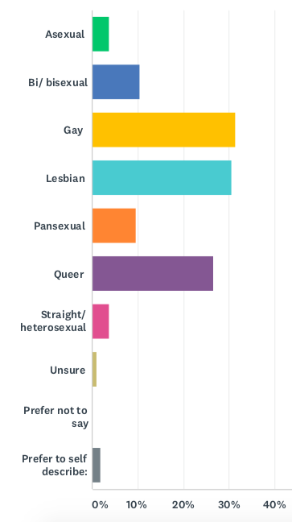There were noticeable differences in sexual orientation between White British and BAME/PoC respondents. Among BAME/PoC, Queer was by far the most common sexual orientation at 43% (compared to 15% among White British people). BAME/PoC respondents were almost three times as likely to describe themselves as Queer than White British respondents. The most common sexual orientation among White British respondents was Gay at 38%, compared to 24% among BAME/PoC respondents.

The combined percentage of people who identified as Bi/ bisexual and/or Pansexual was very similar. However, the specific terms varied: among White British respondents 14% identified as Bi/ bisexual and 6% as Pansexual. The reverse was true among BAME/PoC respondents: 14% identified as Pansexual and 5% as Bi/ bisexual.

Three quarters of Asexual respondents were BAME/PoC (3 people), with one Asexual person being White British.

### Q5 Gender: 105 answers

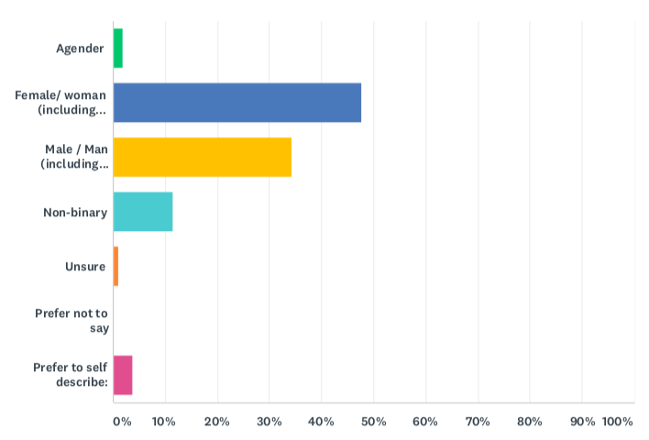We asked respondents, ‘How would you describe your gender?’ We offered the options Agender, Female/ woman (including trans woman), Male/ man (including trans man)’, Non-binary, Unsure, Prefer not to say, and Prefer to self-describe with a free text field.

48% (50 people) said Female/ woman (including trans woman), and 34% (36 people) said Male/ man (including trans man). 11% (12 people) said Non-binary, 2% (2 people) said Agender, and 1% (1 person) said unsure. 4 people (4%) preferred to self-describe, of who 2 people (2%) said ‘Genderqueer’ and 2 people (2%) said ‘Genderfluid’.

There was a degree of difference in the genders of respondents according to race/ethnicity. A higher percentage of White British respondents were men (38%, compared to 31% among BAME/PoC respondents). The reverse was true for women: 53% of BAME/PoC respondents were women, compared to 44% of White British respondents. All of the respondents who self-described as Genderfluid and Genderqueer were White British, whilst all who identified as Agender were BAME/PoC.

### Q5 Trans Status: 105 answers

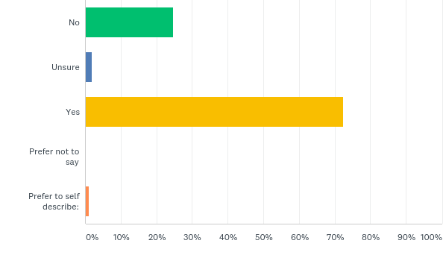We asked, ‘Is your gender the same as the gender you were assigned at birth?’

The majority of respondents selected ‘Yes’, at 72% (76 people). 25% (26) answered ‘No’. 2% (2 people) answered ‘Unsure’, and 1% (1 person) self-described as ‘Sometimes’. There was a very similar picture across respondents who were BAME/PoC and those who were White British.

### Q7 Intersex variation: 105 answers

We asked respondents: ‘Do you have an intersex variation? Intersex is a term for people born with atypical physical sex characteristics. There are many different intersex traits or variations.’ The majority of respondents selected No (90%, 94 people). 6% selected Unsure (6 people), 2% selected Yes (2 people), and 3% (3 people) preferred not to say. The were no significant differences across White British and BAME/PoC respondents.

### Q8 Racial/ethnic origin: 105 answers

We asked respondents: ‘How would you describe your race/ethnic origin?’

61% (63 people) selected only White British, with 38% (41 people) falling under the wide definition of BAME/PoC. 1% (1 person) stated that they ‘Generally seen/identify as white but don’t actually know origin’.

Among the 41 people who did not identify solely as White British, 21% (9 people) selected White European. A further 21% (9 people) selected White Irish, with 19% (8 people) selecting Other White Background. 12% (9 people) selected Black/ Black British: Caribbean, and 7% (3 people) identified as Other mixed background. 7% (3 people) answered that they were White British in combination with another race/ethnicity. 5% (2 people) selected Black/ Black British: African, and 2% (1 person) selected each of Other Ethnic Group: Arab; Mixed: White and Asian; Asian/ Asian British: Indian; and Other Ethnic Group: Turkish. A further 12% (4 people) preferred to self-describe, with 2% (1 person) each describing themselves as: ‘White British, Black Caribbean and Pakistani’, ‘Mixed white British and Jewish’, ‘White British with Russian and Irish Gypsy in the mix’, and ‘Iberian’.

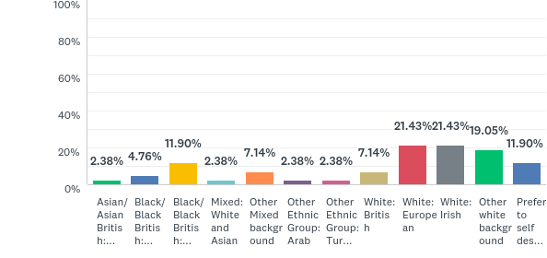

### Q9 Religion, faith and spirituality: 104 answers

We asked respondents ‘If you have a religion, faith, or spirituality, how would you describe it?

42% (44 people) respondents chose No Religion, and 20% (21 people) chose Atheist. 12% (13 people) identified as Christian, and a further 12% (12 people) as Spiritual. 6% (6 people) were Buddhist, 1% (1 person) selected Muslim, and 1% (1 person) preferred not to say. A further 6% (6 people) preferred to self-describe, with 1% (1 person) each describing themselves as ‘Catholic’, ‘Gnostic’, ‘Jewish and spiritual’, ‘Agnostic’, ‘Satanist’, and ‘Wiccan’.

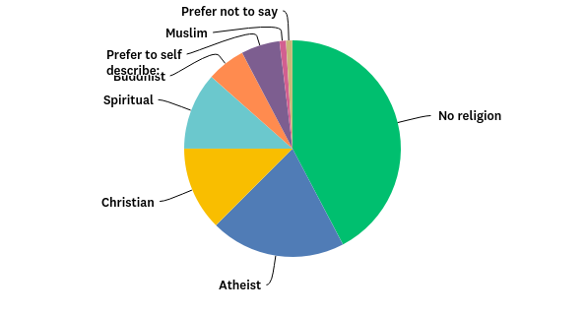

A similar percentage of White British and BAME/PoC respondents said they either had No Religion or were Atheist. The same is true of those who answered Christian, and those who chose Spiritual. A higher percentage of BAME/PoC were Buddhist at 10%, compared to 3% of White British people. All Muslim respondents were BAME/PoC.

### Q10 Disability: 104 answers

We asked respondents: ‘Do you live with a health condition, impairment, learning difference, or neurodivergence that shapes your day to day activities?’

40% (42 people) said that they had no known health condition, impairment, learning difference, or neurodivergence. 37% (39 people) selected that they have a mental health difficulty, with a further 28% (29 people) having a long-term illness or health condition. 14% (15 people) said they have some form of neurodivergence, and 11% (11 people) selected a specific leaning difficulty. 5% (5 people) selected a social or communication condition, with a further 3% (3 people) selected D/deaf or a hearing impairment, and 3% (3 people) with a physical impairment or mobility issues. 1% (1 person) selected blind or visual impairment that can’t be fixed with glasses, and 1% (1 person) preferred not to say. 3% (3 people) preferred to self-describe, of whom 1% (1 person) each chose ‘PTSD’, ‘previous experience of depression and anxiety’, and ‘other’.

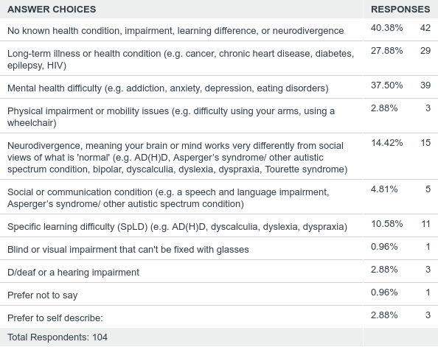

Overall percentages were similar among BAME/PoC and White British respondents. There were some differences: BAME/PoC were more likely to select Specific learning difficulty at 15% (compared to 8% of White British people). Whilst 17% of White British respondents listed Neurodivergence, 10% of BAME/PoC respondents did so. 2% of BAME/PoC people noted a Physical impairment or mobility issue compared to 5% of White British people.

When we exclude all White categories to include only non-White BAME/PoC respondents, the picture is significantly different. Only 23% said that they had no known health condition, impairment, learning difference, or neurodivergence (compared to 40% overall). 54% answered that they live with a long-term illness or health condition (compared to 28% overall), and 23% selected Neurodivergence (compared to 14% overall). Given the small numbers of people represented in this survey, it would be inappropriate to make wider inferences about Brighton & Hove’s LGBTQ PoC population. Nonetheless, future research should pay attention to differences *within* the BAME/PoC community.

## 10.2 Workplaces

### Q11 Sector: 102 answers

We asked: ‘What sector do you work in?’

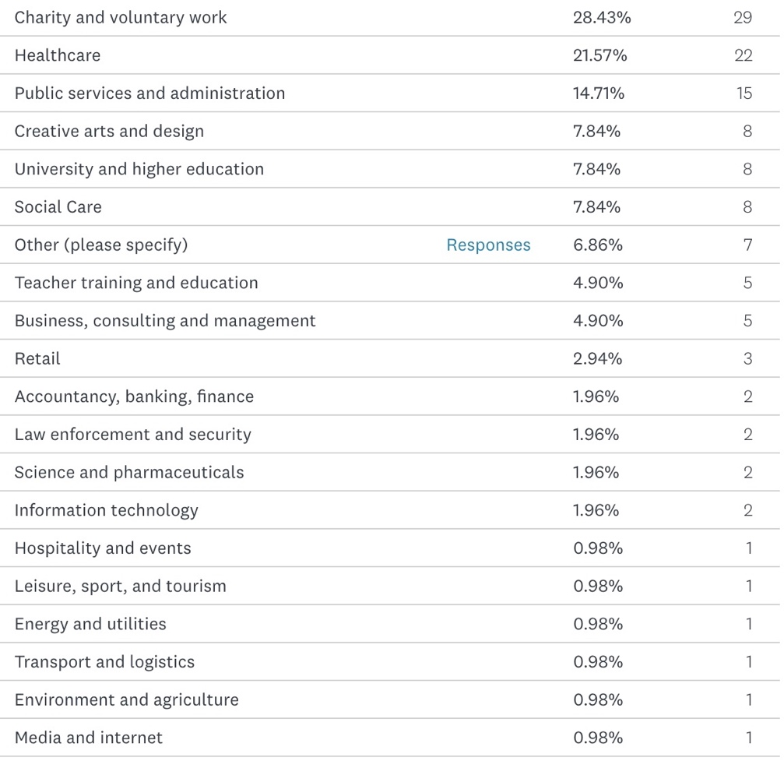Almost a third (28%, 29 people) work in the charity and voluntary sectors, with a further 22% (22 people) working in healthcare. 15% (15 people) work in public services and administration, with 8% (8 people) working in each of Creative arts and design, University and higher education, and social care. 5% (5 people) work in Teacher training and education, and 5% (5 people) in Business, consulting and management. 3% (3 people) work in retail, with 2% (2 people) working in each of Accountancy, banking, finance; Law enforcement and security; Science and pharmaceuticals; and Information Technology. 1% (1 person) works in each Hospitality and events; Leisure, sport, and tourism; Energy and utilities; Transport and logistics; Environment and agriculture; and Media and internet.

A further 7% specified a different sector, with 2% (2 people) choosing Horticulture, and 1% (1 person) choosing each of LGBTQIA Activism; Local Government; Education; Waste Management; and Higher ed.

### Q12 Type of work: 102 answers

We asked, ‘What kind of work do you do?’ Respondents were prompted to select all that applied from Agency, Casual, Freelance/ contractor/ consultant, Full-time, Higher education, Paid, Part-time, Temporary/ short-term/ fixed-term, Unpaid/ voluntary, and Zero hours.

5% of respondents (5 people) are in higher education, all of whom are BAME/PoC. Overall, 13% (13 people) are doing unpaid or voluntary work. The majority (58%, 60 people) are in full-time work, with 21% (21 people) doing part-time work. 11% (11 people) are doing freelance/contract/consulting work, and 4% (4 people) are on temporary/short-term/fixed-term contracts. 3% (3 people) are doing agency work, with 2% (2 people) on zero hours contracts, and a further 2% (2 people) doing casual work.

### Q13 Barriers to work: 73 answers

We asked: ‘Have any of the following made it hard for you to work?’ The options included low confidence; discrimination for sexuality; discrimination for gender; discrimination for race/ethnicity; long-term health conditions, learning difficulty, impairment, or neurodivergence; no relevant opportunities; wrong skills/qualifications; caring responsibilities; and other (please specify).

Across everyone who answered, almost half (49%, 36 people) selected low confidence. However, this figure was higher among BAME/PoC respondents, of whom 61% has been affected by low confidence (compared to 40% of White British people).

Overall, 26% (19 people) said discrimination for sexuality had made it hard to work, rising to 32% among BAME/PoC respondents (compared to 24% of White British people). Significantly more BAME/PoC respondents have struggled to work because of gender discrimination, at 29%, compared to 13% of White British respondents (with an average of 21% across all respondents). One respondent commented that Gender Dysphoria had been a barrier, and another had been affected by their ‘appearance which is alternative’.

23% of BAME/PoC respondents said that discrimination for race/ethnicity has made it difficult for them to work, with one respondent commenting that ‘my foreign accent can be an issue’, despite having studied to MA level in English. Another respondent noted: ‘My current workforce / Teammates are brilliantly non racist - but I can't say the same of all the clients I work with unfortunately’.

Overall, 18% (13 people) have struggled to work because of there being no relevant opportunities, and 15% (11 people) have the wrong skills and qualifications. One White British respondent explained that they have:

‘No experience, both caused by and further contributing to inability to access or remain in voluntary or paid employment throughout teens & adulthood, due to: lack of housing (street homeless/hostels/temp accom./etc since age 12) & education, correct health/mental health/neurodiv dx/drug&alcohol/social care & support, poverty and the punitive & accusatory nature of the benefits system (esp disability benefits), capitalism & class system.’

37% (27 people) found it hard to work because of long-term health conditions, learning difficulty, impairment, or neurodivergence (42% of White British respondents, and 26% of BAME/PoC). Overall, 14% (10 people) had been affected by caring responsibilities.

### Q14 Work satisfaction: 102 answers

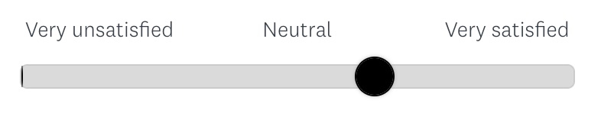We asked: ‘How satisfied are you at work?’ Respondents used a sliding scale from 0-100 to answer, where 0 was labelled Very unsatisfied, 50 was neutral, and 100 was very satisfied. The average number was 64 across all respondents.

White British respondents were overall slightly more satisfied, with an average number of 69, compared to 58 among BAME/PoC respondents.

### **Q15 Work future: 102 answers**

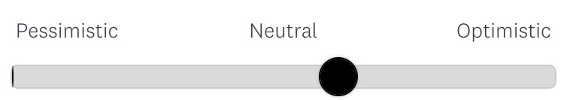We asked: ‘How do you feel when you think about your future at work?’ Participants used a sliding scale to answer where 0 represented pessimistic, 50 was neutral, and 100 was optimistic. The average number was 55.

White British respondents were between neutral and optimistic about their future at work, with an average number of 60. By contrast, BAME/PoC respondents were neutral to pessimistic, with an average number of 48.

### Q16 Recognition: 102 answers

We asked: ‘Do you feel your contributions are recognized at work?’ The sliding scale was labelled with Never at 0, Sometimes at 50, and Always at 100. The average number across all respondents was 62.

White British respondents felt their contributions were recognized fairly often, with an average number of 68. BAME/PoC respondents on average felt their contributions were recognized sometimes, with an average number of 52. 3 BAME/PoC participants (8%) entered a zero, the lowest possible score, to indicate that their contributions are never recognized at work, whilst no White British participants did the same.

### Q17 Connections: 100 answers

We asked, ‘How connected do you feel to other people in your workplace?’ On the scale, 0 was marked as very disconnected, and 100 as very connected. The average response was 57.

BAME/PoC respondents had an average number of 49, indicating that they feel neutral or slightly disconnected from colleagues. The average number among White British respondents was 62, indicating that they feel fairly connected to others at work.

10% of BAME/PoC participants chose a number below 10, indicating that they feel very disconnected from colleagues, compared to 5% of White British participants. Only 3 BAME/PoC respondents (8%) answered above 90, as very connected, compared to 12 White British respondents (18%).

### Q18 wellbeing: 94 answers

We asked, ‘Has your work ever had a negative impact on your wellbeing, in any of these areas: General mood; Burnout/ fatigue/ exhaustion; Mental Health; Sleep disruption; Appetite/ diet/ digestion; Physical health; Relationships/ friendships/ family; Musculoskeletal disorders; Other (please specify)’. Participants were able to select as many categories as they wanted to.

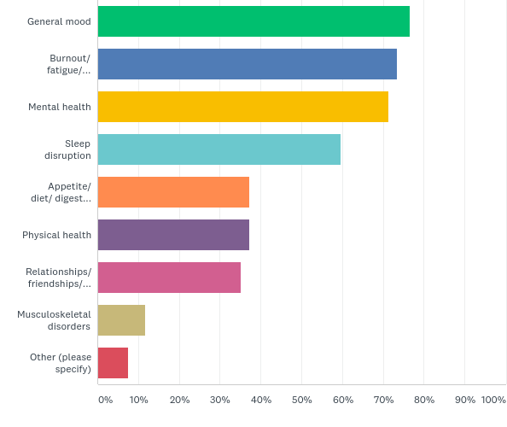An overwhelming majority of those who answered said that work had a negative impact on many areas of their wellbeing. 77% (72 respondents) said it had affected their general mood, 73% (69 people) had experienced burnout, fatigue, or exhaustion, and 71% (69 people) had a negative impact on their mental health. 60% (56 people) had suffered sleep disruption, whilst 37% (35 people) said their physical health was harmed, and the same percentage had their appetite, diet, and digestion affected. 35% (33 people) felt their relationships, friendships, and families were negatively affected, and a further 12% (11 people) experienced musculoskeletal disorders as a result of work. Further comments mentioned anxiety, fatigue after travelling for meetings, eating issues, self-harm, using alcohol, and mentioned struggling with low pay and zero hours contracts.

These high levels were broadly similar across respondents who were BAME/PoC and White British. In all but two categories, slightly more BAME/PoC respondents said they had been negatively affected than White British respondents.

A starker difference is visible when comparing the answers of all non-White respondents with the overall figures. 100% of non-White respondents said work had negatively impacted their mental health (compared to 71% overall), whilst 91% said they had suffered burnout, fatigue, or exhaustion, (compared to 73% overall) and a further 91% had their general mood affected (compared to 77% overall). One person described the stress of working under a manager who continuously referred to ‘refugees and asylum seekers as ‘swamping’ her’, which made them nervous.

## 10.3 Discrimination at work

### Q19 Being ‘out’ at work: 100 answers

We asked, ‘Are you ‘out’ as LGBTQ+ at work?’ Respondents were invited to choose from the following categories: Yes – to some people; Yes – to everyone; Unsure; No – it’s no one’s business; No – I’m worried I will be judged; No – I don’t want it to impact my career; No – I’m not ‘out’ anywhere; No – it’s a hostile environment; and Other (please specify).

Overall, 89% of respondents were ‘out’ to some degree at work, including 66% (66 people) who were ‘out’ to everyone, and 23% (23 people) who were ‘out’ to some people. 6% (6 people) were unsure. Among the 11% who were not out at work, the most common reason was fearing judgement (5%), followed by their environment being hostile and the feeling that it’s no one’s business, each at 3%. 2% had not come out because they worried it would impact their career.

The percentage of White British people who are ‘out’ as LGBTQ+ to everyone or some people at work is even higher, at 94%. Two respondents commented on their openness, with one pointing out that they had to be less open in the past, and another being unsure how many colleagues officially know, though they don’t hide it. One person was open about their sexuality but not their gender, for fear of being judged.

By contrast, 82% of BAME/PoC respondents, and 75% of non-White respondents are ‘out’ as LGBTQ+ to everyone or some people at work.

### Q20 Discrimination: 100 answers

We asked: ‘Have you ever faced discrimination at work because of your race, gender, and/or sexuality? Select all that apply’. Respondents were able to choose from the following categories: No, Asked invasive personal questions, Been bullied or mocked, Ideas ignored or undermined, Made to feel ‘other’ or different, Overlooked for promotions/ opportunities, People making assumptions about you, Treated as a token of your community, Unsure, and Other. There was a comment box asking for explanation.

Across the respondents, only 34% (34 people) said they had not faced any of these issues at work, whilst 11% (11 people) were unsure. More than a third (36%, 36 people) had people making assumptions about them, 34% (34 people) were made to feel ‘other’, and 31% were asked invasive personal questions. A further 24% felt they were treated as a token of their community.

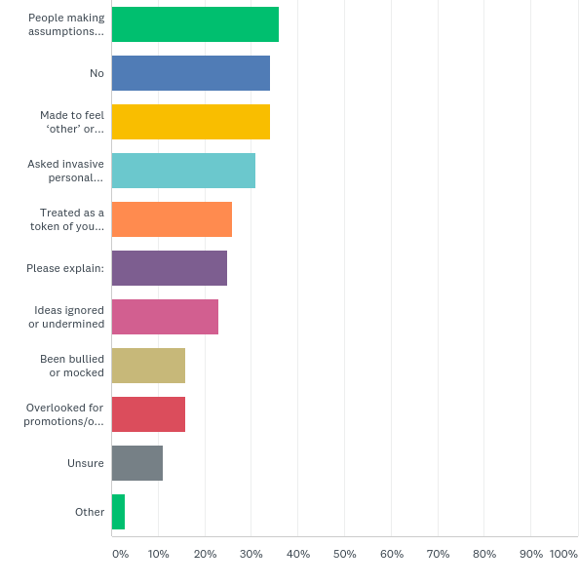

#### Q20.1 Bullying

Given the chance, 25% of respondents offered further comments. 48% of those (12 people) described being bullied. This spanned a range of behaviours such as colleagues repeatedly using the wrong pronouns or being called the name of the only other gay person in the workplace. One respondent explains,

‘As a foreigner living in this country I have felt the glass celling very very close. My accent gets mocked regularly and since the Brexit vote I have had 'jokes' like: 'so... when are you going back home then?' To give you context I have lived in the UK since 1993. The fact that EU citizen's rights have not yet been agreed nor certainly ringfenced means I am not sure of what my life will look like in 18 months time. I hear employers are careful when employing EU passport holders as they might face additional checks from the Home Office and are scared of fines.’

Others described repeated experiences of harassment and discrimination at different stages in their careers, with one respondent describing a ‘campaign of bullying and undermining behaviour’. Another respondent gave a detailed account of repeated harassment:

‘In one workplace I was told I was useless because I didn't present as femme and straight. In another I was asked how for details on how I had sex with my girlfriend, hassled when I refused to say and then threatened with getting a bad reference. In another I was anonymously reported for taking necessary medication which got very complicated. I am not sure if there were homophobic reasons for the reporting or not. The straight white male boss was only sympathetic to straight presenting women and very sexist so he protected the informer and required me to make adjustments that meant I could neither do my job or keep healthy. In another job I came out when asked by a colleague who I worked closely with and he told me if I was his child he would kill or break all contact with me due to my sexuality. After that he didn't work collaboratively with me anymore.’

#### Q20.2 Ignorance and inappropriate comments

The theme of asking inappropriate and sexual questions was echoed by several respondents. One person noted that they have ‘strangers asking what I do in bed/what operations I have had/ what I have 'down below'’.

Another commented, ‘My supervisor asked me questions about my intimate relationships as well as lots about what different LGBTQ identities mean. I didn't have all the answers and it took up time we were meant to be discussing my work’. This was echoed by another respondent, who was asked to provide training to staff and students.

#### Q20.3 Compounding effects of race/ethnicity

Whilst 39% of White British respondents said they had not faced any of the listed issues at work, only 26% of BAME/PoC respondents hadn’t. Among non-White respondents, 50% said they had been treated as a token of the community, 50% had their ideas ignored or undermined, and 50% had been made to feel ‘other’. 42% also said they had been overlooked for promotions and opportunities, and the same percentage had been asked invasive personal questions.

In the comments, several BAME/PoC respondents described facing racism alongside discrimination for being LGBTQ. One respondent suffered ‘four years of hellish treatment that almost got to court’, after challenging someone who was ‘consistently homophobic and racist’. Another person accepted that ‘There can be an element of tokenism in the work I do’, but the discomfort this brings is balanced by ‘the opportunity to diversity services and take up space as a QTIPOC’, whereas previously ‘my ideas and opinions were not listened to and it has been a fight to feel like my opinion was valuable’.

#### Q20.4 Uncertainty

Some participants were unclear about whether they had experienced discrimination, though they had been made to feel uncomfortable or sensed that something wasn’t quite right. As one respondent explained:

Always hard to know whether being overlooked for promotions, or having contribution ignored, is 'because of' being gay or more about how 'difference' is treated (eg. affinity bias/confirmation bias in recruitment/selection). I haven't had overtly homophobic comments to my face - it feels more subversive than that.

Another respondent echoed that they had not faced anything ‘overt’, but they do sometimes get a feeling that ‘my status has changed how people behave around me’.

Some people could only confront harmful behaviours in hindsight: ‘When I worked previously as a chef, staff would sometimes make fun of my sexuality. At the time it hurt but I didn't feel confident to say so’. Another participant set out the impact of seemingly harmless behaviours:

‘none of the above happened to me overtly. Some comments were made in so called "good spirit". One wonders the necessity of those. When you are different from the main group of people among which you work, and you are conscious of your difference, you can sometimes feel awkward with yourself and your interaction with people can be unwantedly stunted. Being different always makes it more difficult to achieve what the normative population never has to think about or overcome to achieve. You sense the walling off effect in your daily relating with colleagues. So one has to redoubled efforts to level up to the normative population. These thoughts make me angry. And I cannot share them easily at work.’

### Q21 Impact of discrimination: 59 answers

Following on from the previous question about discrimination and harassment at work, we asked, ‘if yes, how did it affect you?’ The word cloud depicts the most frequently used words in people’s answers:

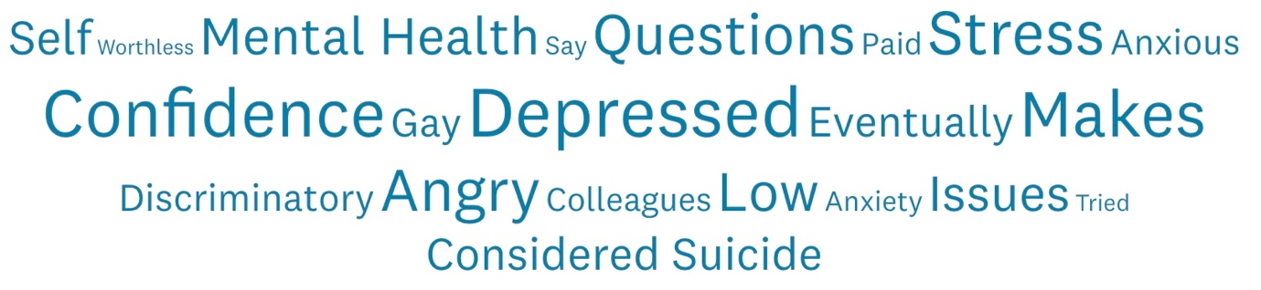

#### Q21.1 Mental health

24% of respondents (14 people) mentioned serious deterioration in their mental health. Stress, depression, anxiety, exhaustion, and frustration were common experiences.

14% (8 people) said that their confidence had been diminished, often with long-term effects. As one respondent explained,

‘It did knock my confidence - when people don't listen to you, you start to think well maybe I don't know what I'm talking about then, and if you can't speak up with confidence then you're even less likely to be listened to, so it's a vicious circle.’

Low confidence was often accompanied by feelings of isolation from colleagues. 15% (9 people) described feeling cut off from their colleagues. A BAME/PoC respondent commented on feelings of isolation at work and their personal life:

‘I have been very very anxious since the Brexit referendum. I feel that I am surounded by people who do not want me here, altough I did not know this before. I feel cheated. I am sick from hearing how inmigration is such a big problem and how it needs to be adressed. I am that inmigrant. I have struggled to related to people at work, I have mayor trust issues right now. My relationship of 8 years didn't make it either.’

Other respondents dealt with harassment by distancing themselves from their colleagues to avoid harmful conversations at work. Interacting with colleagues can become a source of stress:

‘It makes me uncomfortable at work. It's often dismissive of my identity and causes me stress at the thought of interacting with those people again. It makes me angry and that can impact my demeanour at work.’

#### Q21.2 Hopelessness

60% of BAME/PoC respondents who answered (14 people) described feelings of hopelessness and despair. This compared with 6% (2 people) of White British respondents. Among BAME/PoC respondents, people described feeling ‘worthless, and filled with self hate’, and being made to ‘feel subhuman’.

8% of BAME/PoC (2 people) who responded to this question said that they had considered suicide because of workplace discrimination.

Workplace harassment had a serious impact on hope for the future among LGBTQ BAME/PoC. One respondent couldn’t imagine ‘having any kind of career that didn’t involve being harassed’. Another person felt completely trapped, believing that being out at work ‘would make me unable to pay rent’, whilst at the same time feeling that ‘I could never be happy and supported at work’.

Another LGBTQ BAME/PoC respondent described feeling resigned to the situation, depleted of any energy to challenge racism, microaggressions, or assumptions about their sexuality from colleagues:

‘Have become used to just lying if asked questions about personal life to the older people I support to avoid judgement and comments, e.g. yes I have a boyfriend but were not married yet (even though I am poly and queer and primarily date women and am opposed to marriage) use a British sounding version of my name, pretend I support England football team so people don't think I'm an ungrateful immigrant if I tell them the baggage of colonialism (my dad comes from a former British colony) makes me actually despise the idea of 'supporting England'. and cant be bothered to challenge micro agressions around race anymore (e.g. are you going to noodle off, you're too foreign I can't understand you (even though my accent is British and was born here), etc etc.’

This is not an easy course of action, however. The same respondent points out that these acts of survival make ‘me feel alienated, I feel like each time I lie or let a microaggression slide I lose a little part of myself’.

#### Q21.3 Permanent and temporary leave

Of everyone who answered this question, 19% of everyone who answered this question (11 people) ended up leaving their job permanently or temporarily as a result of harassment or discrimination. 7% (4 people) had extended periods of sick leave due to stress and anxiety, with one person off work for 18 months. 12% (7 people) had permanently left their post or even retired from their field.

A slightly higher percentage of BAME/PoC respondents left their job temporarily or permanently due to discrimination. One LGBTQ BAME/PoC respondent described the difficult process that led up to leaving:

‘I eventually left a previous workplace due to manager who made discriminatory remarks about others. I felt uncomfortable and under valued, especially as she overlooked my feelings and assumed I would either agree or not challenge her. I eventually challenged her bullying approach but never raised her prejudices. As a black woman, I was afraid of being accused of playing the 'race card' and I didn't want to be viewed as over sensitive or paranoid.’

Leaving was not always desirable or possible for everyone. A BAME/PoC respondents mentioned that they had moved to a lower paid job because of repeated bullying on the basis of their race and their sexual orientation, leaving them feeling ‘like I have fallen behind’.

#### Q21.4 Little or no impact

Of 59 answers, only 5% (3 people) indicated that they were not particularly offended or impacted by harassment or discrimination. Those people described being able to ‘shrug it off’ or seeing it as ‘fairly innocuous and a little bit amusing’, One noted that they now view discrimination as an ‘opportunity to challenge their assumptions’, although it used to make them feel ‘embarrassed and angry’. All those who indicated that they were not particularly affected were White British.

### Q22 Action on workplace discrimination: 92 answers

We asked: ‘Have you ever taken action on workplace discrimination?’

65% of those who answered said they had taken some form of action. 24% (22 people) had talked to a manager, 14% talked to colleagues, 11% made a formal complaint, and 10% talked to HR. 3% had taken legal action, and 3% took a different course of action.

17% (16 people) responded that they had not taken action because they were unsure if it had been bad enough to complain about. 12% (11 people) didn’t take action because they didn’t want to make a fuss, 5% didn’t know how, and a further 5% was scared it could affect their work. When offered the chance to comment, 26% (24 people) gave further details.

#### Q22.1 Resigned to the situation

10% of those who have not taken action commented that they feel resigned to the situation. For some people, there was simply nowhere to turn for support, or if there was they did not trust that taking action could achieve meaningful change.

Feelings of resignation are notable among BAME/PoC respondents. One person noted that progress is ‘very slow’. Another commented that discrimination ‘is so regular when working with clients that it doesn’t feel worth bringing up’, despite having clients who have been ‘so offensive I have not wanted to go back to them’. One respondent felt conflicted, having worried that taking action would lead to further discrimination or being ignored:

‘I dont feel this way now but at the time I didnt want to make others to suffer for their mistakes. I thought it would make them even more homophobic and I didnt want to contribute to that so I self sacrificed. also I didnt belief management would take me seriously.’

#### Q22.2 Lack of trust

Feeling hopeless about change was sometimes a result of negative past experiences. An example was given about a complaint against a bullying supervisor being dropped because the evidence was ‘too subjective’, despite many colleagues coming forward with similar complaints.

Other respondents lacked trust in the system. It was commented that ‘whistleblowing never works out well for the whistleblower’. One respondent noted that they are affected by wider societal issues:

‘I work in an HR area and have followed procedures for reporting difficult behaviour. One particular case of blatant transphobia was resolved with our mutual manager but most day to day instances don't ever come to anything. It's hard to report non-binary specific transphobia as we currently have no legal or workplace protections in this country.’

### Q23 Outcome of action: 51 answers

Following on from the last question on whether people had taken action due to workplace discrimination, we asked ‘If yes, what was the outcome?’ The options were listed as Changes to policy; Disciplinary action; Improved work environment; Impact on your mental health; Impact on your ability to stay in the job; No change; and Other. There was a comment field for respondents to share more information.

33% of those who had taken action saw no change. 4 people (8%) described further incidences of bullying and harassment after taking action. That included being ‘told off, threatened, and yelled at for bringing it up’, and being ‘victimised’ by a manger despite having achieved equal pay. One respondent pointed out that workplaces rarely discipline people, but instead tend to restructure them out.

16% of those who took action ended up in a better work environment, with 6% having changes to organisational policies, and 10% of cases resulting in disciplinary action. Responses were similar across respondents from different racial/ethnic groups.

### Q24 Leaving jobs: 99 answers

We asked, ‘Have you ever left a workplace because of discrimination?’ The answers listed were Yes – because of racism; Yes – because of LGBTQ+ discrimination; Yes – because of other discrimination; and No. Respondents were able to select as many categories as they wanted to and invited to leave comments.

Overall, 72% of respondents said they had never left a workplace because of discrimination. There were major differences between White British and BAME/PoC respondents, however. Whilst 80% of White British people have not left a job due to discrimination, 59% of BAME/PoC respondents have not.

#### Q24.1 LGBTQ+ discrimination

17% of all respondents said they had left a workplace because of LGBTQ+ discrimination. Three people described suffering abuse and hate speech at workplaces where those behaviours were normalised:

‘I use to work for a toy wholesaler. I had to leave due to the constantly homophobic words used, also the constant questions about my 'lifestyle'. Then they also enjoyed called each other 'f****t', while being fully aware I was gay and sat next to them at the time. It was a company dominated by toxic masculinity, so I never complained as the person I could complain to was the main culprit of the issues. Eventually I quit.’

14% of White British people have left jobs due to LGBTQ+ discrimination, whereas 22% of BAME/PoC have left for the same reason.

#### Q24.2 Racism

10% of BAME/PoC respondents said they have left workplaces because of racism, increasing to 34% among non-White respondents.

Two people, both BAME/PoC, said that they want to leave their current jobs due to harassment, but are not able to because they can’t afford to leave or can’t secure other employment.

#### Q24.3 Other discrimination

10% of all respondents have left workplaces due to other kinds of discrimination, of which 5% related to disabilities, health conditions, mental health difficulties and neurodivergence. Other issues mentioned include harassment after making a complaint, transphobia, and gender-based discrimination.

## 10.4 Race/ethnicity at work

### Q25 Your race/ethnicity: 97 answers

We asked, ‘How often do you think about your race/ethnicity at work?’ The options were Every day; Every few weeks; Every few months; Never; and Other (please specify).

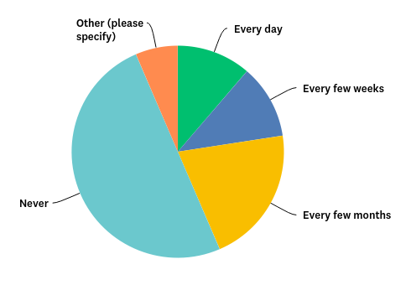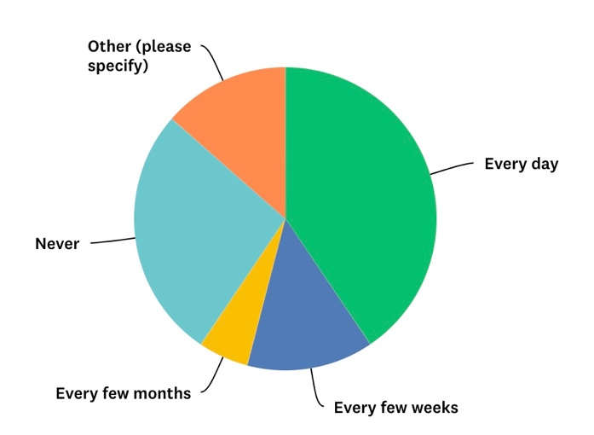

*Answers from White British respondents Answers from BAME/PoC respondents*

Whilst an average of 42% of all respondents never think about their own race/ethnicity at work, that percentage rises to 50% among White British people. 27% of BAME/PoC never think about their race/ethnicity at work, and 13% of non-White respondents never do.

41% of BAME/PoC respondents and 53% of non-White respondents think about their own race/ethnicity at work every day, compared to 11% of White British people.

### Q26 Representation of your race/ethnicity: 96 answers

We asked: ‘Do you feel that people of your race/ethnicity are well represented throughout your workplace?’ Respondents could choose to answer Yes – in all levels; Yes – in lower levels; Unsure; and No. Respondents were invited to share comments.

#### Q26.1 Representation of White British people

82% (50 people) of White British respondents felt that people of their race/ethnicity were well represented throughout their workplace, with just 5% (3 people) answering Yes – in lower levels and 5% (3 people) Unsure. 8% (5 people) said people of their race/ethnicity were not well represented throughout their workplace.

In the comments, 12 White British respondents (20%) noted that White British people are over-represented in their workplace. Several people expressed that other races need more representation in their workplace. Four respondents mention that there should be an extra imperative at charities, local government, and healthcare providers to reflect the communities they work with much more closely.

#### Q26.2 Representation of BAME/PoC

By comparison only 25% (9 people) of BAME/PoC respondents feel that people of their race/ethnicity are reflected in all levels of their organisation. 8% (3 people) say they are reflected in lower levels, with 25% (9 people) being unsure. 42% (15 people) said people of their race/ethnicity were not well represented throughout their workplace.

Three people said they were the only person of their ethnicity, and a further two said they were the only person of colour. One commented that they have never been in a workplace with people of their race/ethnicity in positions of power.

### Q27 Speaking for your racial/ethnic community: 97 answers

We asked, ‘Do you ever feel called on to speak for your whole racial/ethnic community?’

63% of non-White respondents, 39% of BAME/PoC respondents, and 8% of White British respondents answered Yes to this question. 31% of non-White respondents said No, compared to 47% of BAME/PoC respondents, and 92% of White British people. 13% of BAME/PoC were unsure, as were 6% of non-White people.

Among the comments, one LGBTQ BAME/PoC described ‘negative and stereotypical attitudes about where I am from and my culture at work’, but said they ‘usually don’t challenge them because I feel to irritated’. Another respondent expressed frustration with being asked to speak on behalf of BAME people:

‘I think this is inevitable when the workforce is not diverse. My relationship with my ethnicity is complicated, and I don't necessarily feel best placed to comment on lots of aspects of BAME lives and cultures - we are so diverse.’

### Q28 Witnessing behaviours towards BAME/PoC: 92 answers

We asked: ‘Have you witnessed any of these behaviours towards BAME/people of colour at your workplace? Select all that apply’. The options included: Asked invasive personal questions; Been bullied or mocked; Ideas ignored or undermined, Marked out as ‘other’ or different, Overlooked for promotions/ opportunities, People making assumptions, Treated as a token of their community, Unsure, No, and Other. There was an open comment field.

Overall, 54% of respondents had seen at least one of these behaviours or similar happening towards BAME/PoC at work, and 46% had not witnessed them. One third (33%, 30 people) have seen people make assumptions, 28% (26 people) have seen BAME/PoC marked as ‘other’, with the same percentage having seen them treated as a token of their community. 21% (19 people) have witnessed BAME/PoC having their ideas ignored or undermined and 16% (15 people have seen them be passed over for promotions and opportunities. 14% (13 people) witnessed invasive personal questions, 10% (9 people) have seen bullying and mocking, and 4% (4 people) have seen other behaviours like these. 8% (7 people) are unsure.

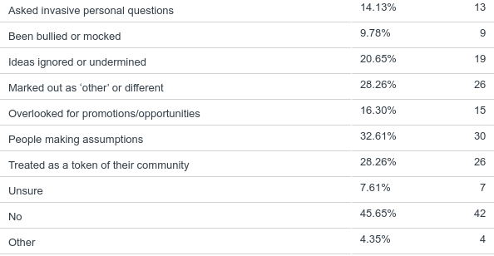Whilst 54% of White British people answered that they have not witnessed any of the listed behaviours towards BAME/PoC at work, only 31% of BAME/PoC respondents answered No, along with 13% of non-White respondents. It is worth noting that some people who answered No commented that they did so only because there are no BAME/PoC staff at their organisation.

### Q29 Chances for BAME/PoC to succeed: 96 answers

We asked: ‘Do you think BAME/people of colour have an equal chance of succeeding at your work?’ Respondents selected Yes, No, or Unsure, and were invited to comment.

Overall, the largest response was No (BAME/PoC do not have an equal chance of succeeding at your work) at 43%, compared to 32% who said Yes, and 25% who were unsure.

Among all non-White respondents, 69% answered No (BAME/PoC do not have an equal chance of succeeding at your work), compared to 52% among BAME/PoC respondents, and 36% of White British respondents who answered No.

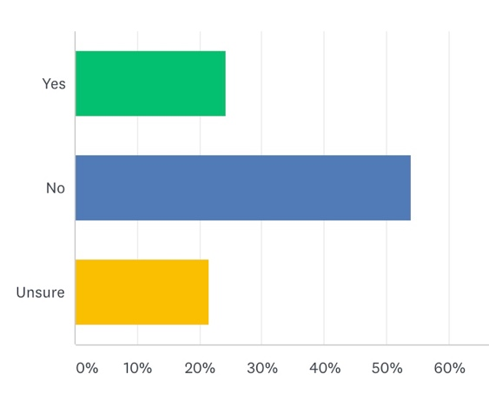

Above: BAME/PoC respondents

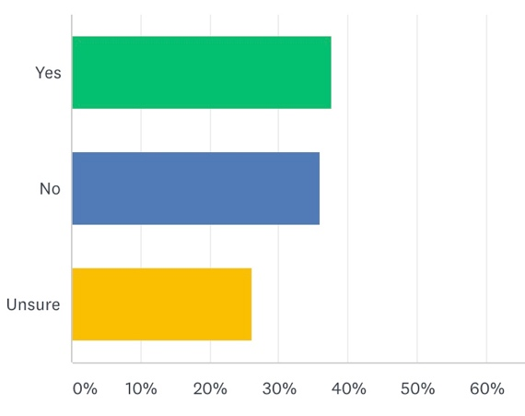

Above: White British respondents

White British respondents were the only group where a higher percentage answered Yes (that BAME/PoC do have an equal chance of succeeding at their work), than those who answered No. 38% of White British people answered Yes, compared with 24% of BAME/PoC and 19% of non-White respondents who said that BAME/PoC have an equal chance of succeeding that their work.

A high percentage of respondents were Unsure about this question (25%, 24 people). In the comments, several White British people expressed a tentative optimism: ‘Would like to think so, but couldn’t say yes with absolute certainty’; ‘I would like to think University of Sussex is beyond issues of race and everyone is treated equally. But I could not say for sure’.

8% of those who answered this question (8 people) commented on a lack of representation of BAME/PoC at all levels in their workplace, and especially in senior positions. As one respondent explained, ‘There are no visible role models in positions of power, so I don’t think most staff imagine poc as future leaders’.

Several respondents pointed out that this issue is not limited to their workplace, but reflects a wider ‘systemic issue extending beyond the organisation’. Another person explained,

‘I think any oppressed identity someone has will make it harder for them to succeed however well intentioned the organisation is. Structures of opproession dont just disapear because people want to be nice.’

### Q30 Racial inequalities: 88 answers

We asked: ‘Do you think there are racial inequalities at your organisation?’ Responses were recording using a sliding scale from 0-100, where 0 was marked No Inequalities, and 100 was marked Major Inequalities.

The average response number was 55, indicating an average feeling of there being fairly moderate inequalities. Again, this varied across groups of respondents: the average among White British people was 51, compared to 63 among BAME/PoC, and 69 among non-White respondents.

## 10.5 LGBTQ+ identities at work

### Q31 Your LGBTQ+ identity: 96 answers

We asked, ‘How often do you think about your LGBTQ+ identity at work?’

Half of respondents (48 people) said they think about their LGBTQ+ identity every day, and a further 27% (26 people). 9% (9 people) said every few months, and 14% of respondents (13 people) never think about their LGBTQ+ identity at work.

In the comments, several people described worrying about how they are perceived by other people at work. One person is ‘regularly reminded by odd insults from passers by’. Another respondent mentioned a complex relationship with colleagues:

‘I go between worrying/feeling scared people will find out somehow, but also feeling rubbish about the fact that I feel I'm being dishonest and that it's a mental burden to have to keep such an important part of myself hidden and that I shouldn't be ashamed.’

There were no significant differences across racial/ethnic groups.

### Q32 representation of your Lgbtq+ identity: 97 answers

We asked, ‘Do you feel that people of your LGBTQ+ identity are well represented throughout your workplace?’

The largest response was Yes – in all levels, with 45% of people (44 people) agreeing that people of their LGBTQ+ identity are well represented through their work. 12% said they were represented in lower levels, whilst 23% (22 people) were unsure. 20% of respondents (19 people) answered No, that people of their LGBTQ+ identity are not well represented through their workplace. There was no marked difference in answers from difference racial/ethnic groups.

Several respondents who answered Yes expressed that this had not always been the case. There were comments that their current workplace was unusual or different to past experiences they had.

Others expressed some uncertainty, because other people are not always visibly LGBTQ+. One person commented, ‘It’s quite a closed environment – people don’t talk about their personal lives if they aren’t “typical”.’ Another respondent explained that ‘There are a number of trans people who don’t feel they can “come out”. There are only a very small number of us who are public and vocal’.

### Q33 speaking for the whole lgbtq+ community: 97 answers

We asked: ‘Do you ever feel called on to speak for the whole LGBTQ+ community?’ Respondents could select from Yes, No, and Unsure, and comments were welcome.

Overall, just half of respondents said No, at 54% (52 people). 37% of people said Yes, and 9% (9 people) are unsure. Responses were similar across different ethnic/racial groups.

In the comments, the most common issue was being called on to speak about trans lives to ‘cis, straight colleagues in a range of organisations’, or being the ‘token NB person to represent a lot of trans issues’.

### Q34 witnessing behaviours towards lgbtq+ people: 94 answers

We asked: ‘Have you witnessed any of these behaviours towards BAME/people of colour at your workplace? Select all that apply’. The options included: Asked invasive personal questions; Been bullied or mocked; Ideas ignored or undermined, Marked out as ‘other’ or different, Overlooked for promotions/ opportunities, People making assumptions, Treated as a token of their community, Unsure, No, and Other. There was also an open comment field.

Overall, 59% of respondents had seen at least one of these behaviours or similar happening to LGBTQ+ people at work, and 41% said they had not witnessed them. Almost half (46%, 43 people) have seen people make assumptions, 36% (34 people) have seen LGBTQ+ people marked as ‘other’, with the same percentage having seen them treated as a token of their community. 26% (25 people) have witnessed LGBTQ+ people being asked invasive questions and 21% (20 people have seen them being bullied or mocked. A further 20% (19 people) have seen LGBTQ+ at work have their ideas ignored or undermined, and 12% (11 people) witnessed them being overlooked for promotions and opportunities. 4% (4 people) were unsure).

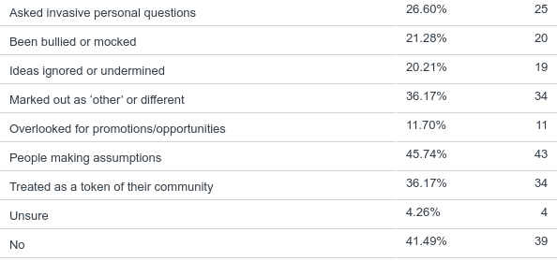

### Q35 chances for LGBTQ+ to succeed: 96 answers

We asked, ‘Do you think LGBTQ+ people have an equal chance of succeeding at your work?’

61% (59 people) said Yes, 18% (17 people) said No, and a further 21% (20 people) were unsure. The percentages differed across ethnic groups: 68% of White British respondents answered Yes, that LGBTQ+ people have an equal chance of succeeding, compared to 50% of BAME/PoC.

In the comments, five respondents pointed out that people’s chances of success are shaped by their specific LGBTQ+ identity and how visible they are. One person said it is ‘different depending on which letter of the acronym’, and another noted that lesbian, gay, and bisexual people have fairly equal chances, but ‘for trans folks absolutely not’. One respondent felt that it depends on their visibility, but they could easily be ‘’ sidelined into only working on that area’. Another respondent commented:

‘I think that LGBTQ+ people who 'pass' have a better chance at succeeding. I think there are more barriers for LBTQ women (due to sexism in the workplace) and trans/ non-binary people’.

Four people pointed out that this varies between workplaces. For one respondent, the barriers to LGBTQ+ people succeeding are tied to their organisation’s culture:

‘In the main, I don't think it's overt/conscious LGBTQ-phobia. But our organisation does not particularly value/leverage diversity, and has not taken meaningful steps to address affinity/confirmation bias ('unconscious bias') in the recruitment/selection process.’

### Q36 lgbtq+ Inequalities: 87 answers

We asked: ‘Do you think there are inequalities for LGBTQ+ people at your organisation?’ Responses were recording using a sliding scale from 0-100, where 0 was marked No Inequalities, and 100 was marked Major Inequalities.

The average response number was 30, indicating an average feeling of there being fairly low inequalities. There was some variation across groups of respondents, although the group averages were always closer to No Inequalities. The average among White British people was 30, compared to 42 among BAME/PoC.

## 10.6 Tackling workplace inequalities

### Q37 responsibility for workplace discrimination: 94 answers

We asked: ‘Who do you believe should be responsible for dealing with discrimination at work? Select all that apply.’ Options given included Everyone in the workplace; HR and workplace policies; Individuals affected; No one; Management/Leadership; Local Council; Central government; Unsure. There was a comment field available.

93% of respondents (87 people) believed that everyone in the workplace has a responsibility for workplace discrimination. 72% (68 people) answered that management/leadership should deal with discrimination, and 67% (63 people) said HR and workplace policies should. 43% (40 people) view central government as having responsibility, and 34% (32 people) selected local councils. 18% (17 people) said that individuals affected had responsibility, and 3% (3 people) were unsure.



There were no significant differences in the answers of different racial/ethnic groups. Several respondents commented that workplace discrimination should be tackled ‘from top to bottom’ and would require a major shift in practices. As one person explained,

‘Individual experiences of discrimination should be managed by HR and line managers. Management/leadership is responsible for creating an open, inclusive workplace environment. Government is responsible for the overall policy context, and regulators/arms-length bodies for supervision and enforcement. And we are all responsible for not being bystanders!’

At the same time, one respondent was keen that microaggressions should specifically be the responsibility of management, in ‘how they support all staff to ensure a healthy working environment’.

One respondent pointed out that progress had been made, but more needed to be done. They explained that ‘A lot of work on making laws inclusive and outlawing discrimination has helped immensely’, but also noted that ‘being trans is now by far the least catered for category under the LGBTQ umbrella’.

### Q38 Training: 80 answers

We asked: ‘Have you had training on any of the following through your work?’ The following options were provided: Equalities and Diversity; Health and Wellbeing; Intersectionality; LGBTQ+ identities; Race/ethnicity; and Unconscious Bias. There was an open comment field.

Almost all respondents (91%, 73 people) had equalities and diversity training, whilst 53% (42%) had health and wellbeing training. Almost half of people had unconscious bias training (44%, 35 people), and LGBTQ+ identities training (41%, 33 people). 11% (9 people) said they had training on Intersectionality.

In the comments, people gave very mixed reviews of the training they had received. Only one person said the training was useful:

‘I have a good understanding of intersectionality and unconscious bias through my professional training, and I have recently started to deliver gender identity training across my workplace to new starters as a means of promoting a cultural shift.’

Five people expressed disappointment with the standard of training, which was ‘Very limited…Insufficient’. Another explained that training exists but is ‘woefully out of date or not representative’ and delivered by people who are not part of the communities they are speaking about. Two people specifically mentioned poor unconscious bias training; one respondent said it was ‘terrible, badly informed and ineffective’.

### Q39 Questioning racial biases: 94 answers

We asked, ‘Do you question your own racial biases at work?’ Respondents could choose from Yes – regularly; Yes – occasionally; Unsure; and No.

Only 16% (15 people) answered No, with the largest response being Yes – occasionally (43%, 40 people). 37% (35 people) said Yes-regularly, and 4% (4 people) were unsure.

There were five comments left by White British respondents, all expressing a desire to reflect on their racial biases. Those respondents said that ‘Everyone, but especially white people, needs to do this’, and pointed out that this should be an everyday act because racial biases are ‘insidious’. One person gave a detailed account of learning to confront their own racial biases:

‘I come from an un-educated family, from a small town originally, and I have grown up under the influence of their teachings. So I make it my business to question my actions, words and biases, because sometimes I find myself unwittingly saying or doing things that I had no idea where their origins came from. I also have a wife from overseas, so we have an open dialogue about difference, race, meanings behind words and sayings etc. I feel ashamed if I am challenged, only to realise that I have unwittingly indeed been racist, however I welcome people challenging me when necessary, in order for me to learn, understand & rectify the situation.’

### Q40 Learning about race, ethnicity, and racism: 93 answers

We asked, ‘Do you take actions to learn more about race, ethnicity, and racism?’ Respondents could select Yes – I talk to BAME/PoC colleagues; Yes - I talk to friends/family; Yes – I find resources, books, TV programmes, and articles; No – I don’t know where to look; No – I don’t need to learn more; Other (please specify), and comments were welcome.

Overall, only 15% (14 people) answered No, with 85% of respondents (79 people) saying they take some action. The most common was finding resources, books, TV programmes, and articles, at 66% (61 people), followed by 49% (46 people) who talk to BAME/PoC colleagues, and 47% (44 people) who talk to friends and family. 9% (8 people) answered that they do not need to learn more, and 6% (6 people) said they don’t know where to look.

In the comments, 5 White British people described wanting to know more but feeling hesitant about how to go about learning. Respondents said they need to learn more and would welcome training, and several people are uncomfortable bringing it up at work and asking BAME/PoC colleagues to teach them.

Two BAME/PoC respondents commented on the importance of keeping up to date with shifting ideas and laws. One person explained,

‘I do lots of internal work deconstructing learned assumptions and hope I never stop because it'll take a life time to unlearn the level of white supremacy we are all steeped in.’

### Q41 Open conversations on race, ethnicity, and racism: 94 answers

We asked: ‘How would you feel if your workplace had open conversations about race, ethnicity, and racism?’ Answer choices included Interested; Uninterested; Confident; Keen to learn; Nervous; Relieved; Singled out; Worried about offending people; and Other (please specify).

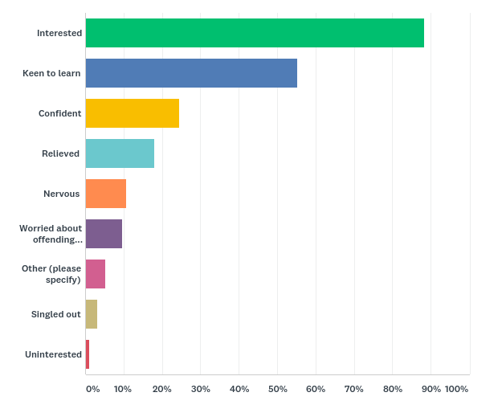Just 1 person (1%) said they would be uninterested, who was BAME/PoC. Overall, 88% (83) people said they would be interested, and 55% (52 people) were keen to learn. Overall, 18% (17 people) said they would be relieved to have open conversations; this rose to 31% among non-White BAME/ PoC respondents.

10% (9 people) said they would be worried about offending people, all but one of whom was White British.

A quarter of respondents (24%, 23 people) said they were confident; however 32% (19) of White British respondents, and 11% (4) of BAME/PoC respondents chose confident. BAME/PoC respondents were also much more likely to say they would feel nervous. 25% of non-White BAME/PoC, and 17% of BAME/PoC respondents chose nervous, whilst 7% of White British respondents did, compared to an overall average of 11% (10 respondents). 3 respondents (3%) said they would feel singled out, all of whom were BAME/PoC.

These anxieties were echoed in the comments from 3 BAME/PoC respondents, who said they would feel ‘scared’, and ‘worried that it would be an open arena for people to be offensive without repercussion’. Another respondent expressed their ambivalence about open conversations on race, ethnicity, and racism:

‘It would always be worthwhile for all workplaces to discuss BAME representation. But as for myself being the only foreign person at work I would feel singled out addressing my colleague's upsetting comments about where I'm from’.

### Q42 Ranking statements: 93 answers

We asked respondents to ‘Please rank how far you agree/ disagree with the following statements’: My workplace is a safe environment for LGBTQ+ BAME/people of colour; LGBTQ+ BAME/people of colour are visible where I work; LGBTQ+ BAME/people of colour don't apply for jobs at my workplace; I trust management to deal with racial and LGBTQ+ discrimination; Racism is not an issue at my workplace; My workplace should take more action to support LGBTQ+ BAME/people of colour. Respondents could rank their answers on a scale from Strongly disagree, Somewhat disagree, Neither agree nor disagree; Somewhat agree; and Strongly agree. Comments were welcome.

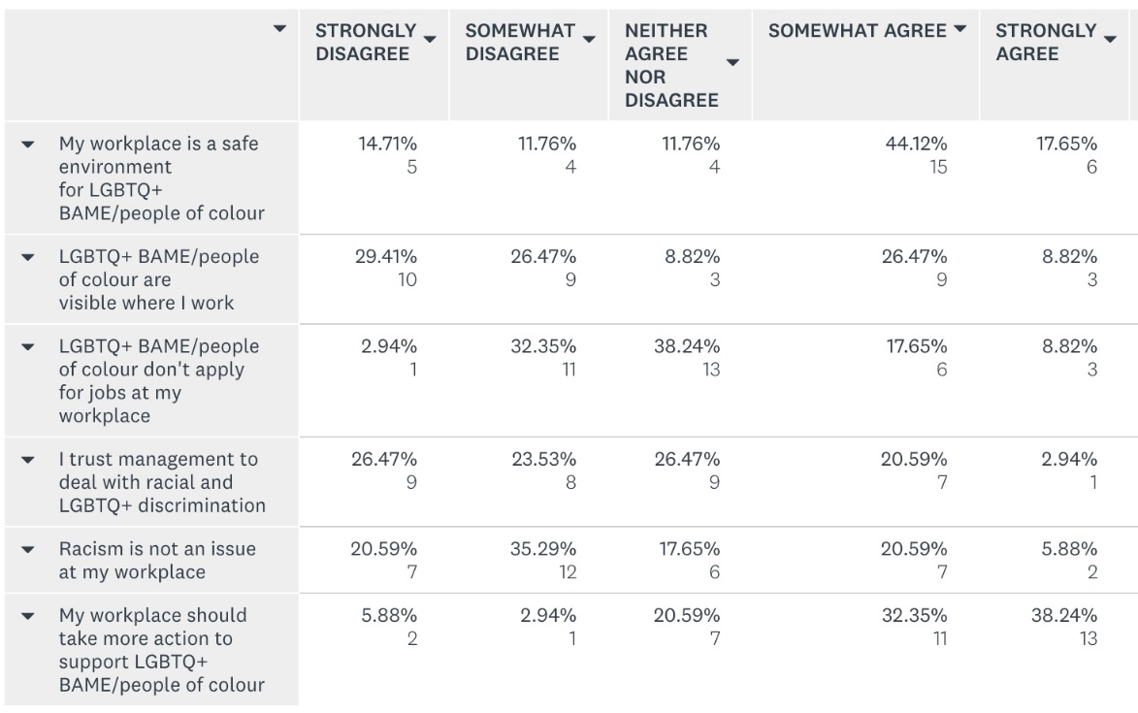

Left: BAME/PoC responses

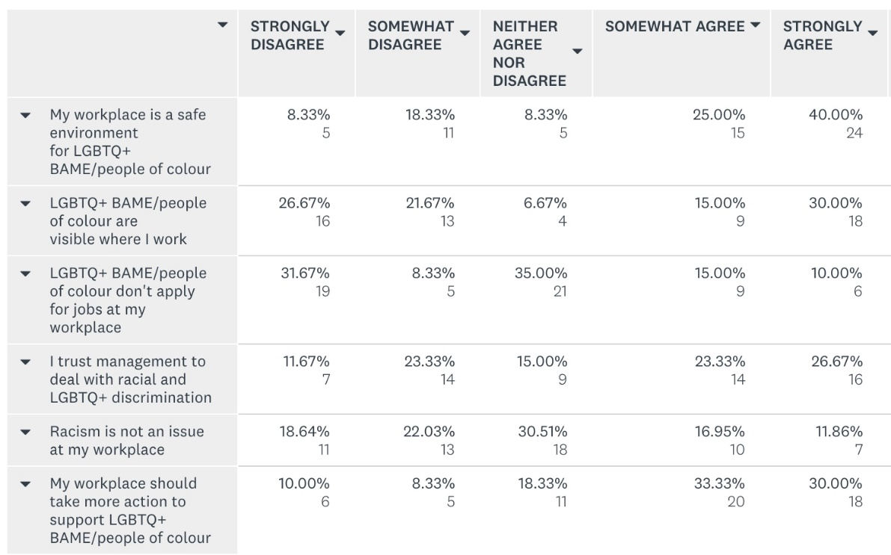

Left: White British responses

#### Q42.1 My workplace is a safe environment for LGBTQ+ BAME/people of colour

Overall, 65% of respondents either somewhat or strongly agreed that their workplace is a safe environment for LGBTQ+ BAME/PoC. White British respondents were much more likely to say they strongly agree (40%, 24 people) than BAME/PoC respondents to say the same (18%, 6 people). Whilst only 8% of White British respondents (5 people) strongly disagreed, 15% (5 people) of BAME/PoC respondents did, rising to 31% (5 people) among non-White BAME/PoC.

#### Q42.2 LGBTQ+ BAME/people of colour are visible where I work

48% of White British people disagreed to some extent with this statement, as did 56% of BAME/PoC, and 75% of non-White BAME/PoC. A significantly higher proportion of White British respondents said they strongly agree that LGBTQ+ BAME/PoC are visible where they work (30%, 18 people), compared to 9% of BAME/PoC respondents.

One respondent commented, on the disconnect between their organisation’s vision and the opportunities given to LGBTQ+ BAME/people of colour:

‘I think my organisation are very open and aware of issues surrounding intersectionality from a theoretical standpoint, and as such I feel supported that any issues of racism I brought up would be taken very seriously, however as the only POC on the staff it's fair to say that this well-meaning doesn't always translate into more or better opportunities for BAME LGBTQ people, despite some effort on their part.’

#### Q42.3 LGBTQ+ BAME/people of colour don't apply for jobs at my workplace

The largest response to this statement was Neither Agree Nor Disagree, chosen by 38% (13) of BAME/PoC and 35% (21) of White British people. Over a third of both groups disagreed to some extent, though a higher percentage of White British people strongly disagreed (32%, 19), compared to 3% (1 person) of BAME/PoC. Roughly a quarter of both groups agreed to some extent.

#### Q42.4 I trust management to deal with racial and LGBTQ+ discrimination

50% of White British respondents agreed to some extent that they trust management to deal with racial and LGBTQ+ discrimination. That compares to 24% of BAME/PoC respondents. Over a quarter of White British people (26.67%, 16 people) strongly agree that they trust management, compared to 3% (1 person) among BAME/PoC respondents.

50% of BAME/PoC respondents disagreed to some extent, indicating they do not trust management to deal with these kinds of discrimination, as did 69% of Non-White respondents. Only 35% of White British respondents said the same.

#### Q42.5 Racism is not an issue at my workplace

Over half BAME/PoC respondents said they disagree to some extent (56%, 19 people), compared with 41% of White British people (24 people). Over a quarter of both groups agreed to some extent, although the percentage of those who strongly agree was twice as high among White British respondents (12%, compared to 6% among BAME/PoC).

#### Q42.6 My workplace should take more action to support LGBTQ+ BAME/people of colour

Among BAME/PoC respondents, 71% (24 people) agreed to some extent that their workplace should take more action, as did almost two thirds of White British respondents (63%, 38 people).

Whilst 18% of White British respondents disagreed somewhat or strongly, 9% of BAME/PoC disagreed that their workplace should take more action.

One respondent commented that ‘All workplaces, no matter how well equipped they are, should still take more action to support LGBTQ+ BAME/people of colour’.

# 11. key insights

## 11.1 for the statutory and public sectors

### 11.1.1 Intersectional oppressions in the workplace

Our findings show that discrimination in the workplace is widespread among LGBTQ people of all races and ethnicities. They also show that being BAME/PoC and LGBTQ compounds these experiences. In addition to racial discrimination, BAME/PoC respondents were also more likely than White British respondents to report facing discrimination for being LGBTQ, and gender discrimination.

This affects people through subtle acts of harassment as well as sustained bullying and discrimination. Many LGBTQ BAME/PoC describe being expected to spend time and energy doing extra institutional work on race, ethnicity, gender, and sexuality alongside their usual workload, whilst other colleagues were able to focus on their own careers.

### 11.1.2 Differences within the lgbtq BAME/PoC community

This research highlights differences within LGBTQ BAME/PoC populations. Comparing White British with BAME people does not tell us everything about the experiences of those groups. In our survey, non-White BAME/PoC often reported significantly heightened levels of workplace harassment and discrimination compared with the average across all LGBTQ BAME/PoC. This echoed advisory panel members, who pointed to additional barriers like colourism among non-White LGBTQ BAME/PoC.

Further differences in the backgrounds of respondents mean that race/ethnicity alone should not be taken as the only (or even the main) explanation for our findings. Future work should pay attention to different experiences *within* LGBTQ BAME/PoC communities, both with regards to race/ethnicity, and other axes of oppression such as disability, gender, faith, and trans status.

### 11.1.3 workplaces are causing harm to LGBTQ BAME/Poc

The pressure to respond calmly to harassment by educating others on race, ethnicity, gender, and sexuality falls disproportionately on LGBTQ BAME/PoC individuals. Workplace harassment has a serious impact on hope for the future among LGBTQ BAME/PoC, with some being unable to imagine a future where they are not harassed.

Our findings show that these experiences can have serious effects on people’s health and wellbeing, resulting in exhaustion, low confidence, and feeling worthless. Some people take long-term sick leave or permanently leave their post; some consider suicide.

### 11.1.4 white british colleagues do not recognize the experiences of LGBTQ BAME/PoC

LGBTQ BAME/PoC describe indifference and even hostility when they speak out about discrimination at work. It is clear that White British colleagues and managers fail to understand why these actions are harassment, or if they do they don’t recognize the extent of them.

The results show that the persistent experiences of harassment at work described by LGBTQ BAME/PoC may be unseen by White British LGBTQ people. Whilst some White British respondents named different barriers facing BAME/PoC in their workplaces, others are optimistic. The average perception of racial equality at work is much positive among White British LGBTQ people than it is among LGBTQ BAME/PoC.

When issues do come up, White British respondents have more trust that their organisations will take appropriate actions to keep them safe than LGBTQ BAME/PoC.

### 11.1.5 Workplaces are not proactive

The findings show that workplaces can be incredibly hostile environments for LGBTQ BAME/PoC. Actions to support LGBTQ BAME/PoC staff are rarely taken until an LGBTQ BAME/PoC arrives in an organisation and faces difficulties, which means that an individual has to be harmed before any change takes places.

The lack of action by workplaces leaves LGBTQ BAME/PoC hopeless and resigned. This is compounded by previous experiences of a backlash for speaking out. People feel that harassment and discrimination are inevitable; whilst some leave their jobs others feel that they have no choice but to accept it.

Instead, organisations should be proactive and take steps whether or not there are currently staff who are LGBTQ BAME/PoC. Actions must be sensitive to ensure the safety of LGBTQ BAME/PoC staff who are already present. BAME/PoC respondents were much less confident than White British LGBTQ people about the idea of having open conversations on race, ethnicity, and racism at work, and expressed fears of being singled out.

### 11.1.6 specialised Mental health support is vital

Specialised mental health services are urgently needed. Without cultural sensitivity, individuals seeking urgent mental health support have to spend time and energy educating support workers about their race, ethnicity, and LGBTQ lives.

The findings show that LGBTQ BAME/PoC feel significantly safer working with an LGBTQ BAME/PoC therapist, because they trust they won’t be asked to justify themselves and their identities, or be dismissed as over-reacting when talking about racial/ethnic discrimination. This is compounded for some Black communities who distrust medical gatekeepers, because of historic and ongoing discrimination.

There is a critical need for specialised mental health and wellbeing services that are equipped to work with LGBTQ BAME/PoC.

## 11.2 For the statutory, public, community, and voluntary sectors

### 11.2.1 Brighton & Hove has few spaces specifically for LGBTQ BAME/PoC

Our findings show that, in workplaces and in mainstream LGBTQ spaces, LGBTQ BAME/PoC often face hostility or indifference when discussing their experiences. There are many different struggles and issues across the community that are not given a platform, such as what it means to ‘come out’, and different ways of being an activist.

People need more spaces where they can talk honestly about their lives, work through shame, and ask for support, without having to justify their existence. Without that, many LGBTQ BAME/PoC do not feel welcome in Brighton & Hove.

### 11.2.2 visibility is a problem

Visible representation of LGBTQ BAME/PoC is lacking in Brighton & Hove. Many people feel isolated from colleagues, from the mainstream LGBTQ community, and from any other LGBTQ BAME/PoC. A role models project is wanted among local partners to shares stories, create hope, and increase understanding among the wider Brighton & Hove population. This would need to balance individual needs for discretion and safety with aims for visibility. Crucially, any project needs to be developed, led, and delivered by LGBTQ BAME/PoC.

### 11.2.3 Creative initiatives already exist

In Brighton & Hove there are already several projects and initiatives that are led by and run for LGBTQ BAME/PoC. These range from social support spaces to campaign groups and creative projects. The vast majority of this work happens outside of the community sector with little formal funding or institutional support. There is a lot of scope for the public sector as well as LGBTQ organisations and others in the charity sector to partner with these groups, support each other’s work, learn from each other, and develop mutual initiatives.

## 11.3 for the community and voluntary sectors

### 11.3.1 LGBTQ organisations are often unsafe

LGBTQ organisations have historically not been safe or inclusive spaces for BAME/PoC. Our findings show that LGBTQ BAME/PoC are frustrated with LGBTQ organisations for failing to engage with them and support their needs. Partners advised that LGBTQ organisations should be prepared to face their past and present mistakes.

This begins with honest self-reflection: questions should be asked at regular intervals about whether LGBTQ organisations reflect the communities they aim to serve, and if not, why not. Actions should then be taken to address specific problems.

### 11.3.2 Engagement varies across Brighton & Hove’s LGBTQ groups

Across Brighton & Hove, there is a very mixed picture of how proactive LGBTQ groups are, both as employers and service providers. Some offer specialized services and take actions to encourage more BAME/PoC to participate as volunteers and staff. Other groups are still entirely made up of White British people across all volunteers, staff, and trustees.

### 11.3.4 LGBTQ BAME/PoC staff are lacking in LGBTQ Organisations

The findings point to how important it is for LGBTQ organisations to reflect the communities they aim to serve. Service users who are BAME/PoC want to know that they are represented and visible within LGBTQ organisations, and that they won’t have to educate staff members on race and ethnicity whilst seeking support. Projects for LGBTQ BAME/PoC must be run by LGBTQ BAME/PoC staff members, so projects cannot be run with current staffing. At the same time, it is key that race work is not delegated to the only BAME/PoC staff members; this can be exhausting and re-traumatise people.

### 11.3.4 Resources and funding are a significant barrier

None of Brighton & Hove’s LGBTQ organisations that have run specialized services for LGBTQ BAME/PoC had specific funding to do this work. Organisations have found creative ways to run projects from generic budgets. However, the funding environment has made this increasingly difficult. All of the organisations that participated recognized that there need to be specialized services to work with Brighton & Hove’s LGBTQ BAME/PoC population. Even when action plans are made, they are often undermined by cuts or grants expiring.

### 11.3.3 Switchboard has not engaged with LGBTQ BAME/PoC

Whilst intersectional inclusion one of Switchboard’s core values, working with LGBTQ BAME/PoC has not been a strategic priority. A past consultation suggested developing specialized services, and BAME/PoC volunteers have made efforts to drive to drive Switchboard’s inclusion of LGBTQ BAME/PoC. These did not result in changes, and LGBTQ BAME/PoC have been underrepresented in the organisation and as service users. Actions must now be taken to proactively engage with the community.

# 12. Recommendations

These recommendations have been developed out of the findings from the insights of the advisory panel, discussions with partner organisations, the community survey, meetings with Brighton & Hove LGBTQ organisations. It is hoped the following recommendations may act as a guide for the CCG.

## 12.1 Public and statutory sectors

### a) Workplace environments: BHCC and BH CGC lead initiatives to improve the work environment for LGBTQ BAME/PoC

* + Work with managers across public sector organisations, to consider new strategies to address workplace harassment and discrimination beyond existing measures. Strategies to focus on pro-active education of White British employees and avoid placing a burden on LGBTQ BAME/PoC staff.
  + Explore ways to hold public and commercial sectors to account on being pro-active in addressing discrimination against LGBTQ BAME/PoC at work.
  + Implement a mentoring/ support scheme to link up LGBTQ BAME/PoC employees across different workplaces in the public and statutory sectors.

### b) MENTal health support: BH CCG offer specialized mental health support for LGBTQ BAME/PoC

* + BH CCG prioritise employing a support worker with specialized knowledge and experience of working with LGBTQ BAME/PoC. Ideally the worker should themselves be BAME/PoC and LGBTQ.
  + Raise awareness about specialized services with existing community groups.

### C) Training: the intersection of race, ethnicity and LGBTQ identity to be part of mandatory equality and diversity training

* + Within public and statutory sector groups, all mandatory staff trainings on equalities and diversity should specifically address the intersection of race, ethnicity, and LGBTQ identity. Content and format to be developed with LGBTQ BAME/PoC trainers, using materials such as Gires’ *Inclusion*, by Sabah Choudrey. Trainings to take into consideration the fears of LGBTQ BAME/PoC staff.
  + Staff in all mental health services to receive additional awareness training on working with LGBTQ BAME/PoC.

### D) Make funding available to support community projects led by LGBTQ BAME/PoC

* + Public sector to partner with voluntary sector and community groups on a role models project, to increase visibility and representation of LGBTQ BAME/PoC in Brighton & Hove.
  + Support new initiatives that engage with and support LGBTQ BAME/PoC.

### E) Prioritise further research with the LGBTQ BAME/PoC community

* + Gather more evidence about the experiences of LGBTQ BAME/PoC, including the impact of intersectional oppressions like disability and migrant status. Aim to identify barriers to accessing health care (specifically mental health services), and community support.
  + Research should be led by people who are both LGBTQ and BAME/PoC. Work with existing local LGBTQ BAME/PoC initiatives to develop questions and approaches.

## 12.2 Community and voluntary sectors

### F) Role models: work on developing projects to support the visibility and representation of Brighton & Hove’s LGBTQ BAME/PoC communities.

* + Stonewall and TDC bring together potential partners to explore logistics, funding sources, and legacies of a role models project. Partners identified through the consultation include Brighton QTIPOC Narratives. For archiving, possible partners include QueenSpark Books, Brighton & Hove City Council Libraries, The Keep, and New Writing South.
  + Switchboard and TDC explore options for training LGBTQ BAME/PoC as community researchers, to carry out a role models project, and support in future consultations.
  + Learn from Stonewall’s Role Models Programme, especially that the project should be owned, led, and delivered by LGBTQ BAME/PoC.

### G) Community engagement: voluntary organisations work more closely with LGBTQ BAME/PoC community groups

* + All voluntary groups in Brighton & Hove build closer links with existing initiatives, to support and signal boost their work.
  + LGBTQ organisations to lead on supporting LGBTQ BAME/PoC initiatives. BAME/PoC groups to be invited to all events, including groups for migrants, refugees, and asylum seekers.
  + TDC include LGBTQ BAME/PoC community groups at the 2019 Wellbeing Event, to facilitate sharing and connection across communities.

### H) WORKPLACES: TDC work towards developing inclusive workplace policies and share with the voluntary sector

* + TDC update HR policies to improve access and inclusivity, paying attention to BAME/PoC and LGBTQ communities. Collaborate with partners and communities in developing new, inclusive approaches to recruitment, job opportunities, and working environments for paid staff and volunteers from BAME/PoC and LGBTQ communities.
  + Job/ volunteer applications: key issues include updating scoring systems and job criteria to value different kinds of expertise; having an open morning or named person to speak with before applying; offering support with completing application forms; and leaving enough time for deadlines. Shortlisting to be done with care, time, and attention – not just ticking off key words.
  + Working arrangements: key issues include flexibility with working hours and days, to support people with caring responsibilities and other commitments; being open to job shares; building an intersectional lens into all new projects.
  + Share findings with the sector, for example via Community Works networks and the Volunteer Co-ordinator Forum.

### I) Partnership initiatives: LGBTQ and BAME/PoC organisations work in partnership to develop initiatives to support LGBTQ BAME/PoC employees

* + LGBTQ organisations partner with BAME/PoC organisations to explore creating an informal mentoring scheme to connect LGBTQ BAME/PoC in different organisations, especially where they are the only person at their workplace.
  + Switchboard and TDC explore creating a training programme on LGBTQ BAME/PoC staff, to deliver to other organisations. This should take into account fears of being singled out and re-traumatised among LGBTQ BAME/PoC.
  + Switchboard and TDC come together to talk about current work. Host a speed dating style event for staff across both organisations to inform each other about current projects and allow better signposting between support groups, community development workers, youth workers, and phoneline.

### J) LGBTQ employers: LGBTQ organisations to be proactive in recruiting and supporting LGBTQ BAME/PoC as volunteers, staff, and trustees

* + Implement self-reflection and monitoring of all staff, volunteers, and trustees as a routine practice, to ask how far the organisation reflects the communities it aims to serve, and take action when issues are identified.
  + Take positive action to encourage BAME/PoC people to apply for positions as trustees, volunteers, and staff, by identifying and working with new channels to advertise posts and opportunities. That includes BAME/PoC groups as well as LGBTQ BAME/PoC community initiatives.
  + LGBTQ organisations host a joint meeting to write new policies on anti-racism and supporting LGBTQ BAME/PoC as staff.
  + Switchboard continue discussions with Stonewall about facilitating a session on race and ethnicity for Brighton & Hove’s LGBTQ organisations.

### K) National links: build links with national organisations to bring learnings from national projects into Brighton & Hove’s voluntary sector

* + Switchboard and TDC to work on developing links with Stonewall and Black Pride, to share information about national LGBTQ BAME/PoC initiatives and groups.

### L) raisE awareness: use platforms to discuss intersection of race, ethnicity, and LTGBTQ lives

* + TDC use its platform across health and wellbeing services to discuss the intersection of race/ethnicity and LGBTQ lives. When consulted by statutory, public, voluntary, and community groups on racial and ethnic inclusion, include a specific discussion about LGBTQ BAME/PoC. Training include breaking down assumptions that BAME/PoC are not LGBTQ.
  + Switchboard and TDC centre intersectional identities in the planning of community cohesion work, support work, and future projects.

### M) TDC: identify where links can be built with existing community work

* + Begin asking questions with community influencers and leaders in BME and neighbourhoods work, to scope areas that are open to community conversations or building links with LGBTQ groups.
  + Questions aim to identify areas open to future projects, such as role models work. This is not about forcing people to come out as LGBTQ, having formal training, or over-riding existing concerns and priorities of community groups.
  + Links aim to build common ground, encourage connection and support allyship.

### N) Switchboard: implement a programme of work around race and ethnicity as a strategic priority

* + Establish an action plan in a staff workshop. Staff to reflect on how race and ethnicity fit into their work, collectively set outcomes, and problem-solve together. Work should be taken on by the whole organisation, with one trustee designed to lead and monitored by the Service User Advisory Panel.
  + Once an action plan is established, issue a public apology for the lack of support for LGBTQ BAME/PoC and set out what steps will be taken.
  + Hold training for all existing and new trustees, staff and volunteers addressing the intersection of race, ethnicity, and LGBTQ identity.
  + Take positive action to encourage BAME/PoC people to apply for all positions
  + Explore options for hosting specialized services for LGBTQ BAME/PoC in Brighton & Hove. Consider designating one night per week on the helpline for LGBTQ BAME/PoC callers, where volunteers on the phone will all be LGBTQ BAME/PoC. Build on the model of the Trans Survivors helpline: this should be volunteer-led, so can happen once Switchboard has more LGBTQ BAME/PoC volunteers.

# 13. Conclusions

### 13.1 report conclusions

This consultation points to the critical importance of working intersectionally. LGBTQ people of all races and ethnicities are facing serious harassment at work. For LGBTQ Black, Asian, Minority Ethnic and/or people of colour in Brighton & Hove, those situations are compounded. It isn’t simply that LGBTQ BAME/PoC face racism in addition LGBTQ discrimination; the oppressions interact and reinforce each other, taking on new forms and affecting people in new ways.

LGBTQ BAME/PoC in Brighton & Hove report insidious forms of workplace discrimination. These range from subtle microaggressions to being forced to permanently leave workplaces. For too many LGBTQ BAME/PoC, work is a hostile environment that that harms their health, and wellbeing. Those facing harassment often lack trust in organisations to take concrete actions that will keep them safe at work, because of past experiences of being dismissed and ignored. This is occurring within a wider context of health and wellbeing services that are not properly equipped to work with LGBTQ BAME/PoC.

There is a real need for the public, statutory, voluntary, and community sectors, as well as commercial employers, to address the lack of support for LGBTQ BAME/PoC as staff. Action should be taken to support LGBTQ BAME/PoC, and partnerships built with community-led projects, to support projects that promote representation and visibility of role models.

Brighton & Hove’s organisations now show leadership in this area. Given the historic exclusion of BAME/PoC from many LGBTQ groups, there is a need for honest self-reflection about what harm has been caused, followed by meaningful action. It is clear from the consultation that LGBTQ BAME/PoC are still excluded and marginalised in mainstream LGBTQ spaces as well as health and wellbeing services, although these barriers are often under-estimated by White British people.

### 13.2 intersectional understandings

We should be careful not to assume that race is the only (or even the main) explanation for all of our findings. In the first instance, the White British and BAME/PoC we surveyed differed in many more ways than race, especially with regards to gender, disability, and sexual orientation. The central goal of intersectional working is to recognize that different axes of oppression come together and interact. Any number of additional vulnerabilities that we didn’t explore are likely shaping the experiences of LGBTQ BAME/PoC in Brighton, such as caring responsibilities, socio-economic status, and migrant status, among others. Our findings also point to significant differences within racial/ethnic groupings, especially among LGBTQ non-White BAME/PoC.

Through working with an advisory panel, we aimed to make the consultation process itself more inclusive. From our perspective, the guidance of the advisory panel was invaluable to the process and findings. Drawing on their feedback, the focus and scope of the consultation took a very different direction than what would have been done by a White British LGBTQ staff member. This is a model that could be used again in the future (although we hope to have LGBTQ BAME/PoC staff to lead on work on this topic).

# 14. Key contacts

Switchboard CEO

Daniel Cheesman

[daniel.cheesman@switchboard.org.uk](mailto:daniel.cheesman@switchboard.org.uk)

LGBTQ Development Officer

Jessica Sandelson

[jessica.sandelson@switchboard.org.uk](mailto:jessica.sandelson@switchboard.org.uk)

Trust for Developing Communities Projects Manager

Lyndsay Macadam

[lyndsaymacadam@trustdevcom.org.uk](mailto:lyndsaymacadam@trustdevcom.org.uk)

1. GIRES (2016). [Inclusivity – Supporting BAME Trans People](http://www.gires.org.uk/wp-content/uploads/2016/02/BAME_Inclusivity.pdf).
2. Beyond the Binary (2016). [Inclusivity – introducing the new UK guide for TPOC in trans spaces*.*](http://beyondthebinary.co.uk/inclusivity/)
3. Kat Gupta (2015). [Where are our elders?](http://mixosaurus.co.uk/2015/01/where-are-our-elders-2/)
4. Frediksen-Goldsen et al. 2014. [Reconceptualization of lesbian, gay, bisexual, and transgender (LGBT) health disparities.](https://www.ncbi.nlm.nih.gov/pmc/articles/PMC4350932/)
5. Brighton & Hove City Council (2015). [Black and Minority Ethnic Communities in Brighton & Hove](http://www.bhconnected.org.uk/sites/bhconnected/files/Black%20and%20Minority%20Ethnic%20Communities%20in%20Brighton%20%26%20Hove%20%28April%202015%29%20-%20Full%20report.pdf).
6. Brighton & Hove City Council & NHS (2015). [Trans Needs Assessment](https://www.bhconnected.org.uk/sites/bhconnected/files/Brighton%20%26%20Hove%20Trans%20Needs%20Assessment%202015.pdf).
7. Brighton & Hove City Council (2014). [Brighton & Hove City Snapshot: Report of Statistics 2014](https://www.bhconnected.org.uk/sites/bhconnected/files/City%20Snapshot%20Report%20of%20Statistics%202014%202.pdf).
8. Brighton & Hove City Council & NHS (2015). [Trans people in Brighton & Hove: A snapshot report](https://www.bhconnected.org.uk/sites/bhconnected/files/Brighton%20%26%20Hove%20Trans%20Data%20Snapshot%202015.pdf).
9. Brighton & Hove City Council (2015). [Black and Minority Ethnic Communities in Brighton & Hove](http://www.bhconnected.org.uk/sites/bhconnected/files/Black%20and%20Minority%20Ethnic%20Communities%20in%20Brighton%20%26%20Hove%20%28April%202015%29%20-%20Full%20report.pdf).
10. Brighton & Hove City Council. (2015). [Black and Minority Ethnic Communities in Brighton & Hove](http://www.bhconnected.org.uk/sites/bhconnected/files/Black%20and%20Minority%20Ethnic%20Communities%20in%20Brighton%20%26%20Hove%20%28April%202015%29%20-%20Full%20report.pdf).
11. Stonewall (2018). [LGBT in Britain: Work Report](https://www.stonewall.org.uk/sites/default/files/lgbt_in_britain_work_report.pdf).
12. Dr Kath Browne (2007). [Count Me In Too. LGBT Lives in Brighton & Hove Initial Findings: Academic Report](http://www.realadmin.co.uk/microdir/3700/File/CMIT_AcademicReport_final_June07.pdf).
13. Switchboard: HIP (2014). [Consultation on LGBTQ BME People’s Forum – Meeting Note](https://www.switchboard.org.uk/wp-content/uploads/2013/09/LGBT-HIP-BME-Peoples-Meeting-Final-Draft.pdf).
14. FS (2017). [159 - "The gay community is racist." - How do we change it?](https://issuu.com/gmfa/docs/fs_159_final)
15. FS (2017). [Racism and re-imagining Queer Black Masculinities](https://issuu.com/gmfa/docs/fs_159_final).
16. Switchboard: HIP (2014). [Consultation on LGBTQ BME People’s Forum – Meeting Note](https://www.switchboard.org.uk/wp-content/uploads/2013/09/LGBT-HIP-BME-Peoples-Meeting-Final-Draft.pdf).
17. GIRES (2016). [Inclusivity – Supporting BAME Trans People](http://www.gires.org.uk/wp-content/uploads/2016/02/BAME_Inclusivity.pdf).
18. Dr Kath Browne (2007). [Count Me In Too. LGBT Lives in Brighton & Hove Initial Findings: Academic Report](http://www.realadmin.co.uk/microdir/3700/File/CMIT_AcademicReport_final_June07.pdf).
19. Public Health England (2014). [The health and wellbeing of black and minority ethnic gay, bisexual and other men who have sex with men](https://assets.publishing.service.gov.uk/government/uploads/system/uploads/attachment_data/file/498039/HealthWellBeingOfBlackMinorityEthnicMenWhoHaveSexWithMenfinal05122014.pdf).
20. Race Equality Foundation (2016). [Barriers to health faced by transgender and non-binary black and minority ethnic people](http://raceequalityfoundation.org.uk/wp-content/uploads/2018/02/Better-Health-41-Trans-NB-final.pdf).
21. The Guardian (2016). [Homophobic attacks in UK rose 147% in three months after Brexit vote](https://www.theguardian.com/society/2016/oct/08/homophobic-attacks-double-after-brexit-vote).
22. The Argus (2018). [Rise in racist hate crimes](http://www.theargus.co.uk/news/15885554.How_racist_is_where_you_live_since_Brexit_vote__You_will_never_guess_where_is_worst/).
23. Brighton & Hove City Council (2018). [International Migrants in Brighton & Hove: Part of the Joint Strategic Needs Assessment programme](http://www.bhconnected.org.uk/sites/bhconnected/files/180215%20IMNA%20full%20report%20-%20final.pdf).