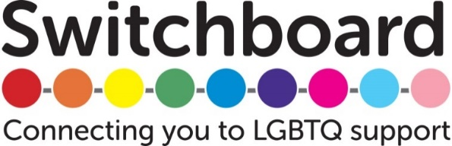
TRUSTEE

Main duties and responsibilities
Each individual member of the trustee board has a responsibility to contribute to the discharging of the board's duties. They can do this by:
- maintaining an awareness of the business
- taking responsibility for their own learning and development
- regularly attending, preparing for and taking a full part in meetings
- actively contributing to setting policy and strategic direction, defining goals, setting targets and evaluating performance
- monitoring whether the service complies with its governing document, and how well the advice needs of the local community are being met
- monitoring the financial position of the organisation and ensuring that it operates within its means and objects, and that there are clear lines of accountability for day-to-day financial management
- supporting the development of the organisation through participation in agreed projects
- actively seeking to further the strategic objectives of the organisation, and acting in the best interests of the organisation at all times
- maintaining confidentiality about any sensitive or confidential information received in the course of duties as a trustee.
Personal skills and qualities for all trustees
Each individual member of the trustee board brings skills and qualities to the board. They add to the collective knowledge and experience by providing:
- commitment and availability to attend trustee board meetings
- effective communication skills and willingness to participate actively in discussion
- willingness to gain knowledge of local needs and resources
- commitment to the vision, mission, values, aims, principles and policies of Switchboard, including those relating to equal opportunities, independence, and research and campaigns
- willingness and ability to act in the best interests of the organisation
- ability to understand and accept their responsibilities and liabilities as trustees and employers
- numeracy to the extent required to understand the organisations accounts with the support of a treasurer
- willingness and ability to learn, and to develop and examine their own attitudes
- ability to think creatively and strategically, and exercise good, independent judgement
- ability to work effectively as a member of a team.

