
Reflective Worksheet 10
EFT


Emotional Freedom Technique (EFT) can help release tension, soothe distress and interrupt unhelpful patterns, including gambling urges. This worksheet invites you to explore how tapping can support emotional regulation and affirm your identity. If you would like to explore this further in your coaching sessions, please speak to your Recovery Coach

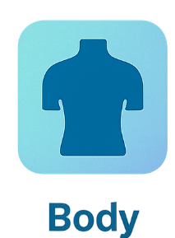


What emotions feel most present when you experience gambling urges?

_________________________________________________________________________________________________________
What statements or affirmations feel grounding or empowering for you?

_________________________________________________________________________________________________________
What identity-related experiences might tapping help you process?

_________________________________________________________________________________________________________
Where do you feel these emotions in your body? Can you locate them?

_________________________________________________________________________________________________________

How does tapping shift your emotional or physical state?

_________________________________________________________________________________________________________





When could tapping be a helpful tool in your recovery?

_________________________________________________________________________________________________________

Reflective Worksheet
Extra Writing Space
Use the space below to extend your answers, thoughts, feeling or any questions you may have to reflect on, or to bring to your coaching session

__________________________________________________________________________________________________________________________________________________________________________________________________________________________________________________________________________________________________________________________________________________________________________________________________________________________________________________________________________________________________________________________________________________________________________________________________________________________________________________________________________________________________________________________________________________________________________________________________________________________________________________________________________________________________________________________________________________________________________________________________________________________________________________________________________________________________________________________________________________________________________________________________________________________________________________________________________________________________________________________________________________________________________________________________________________________________________________________________________________________________________________________________________________________________________________________________________________________________________________________________________________________________________________________________________________________________________________________________________________________________________________________________________________________________________________________________________________________________________________________________________________________________________________________________________________________________________________________________________________________________________________________________________________________________________________________________________________________________________________________________________________________________________________________________________________________________________________________________________________________________________________________________________________________________________________________________________________________________________________

