
Reflective Worksheet 12
Mindfulness
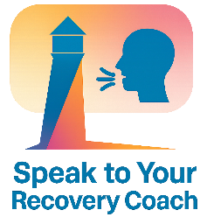
Mindfulness helps you stay present, reduce overwhelm and reconnect with your values. For LGBTQ+ people navigating stress, stigma or identity pressure, mindfulness can be a powerful tool for grounding and recovery.
If you would like to explore this further in your coaching sessions, please speak to your Recovery Coach


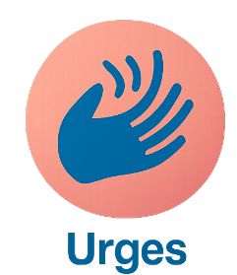


When do you feel most disconnected from the present moment?

_________________________________________________________________________________________________________
How could mindfulness support you during difficult conversations?

_________________________________________________________________________________________________________
What mindful activities help you feel safe or affirmed?

_________________________________________________________________________________________________________
How does mindfulness affect your urges or emotional intensity?

_________________________________________________________________________________________________________

What identity-related stressors pull you out of the present?

_________________________________________________________________________________________________________



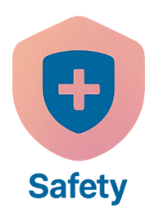

What small mindful moment could you add to your day?

_________________________________________________________________________________________________________

Reflective Worksheet
Extra Writing Space
Use the space below to extend your answers, thoughts, feeling or any questions you may have to reflect on, or to bring to your coaching session

__________________________________________________________________________________________________________________________________________________________________________________________________________________________________________________________________________________________________________________________________________________________________________________________________________________________________________________________________________________________________________________________________________________________________________________________________________________________________________________________________________________________________________________________________________________________________________________________________________________________________________________________________________________________________________________________________________________________________________________________________________________________________________________________________________________________________________________________________________________________________________________________________________________________________________________________________________________________________________________________________________________________________________________________________________________________________________________________________________________________________________________________________________________________________________________________________________________________________________________________________________________________________________________________________________________________________________________________________________________________________________________________________________________________________________________________________________________________________________________________________________________________________________________________________________________________________________________________________________________________________________________________________________________________________________________________________________________________________________________________________________________________________________________________________________________________________________________________________________________________________________________________________________________________________________________________________________________________________________________

