
Reflective Worksheet 14
Health & Fitness
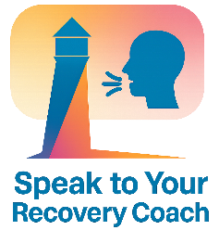
Movement and physical wellbeing can support emotional regulation, confidence and recovery. This worksheet helps you explore how health and fitness can strengthen your identity, resilience and sense of agency.
If you would like to explore this further in your coaching sessions, please speak to your Recovery Coach

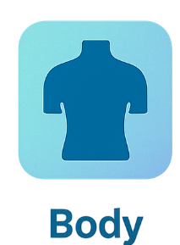

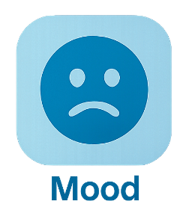

How does movement affect your mood or stress levels?

_________________________________________________________________________________________________________
What small, realistic step could support your wellbeing this week?

_________________________________________________________________________________________________________
What barriers (emotional, physical, identity-related) make fitness difficult?

_________________________________________________________________________________________________________
What forms of movement feel affirming or enjoyable for you?

_________________________________________________________________________________________________________

How does your body feel when you’re taking care of it?

_________________________________________________________________________________________________________


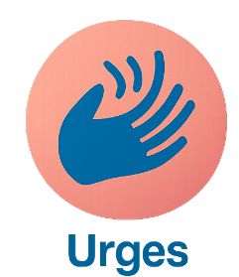


How might movement help you manage urges or difficult emotions?

_________________________________________________________________________________________________________

Reflective Worksheet
Extra Writing Space
Use the space below to extend your answers, thoughts, feeling or any questions you may have to reflect on, or to bring to your coaching session

__________________________________________________________________________________________________________________________________________________________________________________________________________________________________________________________________________________________________________________________________________________________________________________________________________________________________________________________________________________________________________________________________________________________________________________________________________________________________________________________________________________________________________________________________________________________________________________________________________________________________________________________________________________________________________________________________________________________________________________________________________________________________________________________________________________________________________________________________________________________________________________________________________________________________________________________________________________________________________________________________________________________________________________________________________________________________________________________________________________________________________________________________________________________________________________________________________________________________________________________________________________________________________________________________________________________________________________________________________________________________________________________________________________________________________________________________________________________________________________________________________________________________________________________________________________________________________________________________________________________________________________________________________________________________________________________________________________________________________________________________________________________________________________________________________________________________________________________________________________________________________________________________________________________________________________________________________________________________________________

