
Reflective Worksheet 16
Keeping Busy

Staying occupied can help reduce urges, but meaningful activity also supports identity, connection and self-worth. This worksheet helps you explore how to fill your time in ways that nourish you.
If you would like to explore this further in your coaching sessions, please speak to your Recovery Coach



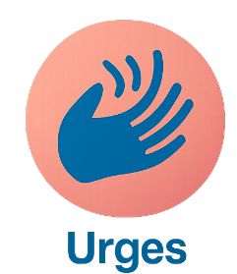

When do gambling urges tend to appear during your day?

_________________________________________________________________________________________________________
What small activity could you add to your week to support recovery?

_________________________________________________________________________________________________________
What activities help you feel like yourself and being present and in the now?

_________________________________________________________________________________________________________
What activities help you feel grounded, creative or connected?

_________________________________________________________________________________________________________

What LGBTQ+-affirming spaces or hobbies interest you?

_________________________________________________________________________________________________________



How does meaningful activity affect your mood or urges?

_________________________________________________________________________________________________________

Reflective Worksheet
Extra Writing Space
Use the space below to extend your answers, thoughts, feeling or any questions you may have to reflect on, or to bring to your coaching session

__________________________________________________________________________________________________________________________________________________________________________________________________________________________________________________________________________________________________________________________________________________________________________________________________________________________________________________________________________________________________________________________________________________________________________________________________________________________________________________________________________________________________________________________________________________________________________________________________________________________________________________________________________________________________________________________________________________________________________________________________________________________________________________________________________________________________________________________________________________________________________________________________________________________________________________________________________________________________________________________________________________________________________________________________________________________________________________________________________________________________________________________________________________________________________________________________________________________________________________________________________________________________________________________________________________________________________________________________________________________________________________________________________________________________________________________________________________________________________________________________________________________________________________________________________________________________________________________________________________________________________________________________________________________________________________________________________________________________________________________________________________________________________________________________________________________________________________________________________________________________________________________________________________________________________________________________________________________________________________

