
Reflective Worksheet 17
Volunteering
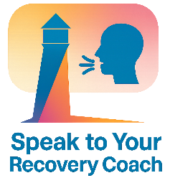
Volunteering can build connection, purpose and community, especially for LGBTQ+ people seeking belonging or affirmation. This worksheet helps you explore how volunteering might support your recovery and identity.
If you would like to explore this further in your coaching sessions, please speak to your Recovery Coach





What causes, charities, or communities matter to you?

_________________________________________________________________________________________________________
How could volunteering support your personal recovery goals?

_________________________________________________________________________________________________________
What LGBTQ+‑affirming spaces would feel safe to volunteer in?

_________________________________________________________________________________________________________
How might volunteering help you feel more connected or valued?

_________________________________________________________________________________________________________

What skills or strengths could you offer to a volunteer placement?

_________________________________________________________________________________________________________

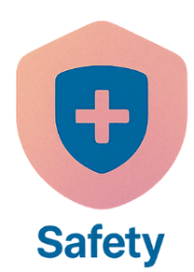


What is one small step you could take toward exploring opportunities?

_________________________________________________________________________________________________________

Reflective Worksheet
Extra Writing Space
Use the space below to extend your answers, thoughts, feeling or any questions you may have to reflect on, or to bring to your coaching session

__________________________________________________________________________________________________________________________________________________________________________________________________________________________________________________________________________________________________________________________________________________________________________________________________________________________________________________________________________________________________________________________________________________________________________________________________________________________________________________________________________________________________________________________________________________________________________________________________________________________________________________________________________________________________________________________________________________________________________________________________________________________________________________________________________________________________________________________________________________________________________________________________________________________________________________________________________________________________________________________________________________________________________________________________________________________________________________________________________________________________________________________________________________________________________________________________________________________________________________________________________________________________________________________________________________________________________________________________________________________________________________________________________________________________________________________________________________________________________________________________________________________________________________________________________________________________________________________________________________________________________________________________________________________________________________________________________________________________________________________________________________________________________________________________________________________________________________________________________________________________________________________________________________________________________________________________________________________________________________

