
Reflective Worksheet 2
LGBTQ+ Experiences

LGBTQ+ lives are shaped by unique pressures, joys and challenges. This worksheet invites you to reflect on how different parts of your identity journey, from affirmation to discrimination, may influence your wellbeing and gambling behaviour. There is no right or wrong way to explore these questions; they are here to help you understand your story with clarity and kindness. If you would like to explore this further in your coaching sessions, please speak to your Recovery Coach



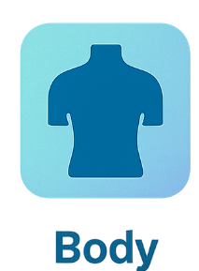

Which parts of your identity journey feel most connected to your gambling behaviour?

_________________________________________________________________________________________________________
What alternative coping strategies feel realistic and compassionate for you?

_________________________________________________________________________________________________________
What emotions do you tend to avoid or soothe through gambling?

_________________________________________________________________________________________________________
What pressures or experiences feel most relevant to you right now?

_________________________________________________________________________________________________________

How do these pressures show up in your body? (e.g., tension, numbness, restlessness)

_________________________________________________________________________________________________________





What would “safety” look like for you today — emotionally, socially or physically?

_________________________________________________________________________________________________________

Reflective Worksheet
Extra Writing Space
Use the space below to extend your answers, thoughts, feeling or any questions you may have to reflect on, or to bring to your coaching session

__________________________________________________________________________________________________________________________________________________________________________________________________________________________________________________________________________________________________________________________________________________________________________________________________________________________________________________________________________________________________________________________________________________________________________________________________________________________________________________________________________________________________________________________________________________________________________________________________________________________________________________________________________________________________________________________________________________________________________________________________________________________________________________________________________________________________________________________________________________________________________________________________________________________________________________________________________________________________________________________________________________________________________________________________________________________________________________________________________________________________________________________________________________________________________________________________________________________________________________________________________________________________________________________________________________________________________________________________________________________________________________________________________________________________________________________________________________________________________________________________________________________________________________________________________________________________________________________________________________________________________________________________________________________________________________________________________________________________________________________________________________________________________________________________________________________________________________________________________________________________________________________________________________________________________________________________________________________________________________

