
Reflective Worksheet 5
Isolation & Loneliness

Loneliness and disconnection can affect anyone, but many LGBTQ+ people face unique barriers to finding safe, affirming community. This worksheet offers space to reflect on how isolation influences your wellbeing and gambling behaviour, and to explore what kinds of connection feel meaningful and possible for you right now. If you would like to explore this further in your coaching sessions, please speak to your Recovery Coach





When do you feel most disconnected or alone? (Environment, Certain Times)

_________________________________________________________________________________________________________
What routines and structure help you feel grounded or less alone?

_________________________________________________________________________________________________________
What small, safe steps and goals could help you build connection?

_________________________________________________________________________________________________________
How does loneliness influence your gambling urges, behaviours or habits?

_________________________________________________________________________________________________________

What kinds of connection do you crave — emotional, social, identity-based?

_________________________________________________________________________________________________________


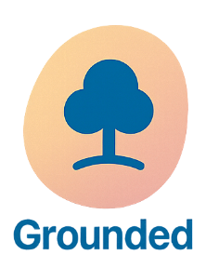


What is one “micro-connection” you could try this week?

_________________________________________________________________________________________________________

Reflective Worksheet
Extra Writing Space
Use the space below to extend your answers, thoughts, feeling or any questions you may have to reflect on, or to bring to your coaching session

__________________________________________________________________________________________________________________________________________________________________________________________________________________________________________________________________________________________________________________________________________________________________________________________________________________________________________________________________________________________________________________________________________________________________________________________________________________________________________________________________________________________________________________________________________________________________________________________________________________________________________________________________________________________________________________________________________________________________________________________________________________________________________________________________________________________________________________________________________________________________________________________________________________________________________________________________________________________________________________________________________________________________________________________________________________________________________________________________________________________________________________________________________________________________________________________________________________________________________________________________________________________________________________________________________________________________________________________________________________________________________________________________________________________________________________________________________________________________________________________________________________________________________________________________________________________________________________________________________________________________________________________________________________________________________________________________________________________________________________________________________________________________________________________________________________________________________________________________________________________________________________________________________________________________________________________________________________________________________________

